

TECHNOLOGY

Name: AFWERKI GHIRMAY

Student ID: P1095278

Lecturer: Gayathri Karthri

# HND project

Table of Contents

HND project 1

Chapter 1: Introduction 6

What motivates me to develop this project and what is the problem that existed before this project. 6

Aim and objectives 6

Issus that might occur 6

The first problem is the credibility of the documents. 6

The second problem is preventing non-students from login to the website 7

The 3rd problem is plagiarism 7

The plan and deliverables in this project 7

Chaper2: Literature review 7

Literature review about domains and current educational websites 7

The expected befits of this project 8

Technological literature review 8

Used technology 8

Technological methods and techniques 8

Development tools and techniques review 8

Project life cycle 9

Project methodology 9

Software development platform 9

Programming language 9

Database choice 9

phpMyAdmin 9

Chapter Summary 10

Chapter 3: planning and design of the project 10

Project planning 10

Main features of the website 10

Design 11

Implementation of the website 11

Project completion 11

Chapter 4: Analysis and design 11

Functional and non-functional requirements of the project 11

System analysist 12

Main legacy of the students to students support website 12

Chapter summary 14

Chapter 5: Implementation 14

Database 15

1. Registration page 20

2. Index(main)page 20

3. Subjects page 21

Technology subjects Page 21

Technology documents page to upload or download documents 21

Social science subjects Page 22

Social science documents page 23

Natural science subject’s pages 23

Natural science document page 23

Maths subjects Page 24

Maths documents page 24

Admin page 25

Admins login page 25

Admin dashboard 25

Registered users list 26

Chapter 6: Testing 26

Different testing techniques 26

Testing plan 27

Students to students website 27

Registration test validation 29

Redirection to login page test validation 30

Logout functionality test validation 31

Sending friend request test validation 32

Searching for other users validation test 33

Liking and commenting test validation 33

Sending messages test validation 34

Message alert from receiver’s side test validation 34

Posting pictures and writing texts test validation 35

Clickable Subjects list test validation 35

Getting all documents available test validation 36

Downloading documents from the website test validation 36

Uploading documents in to database test validation 37

Searching documents test validation 37

Admin login functionality test validation 38

Admin users list view test validation 39

Admin view all the documents test validation 39

Admin logout functionality test validation 40

Chapter summery 41

Chapter7: Deployment and maintenance 41

Deployment 41

Table migration from local server to bluehost cpanel 41

Chapter 8: Evaluation and conclusion 43

Cross-checking the objectives of the project 43

From user students prospective 43

From project management prospective 43

This project from developing prospective 43

Chapter summery 43

Chapter 9: Future work 43

Adding more in to the Registration page 43

Adding Forget password 44

Styling the Index page 44

Make use of all the Subjects page 45

Separating all subjects in to different Document holder page 46

Adding Delete button in to the file 46

Adding Like and dislike buttons in to the file 46

Adding more detail about the file 46

Collecting users based their preferred subject 46

Chapter summery 47

Chapter 10: Overall conclusion 47

Registration and login sequence diagram 48

Searching a person and sending a friend request sequence diagram 48

Uploading the file sequence diagram 49

Downloading the file sequence diagram 49

Searching the file sequence diagram 50

Registration page source code 50

Registration handler.php 51

Index.php home page source code 55

Search.php for searching users source code 59

request.php for sending a friend request source code 62

like.php to like a picture or text that has been posted by students source code 63

Comment_frame.php to comment on anything that has been posted source code 66

Message.php for chatting source code 70

education.php to list all subjects source code 72

Document handler page Index.php source code 74

Download.php to download the document source code 76

Bibliography 78

# Chapter 1: Introduction

In the introduction I am going to show the importance of students to students support website and description of the development. For example, what motivates me to develop the website, the problem that exist and the solution of the problem, the plan of the project and what I Am going to deliver in this project.

## What motivates me to develop this project and what is the problem that existed before this project.

What motivates me to develop this project is luck of sufficient resources. Whenever I want to get some information about the topic that I am studying I have to search all the internet to get the relevant information that I want to use for some tasks.

After long search if I get the resources that I am looking for, most of the resources have an issue of reliability. This resources cannot be a credible source for academicals work.

So in order to overcome this issues for all students throughout the world, I decided to create the website that can handle all necessary documents for most subjects that have academicals confirmation. For example, my document that have been submitted to the college and got a high mark, can be used for other students who face the issue that I faced and follows my step to be where I am now. This person can be a first year computer science student from Africa or from India.

## Aim and objectives

The aim of this project is to design, develop and deploy the **students to students support** website that can be able to support students throughout the world. In order to come up with this idea I did a lot of researches.

For example,

what are the option that are available in the internet for students to get support?

Which subjects should be included in the project?

What technology do I have to use to develop the website?

What are the SDLC of the project that I have to use? Such as, Design, implement, testing and maintenance of the website.

What are the security measure that I have to use in order to protect my website from any harm?

## Issus that might occur

In this project there are three problems expected.

The first problem is the credibility of the documents. As the support givers (document suppliers) are students, the documents that are uploaded on the website might not be enough for other students. For example, on the previous term in OOP (object oriented programming) in python I got merit. So if I upload the document on the website those who download the document might think it’s enough when they supposed to dig more in order to get more marks to get more understanding in this subject.

The second problem is preventing non-students from login to the website. This is also very difficult to differentiate students from non-students. Non-students may use it as a social media rather than students support platform. In order to prevent them from login in to the system we have to differentiate who is a student and who is not a student. it’s very hard to find out students from Africa is a student or not when there is no technological prove to use as an evidence.

The 3rd problem is plagiarism. The copy write issue will be very high epically in countries that doesn’t have functional plagiarism checker system. For students who live in countries that doesn’t check plagiarism technologically, will be just downloading the file and submitting to the college or university that they are studying.

## The plan and deliverables in this project

The plan is to create a website that can connect students throughout the world. Not only based on the languages they speak, the nations they belong to or the ethnic that they can define themselves, even though students can be able to use them as a tool to connect with other students but also based on the subjects that they are studying.

This is the common norm that since is currently creating and connect human kind based on the academicals education. For example, A German computer programmer can communicate with British computer programmer and work together without any problem. This is the common norm that is emerging currently and something that I want to take an advantage of it.

This will be implemented using MySQL database, jQuery and php including HTML and CSS.

# Chaper2: Literature review

Literature review is a review of each task of the project. For example:

* Security and privacy of the website
* User interface and usability of the website
* MySQL database

## Literature review about domains and current educational websites

There are many website and application that has been developed to support students. However most of the websites that I visited doesn’t have enough documents to support. Some websites are built to explain very specific tasks. Rather than supplying the full document. This is very time consumer to search for each task. For example, there are lot of support about python but there is no word document file with the given scenario that can explain python from printing the name all the way to advance python such as OOP. So this is where my assignment that I submitted in the previous term becomes very important for python students.

Here are some of the websites that I visited

* W3 School: this website is very good for beginner computer programmers even though it doesn’t support for other subjects. However, this website doesn’t have that much support for advance programmers.
* Google scholars: google scholars is very good website for academicals but its very advance and some of the documents are there for sell.
* Udemy: udemy is very good as far as you pay for the lessons you take but mostly they give support on the pdf file or word document with give scenario and problem solving.

I can count a lot more websites but most of the websites that I visited are not supplying the students document to other students who are in need of it. Therefore, I prefer to build something better than the websites that exist on the internet. A website that can probably support the entire world students. A website that might make students life easier than ever before.

## The expected befits of this project

This system will allow students to upload the documents and download the documents whenever they need. Documents can be any file extensions such as pdf, word documents, PowerPoint, mp3 and video file. Moreover, students can be able to chat with other students who is registered in the website. such as with the document uploaders or with classmates.

Just like how they chat on Facebook. This will connect students based on their subject that they are studying without any geographical location restriction. Therefore, the system will save some of the student’s time and resources that is spent for searching all over the internet to get the information that they are needed.

## Technological literature review

### Used technology

The technology that I going to use to build this website are JavaScript, PHP, HTML, and CSS. For backend programming in order to interact with the server I am going to use PHP as PHP is natively relates to Apache and for frontend programming I am going to use JavaScript, html and CSS (for design). (Rouse, 20128).

### Technological methods and techniques

I am going to host the website in the internet so that everyone can access it. The website can be accessed by any device including computers, tablets, and phones. The website can be accessed by different search engines. Such as google, google chrome, internet browser. For registration, chatting, upload or download the file will be done by using MySQL and php cooperating with JavaScript, HTML and CSS.

### Development tools and techniques review

For this new system to build I am going to use a methodology that will guide me to pass through different phases so that can meet the requirements of the project. There are many methodologies that can help me to do the analysis and design. These methodologies combined together to make system life cycle(SDLC).

### Project life cycle

Mostly developers are using waterfall, spiral, iterative, and RAD life cycles. However, waterfall cycle is the oldest and very straightforward even though it’s not very efficient for small projects as it doesn’t have enough flexibility for amendment. On the other hand, RAD enable a development team to finish the project within very short period of the time if all the requirements of the project are fully understood. For my project I am going to use iterative and incremental SDLC where cycles of work called sprits iterate during relatively short periods of the time. This will enable to have more flexibility and ability to quickly identify and fix arising errors.

## Project methodology

Recently the most important Information System Development Methodology (ISDMs) including Rational Unified Process (RUP), Scrum, XP (eXtreme Programming) and ICONIX. However, for my **students to students support** project I am going to use the scrum methodology as its better than others.

In scrum the development is divided in to different phases. All the phases are ready-to-use product. Finally, the end of each phase which is called sprint in scrum terminology a readymade product will be delivered to a customer.

Additionally, there is short daily scrum meeting to pinpoint progress and obstacles. Here remaining time required for completion of the tasks is monitored in sprint burn-down chart. This effective and flexible approach is the most suitable for the project of **students to students support** scope. At the end of each scrum the code delivered is tested and ready to be delivered to next stage (spin) of the project development.

## Software development platform

There are many tools available for developing the software. However, I am going to use sublime text3. Sublime text is very advance and it easy for writing the code, running the code and also easy to connect to phpmyadmin.

## Programming language

I am using different languages to develop this website. Such as JavaScript and PHP. All of this languages can be accessed using sublime text.

## Database choice

There are three database models that can be used to develop the website. This are Oracle, MSSQL and MySQL. However, I choose MySQL database that comes with phpMyAdmin as it is available under non-proprietary license, and its speed and the level of security and reliability parameters are suitable for the **students to students support** project.

### phpMyAdmin

phpMyAdmin is an open source platform that is written in php programmed to handle the administration of MySQL over the web. The main benefit of phpMyAdmin is to support MySQL and Maria DB operation. In my case I am going to use phpMyAdmin for managing the databases (phpMyAdmin, 2019).

## Chapter Summary

Even though the education system is different from one country to another country this website will have a big impact in terms of knowledge exchange. In the literature review I have spotted what is needed from the website and what is needed to develop the website.

# Chapter 3: planning and design of the project

It’s very important to have well designed project management in order to have very successful project. Therefore, in this chapter I Am going to explain the design part of my project for the better quality and maintainability of the website.

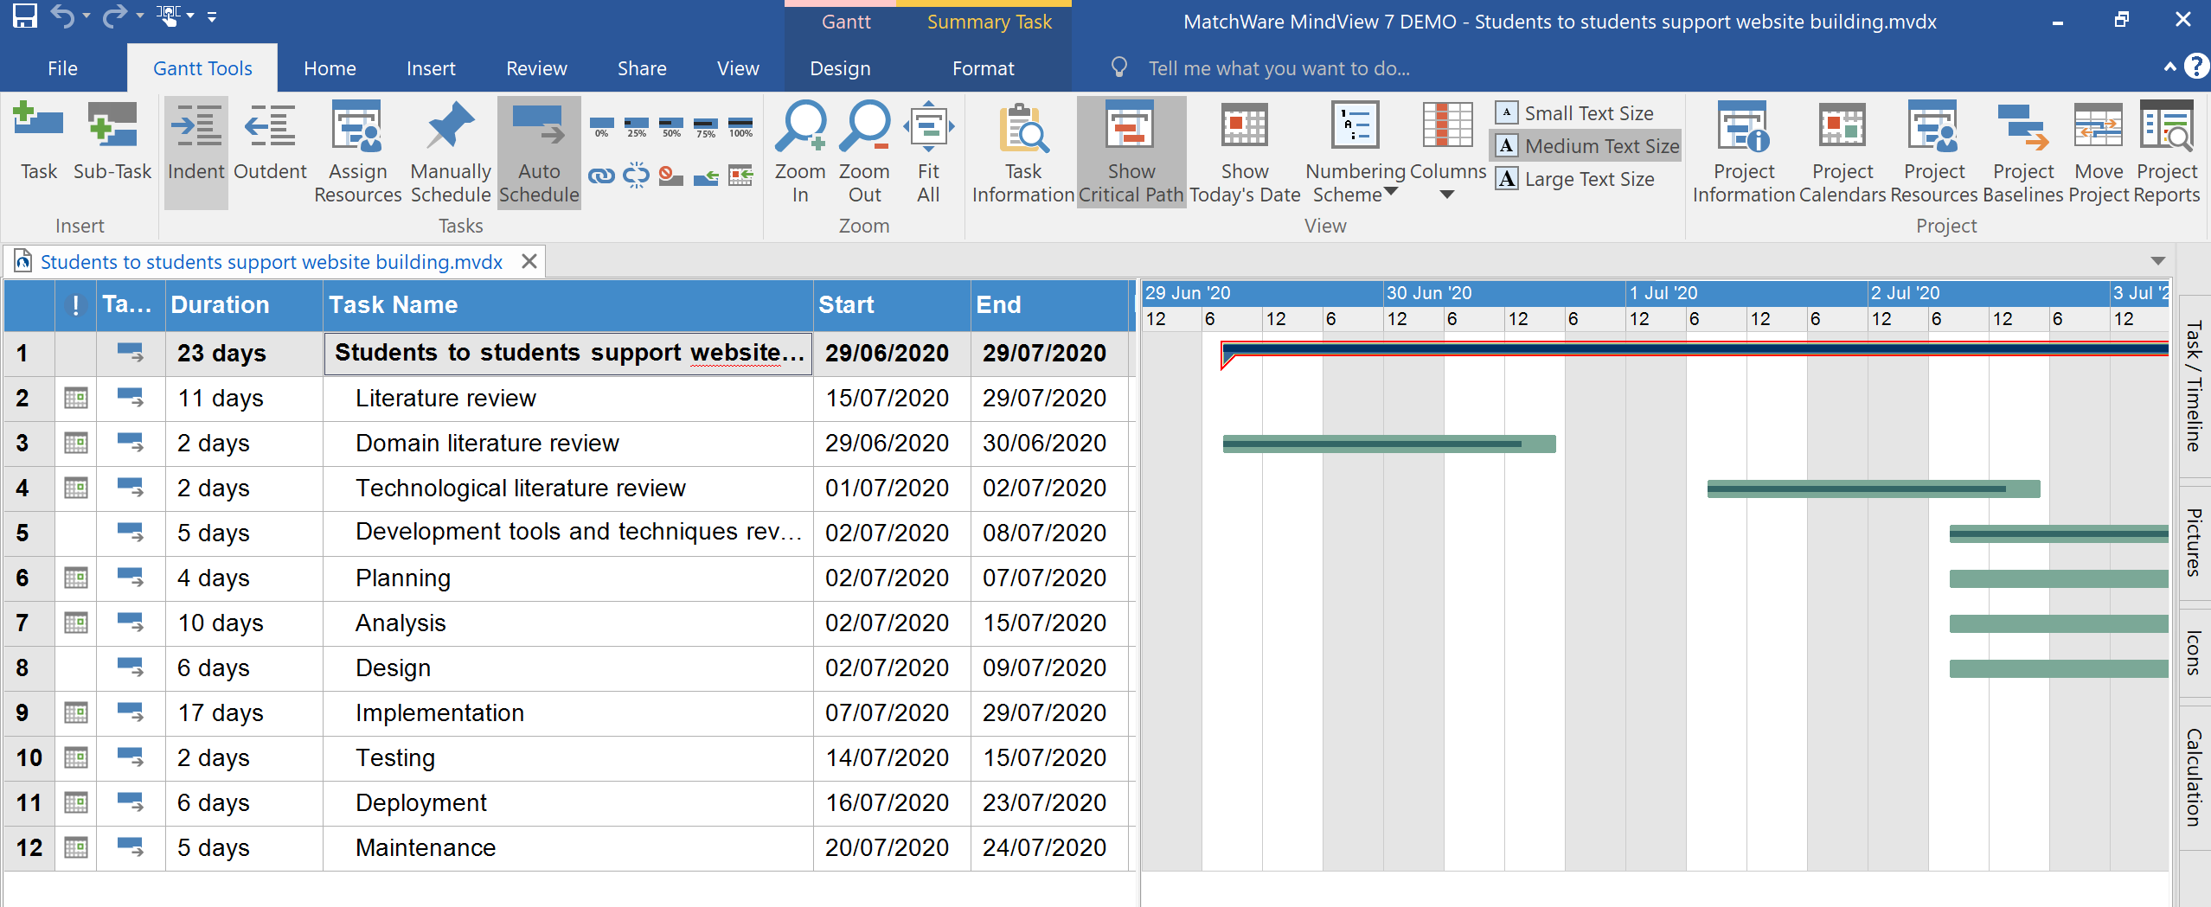

# Project planning

On the following section I am going to describe the students to students support website development plan in four stages. This are:

* Project setup
* Deadline setup
* The website objectives
* Design objectives survey

## Main features of the website

* Registration page
* Home page
* Subjects page
* Document uploading and downloading page.
* Admins page

## Design

The website will have different easy shortcuts so that students can get the documents that they are looking forward in order to download or upload their document to the website. The feature that I am going to include are

* Custom website design concepts
* Templates and interface code for:

Registration page

Home page

Subjects page

Document uploading and downloading page

Admin page

* Cross-browser tested in internet Explorer, Firefox, Safari& Google Chrome.

## Implementation of the website

This website will include text to chat in private with other students and teachers or posting text on public in the website, posting the pictures whenever students struggle to find solution, uploading any type of file in to the website, downloading the file from the website when its needed.

Therefore, the deliverable of this project is:

* Fully functional website

## Project completion

Before the competition of this website and host in in to the internet I will cross check to make sure all the web pages are fully functional and have no problem for service.

# Chapter 4: Analysis and design

Failing to do the project analysis might cost a lot more than expected. For example, project failure, project delay, etc. therefore its very mandatory to spend more time and resource for project analysis. On the other hand, design can enable to control both the internal and external part of the system. Moreover, the design documentation provides the application architecture, providing the way how to transform the logical design in to program models and code.

## Functional and non-functional requirements of the project

The project requirements can be divided by two. Which are functional and non-functional requirements. Functional requirements are the main features that is needed for the functionality of the system that can be used to perform certain tasks. In other word if functional requirements are not met the system will never work.

Functional requirements can be met using UML (unified modelling language) use case diagram that can enable to capture the main features that is required in the system.

On the other hand, non- functional requirements are basic principles of user interface design including structural principle that making sure all related items are placed together and non-related ones are separate. Interface architecture determines its structure, ensuring meaningful and purposeful user interface.

Another principle is simplicity, visibility and feedback. Feedback keeps user informed of any actions and changes. Errors and exceptions should be handled accordingly (QRA, 2017).

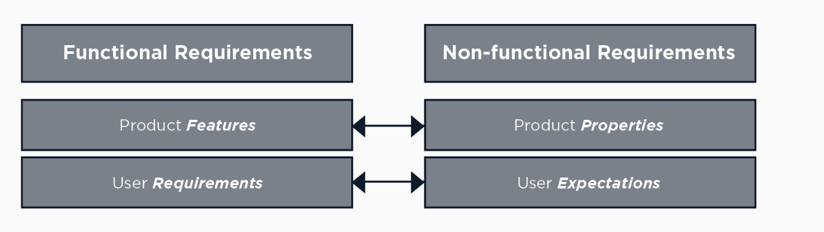

## System analysist

In order to develop the customer oriented website, it’s Very important to analyse the needs of the users. Therefore, in the **students to students support** website students will have a search button in order to search the documents that they want to download. Moreover, students can upload the document in to the website and download the document form the website. Finally, students are allowed to chat in private in order to get help from someone who have been in this situation or someone who is capable of resolving the issue(teacher).

|  |
| --- |
| Main legacy of the students to students support website |
| Students can upload any types of documents in to the website. |
| Students can search the documents by typing on the search button. |
| Students can download the documents that is available in the website. |
| Students can delete the documents that to uploaded in to the website. |
| Students can search for friend and send friend request. |
| Students can chat with friends or post the photo and text in to the website. |
| Students can like or comment on the posts. |
| Admins can overview the all documents that are uploaded in all pages. |

In order to accurately capture the requirements and the flow of the system I am going to draw the use case diagram. The main importance of the use case diagram is to understand the dynamics of the system in a very deeper level (point, 2017).

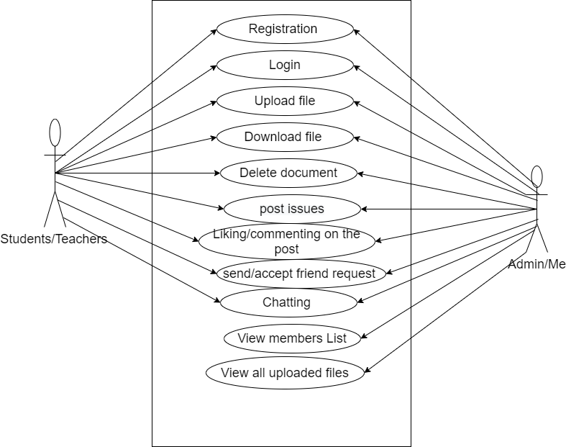students to students support use case diagram

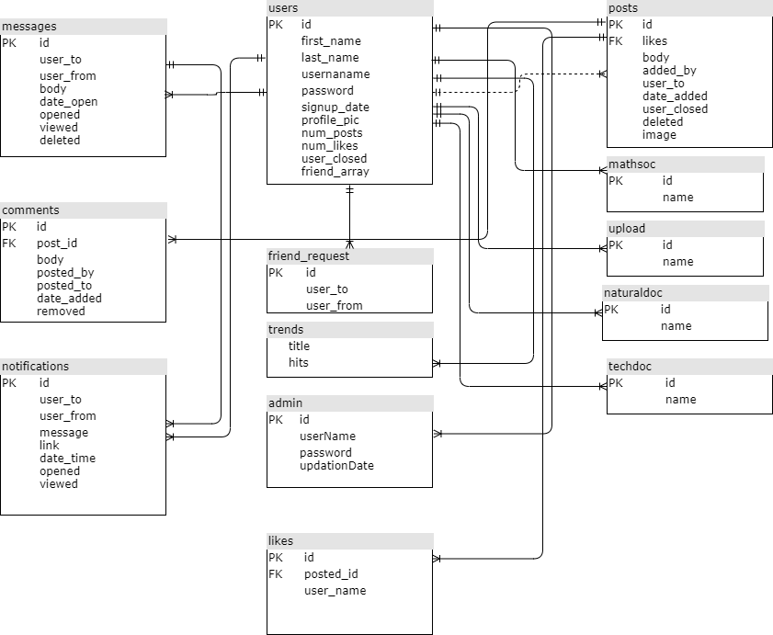

Students to students support website entity database relationship diagram

## Chapter summary

The analysis and design of the **students to students support** website has come to the end. Even though the design part of the database was a bit challenging. After concluding the design part of the system now it’s time to convert the design in to the code. If I missed anything in the design part I will probably find out in the implementation.

# Chapter 5: Implementation

This stage will target the actual construction of the **students to students support** website following the design that I explained in the chapter 4. Sublime text 3 is my preference tool to build the project.

To create a new project first, I have to open sublime text and then create a new page. Once I create a new page I will click **save as** and save it in the phpMyAdmin htdocs folder.

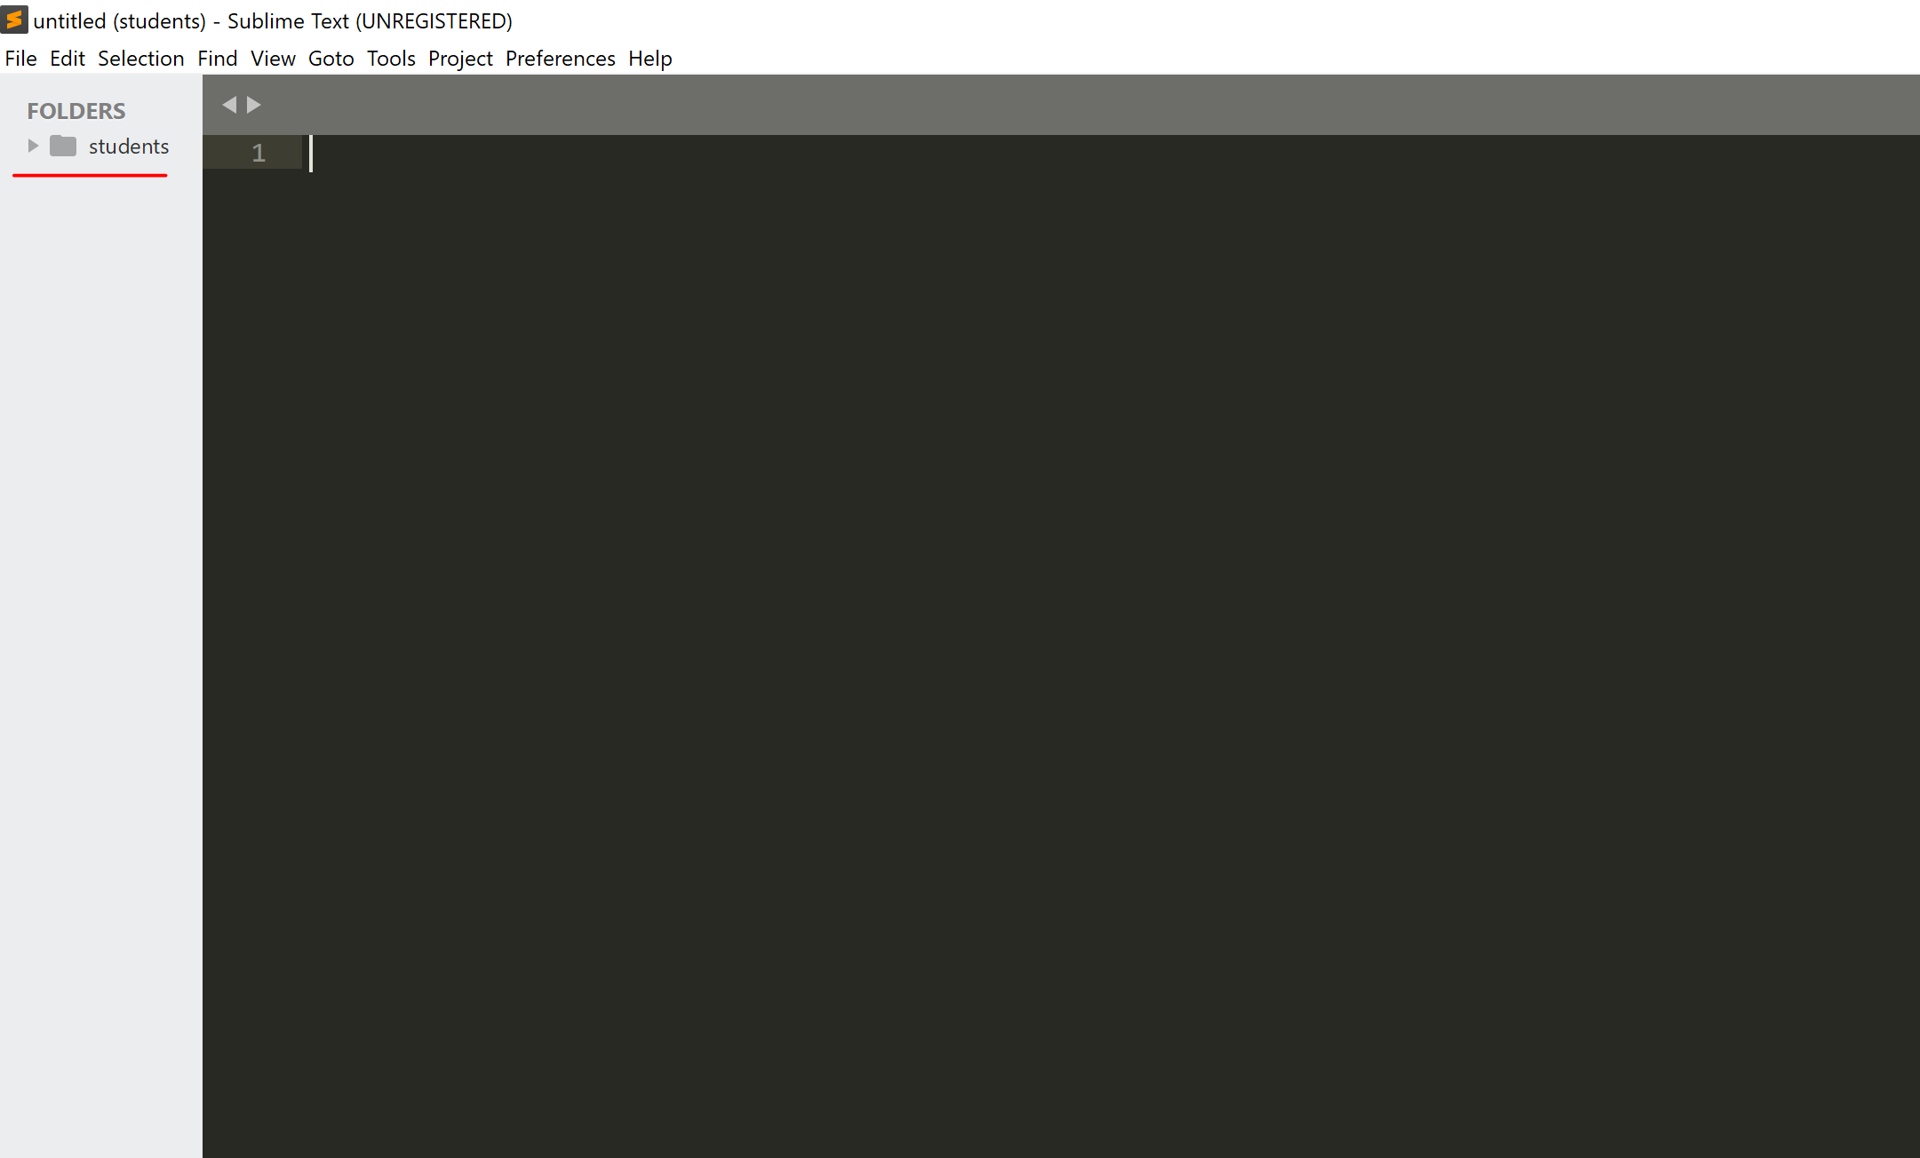

Creating new file in Sublime Text

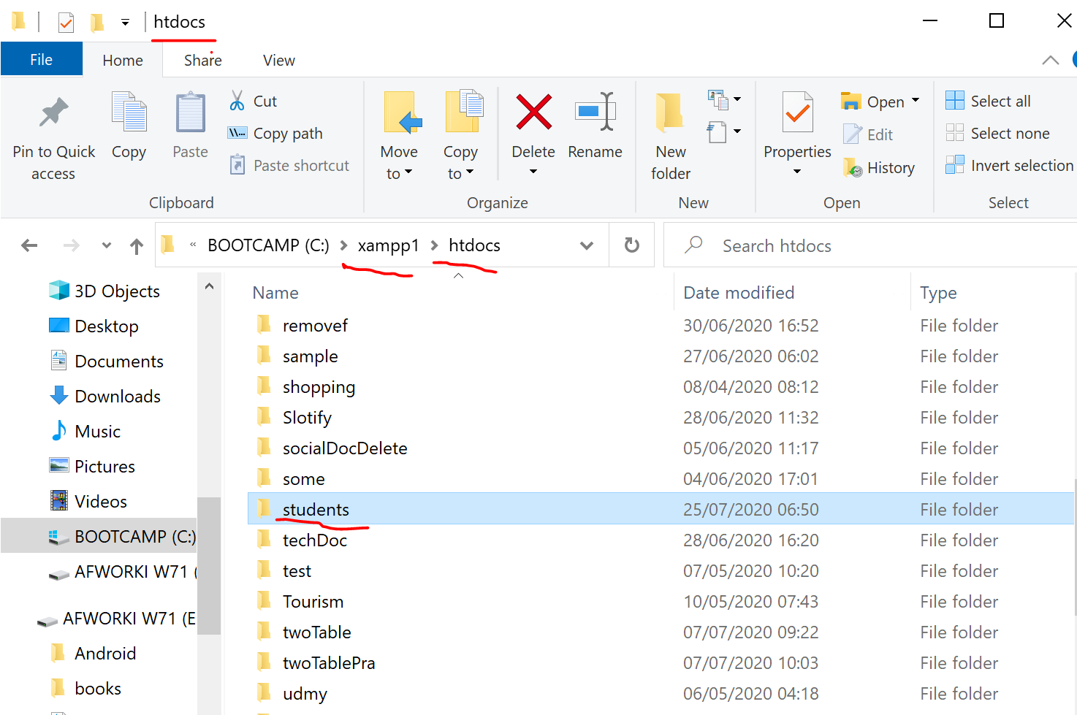

Saving the project on xampp htdocs

After creating the first page in the sublime text the next step is to go and create sql database in xampp.

## Database

After running phpMyAdmin the next step is to click the databases and create new database. inside the database we can create the tables as it shows in the following picture.

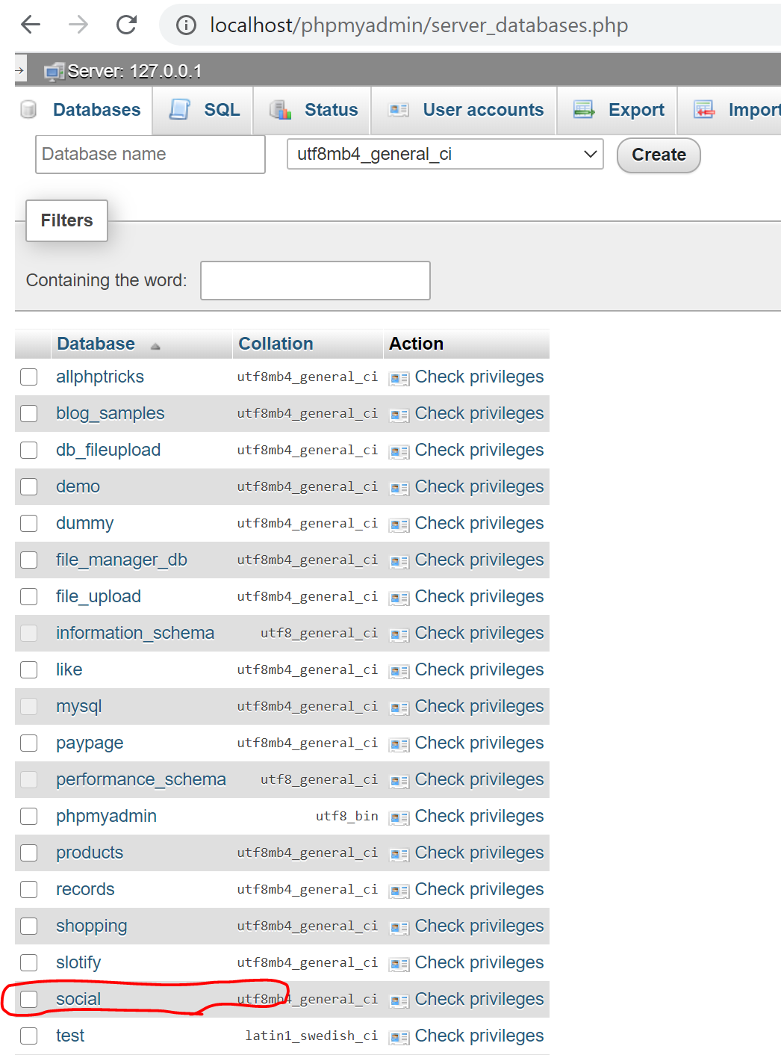

Database inside the phpmyadmin

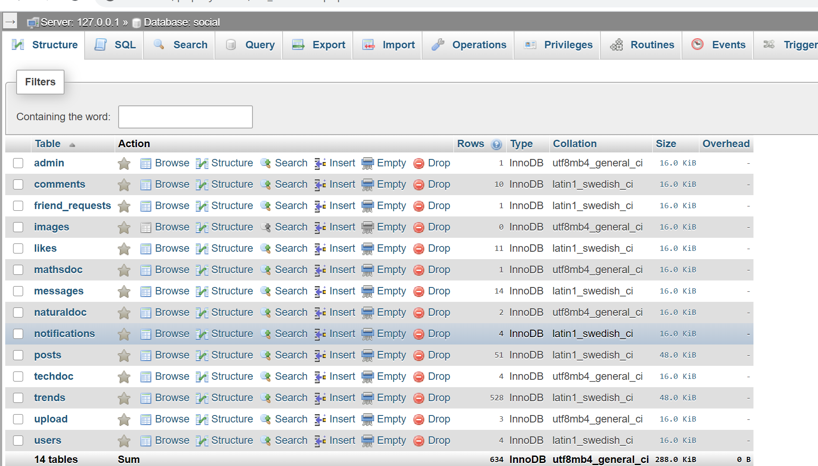

Tables inside the database

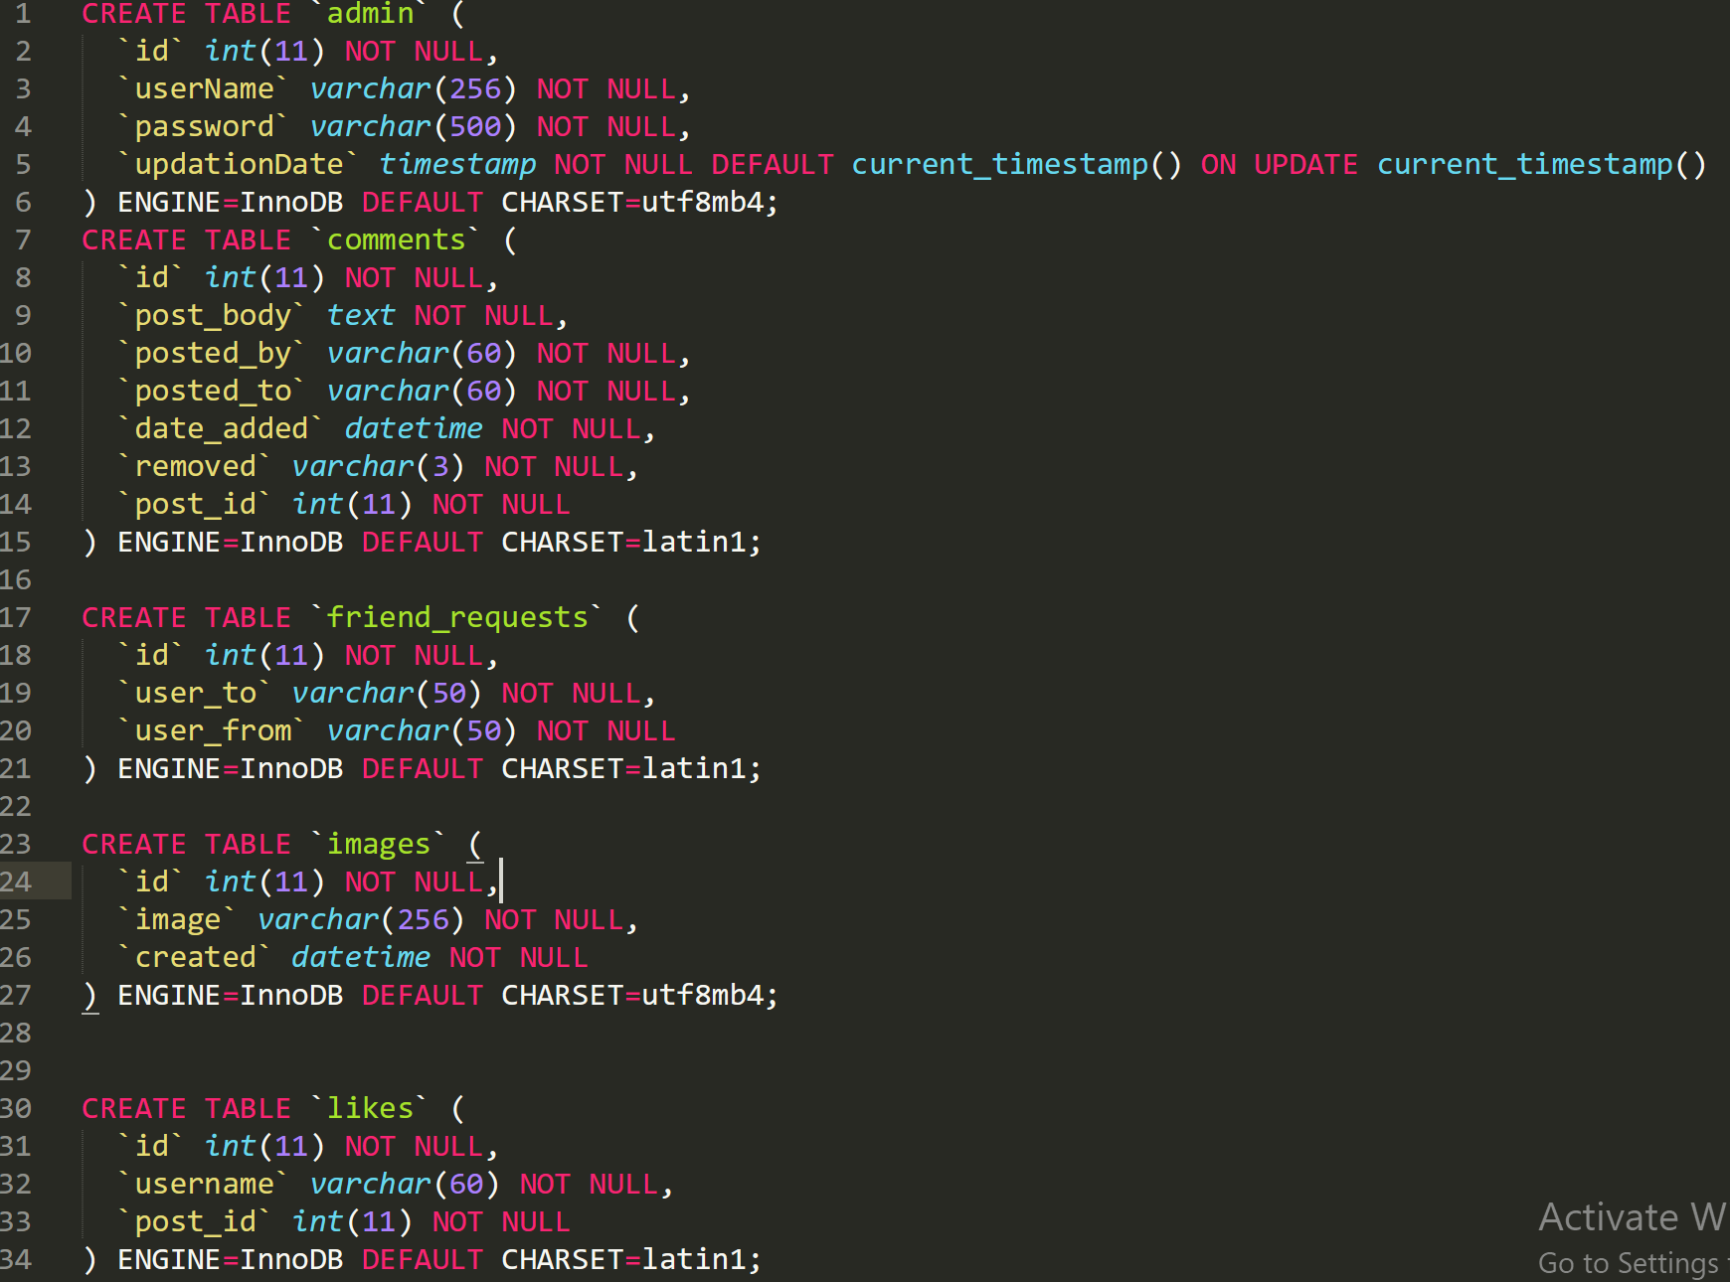

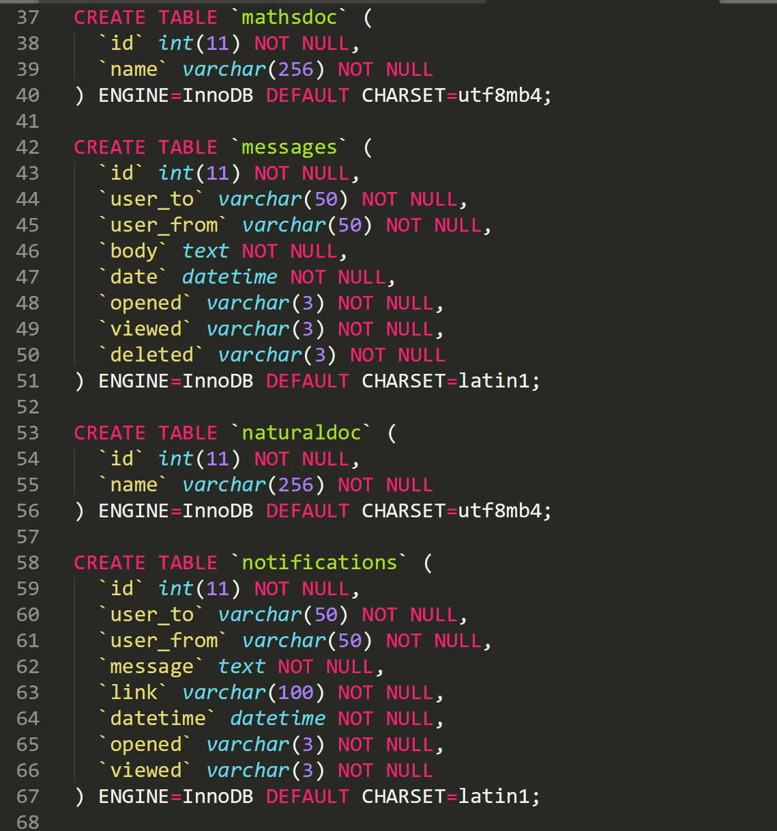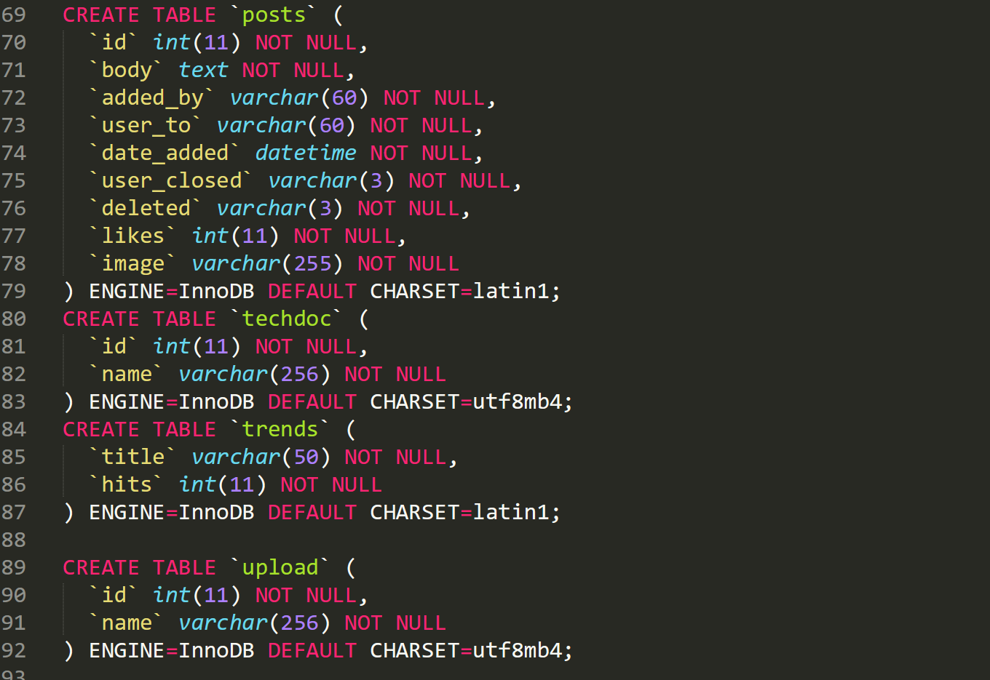

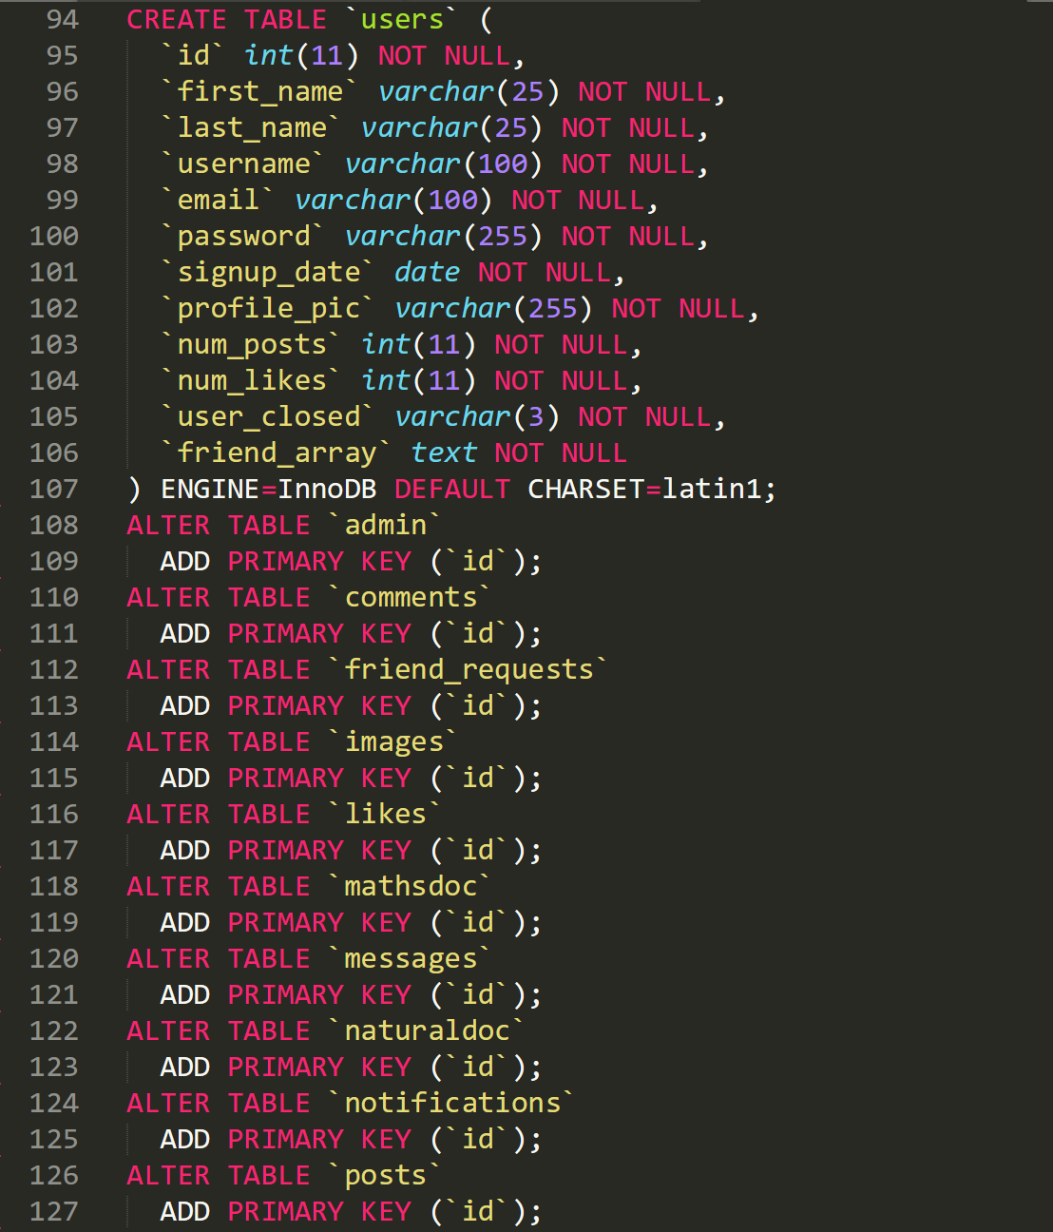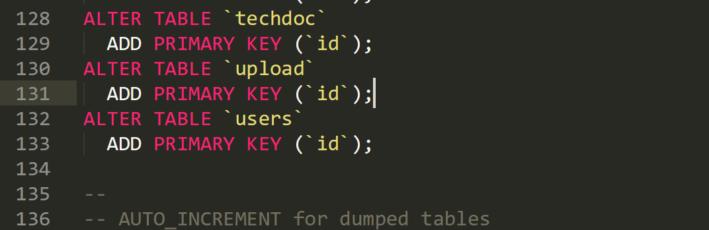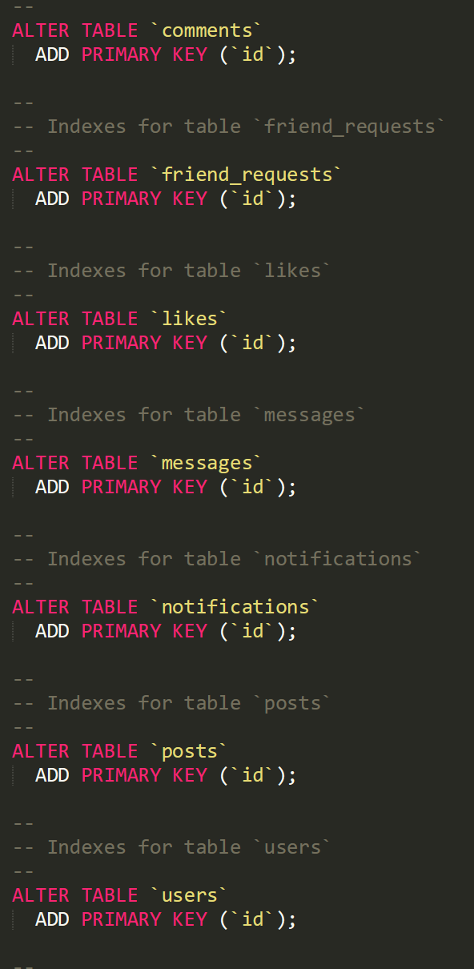

The first page is registration page.

## Registration page

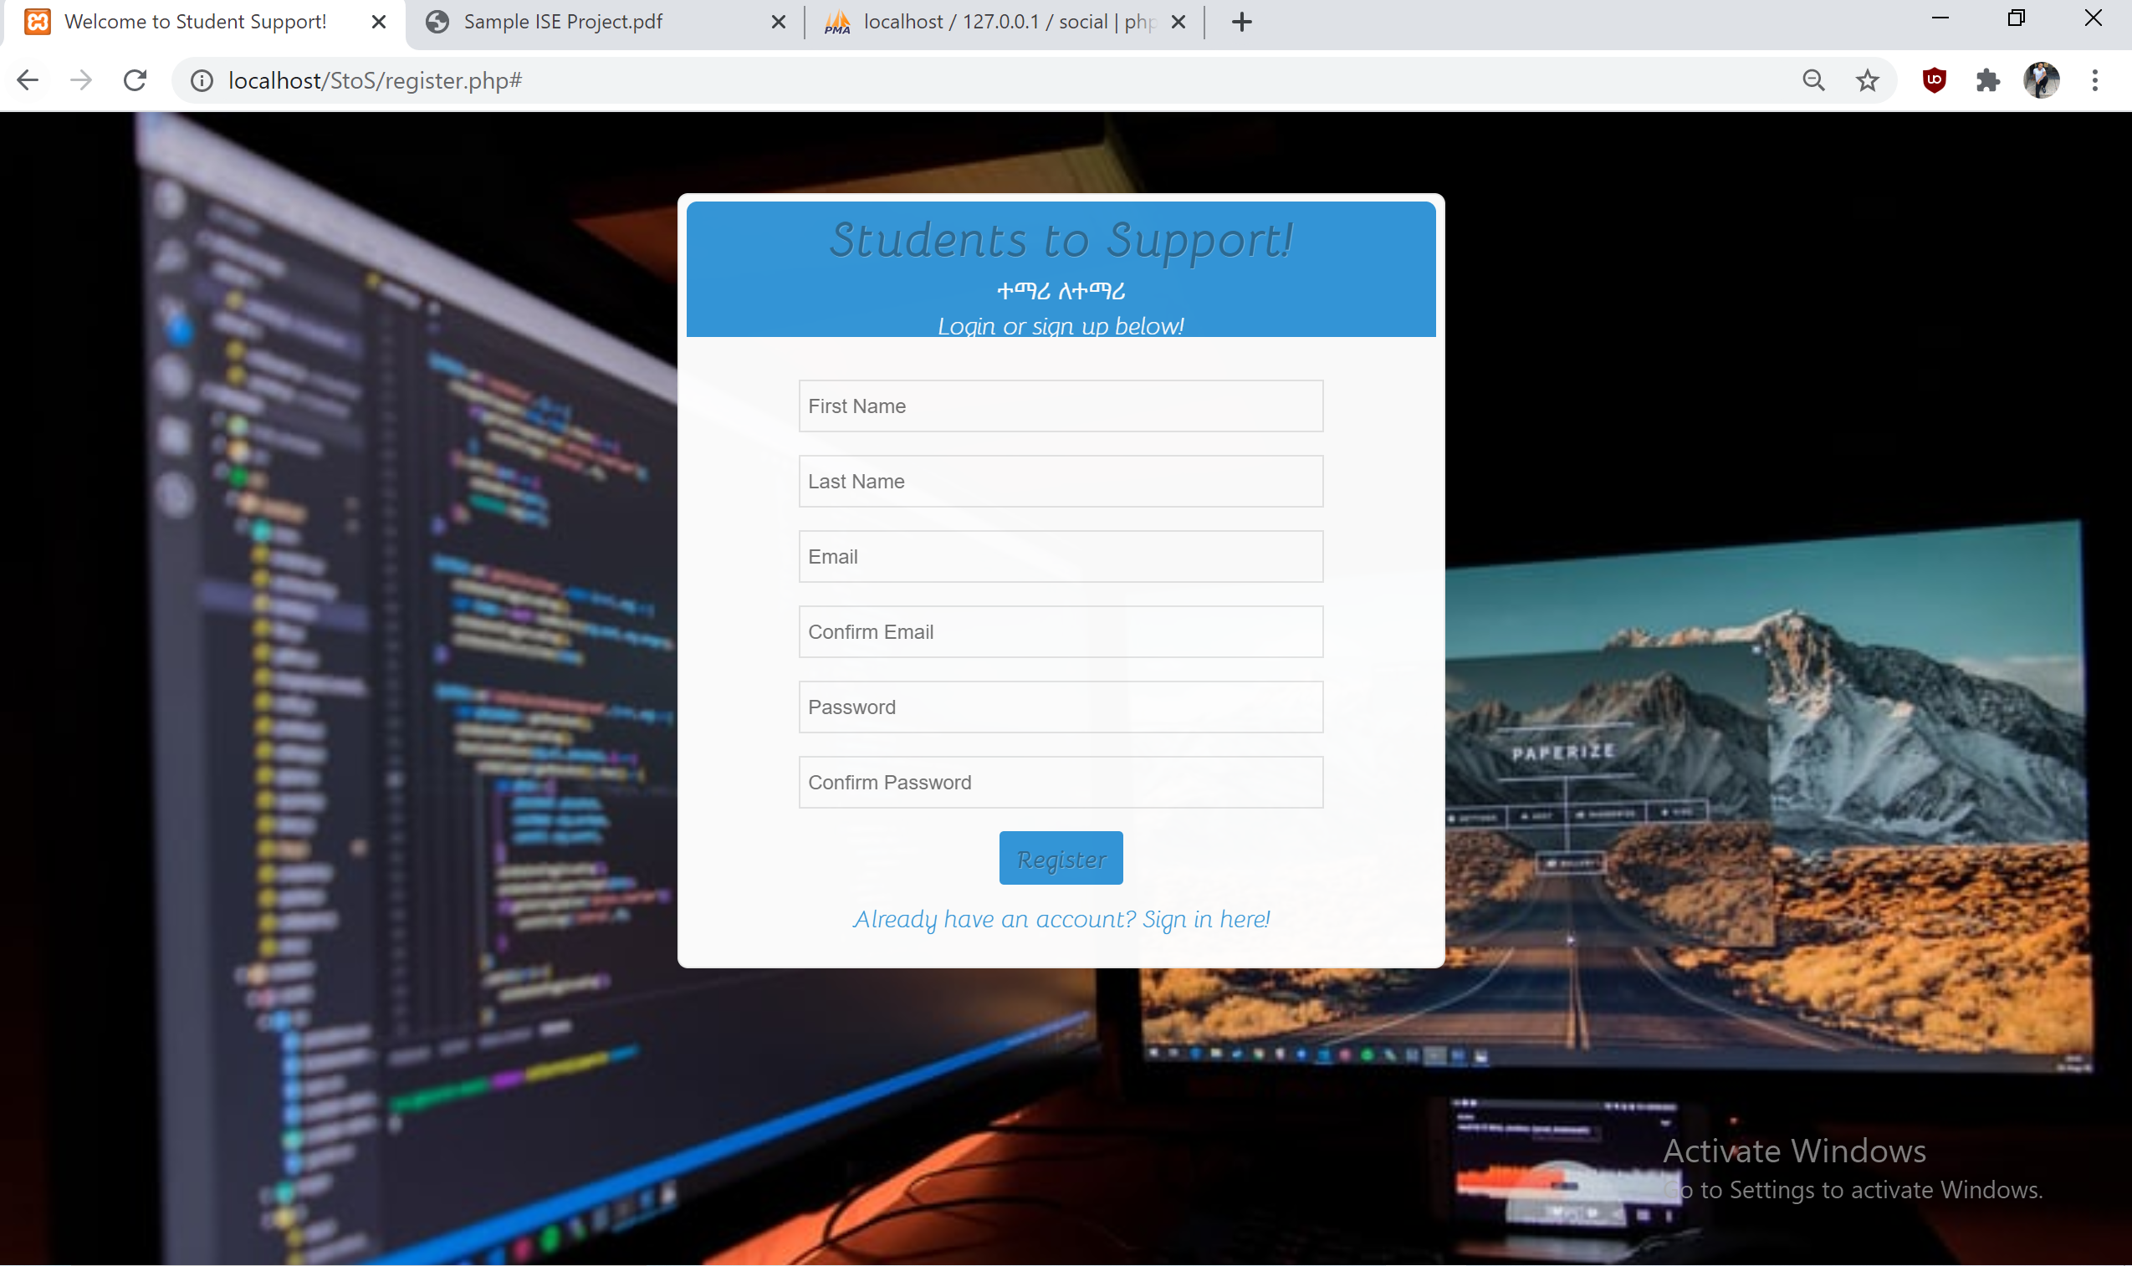

## Index(main)page

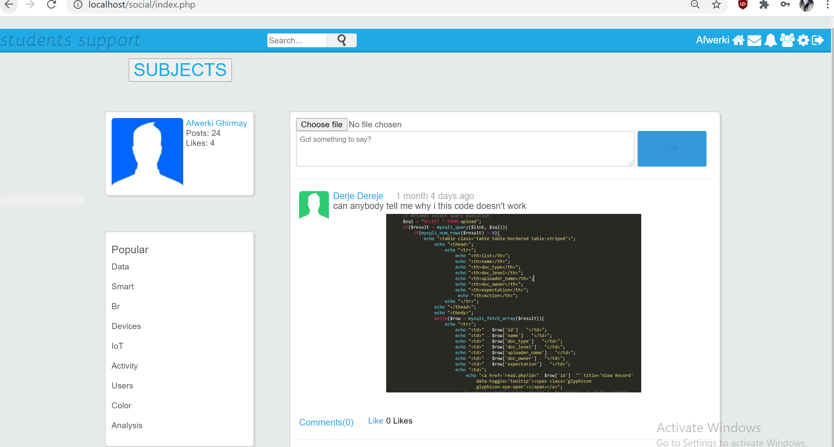

## Subjects page

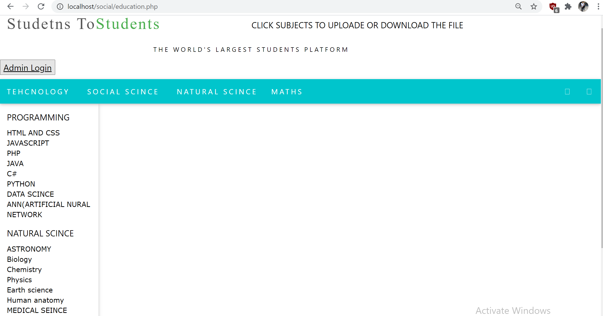

## Technology subjects Page

This page shows different subjects that can be found in the technology department only.

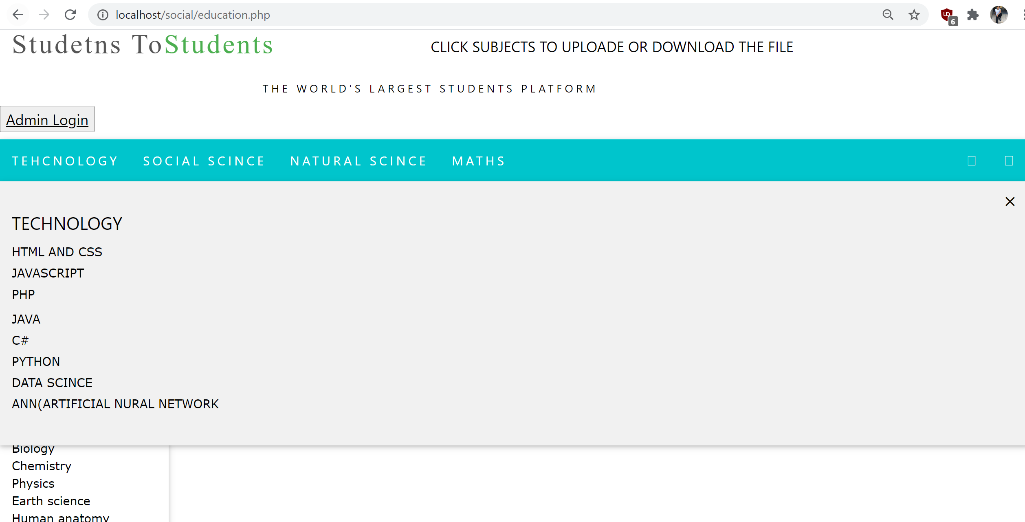

### Technology documents page to upload or download documents

In this page students can upload or download any types of documents. Such as sound record, video record, pdf, word document Etc. moreover in long term as the page might be overcrowded students can search using the searching button.

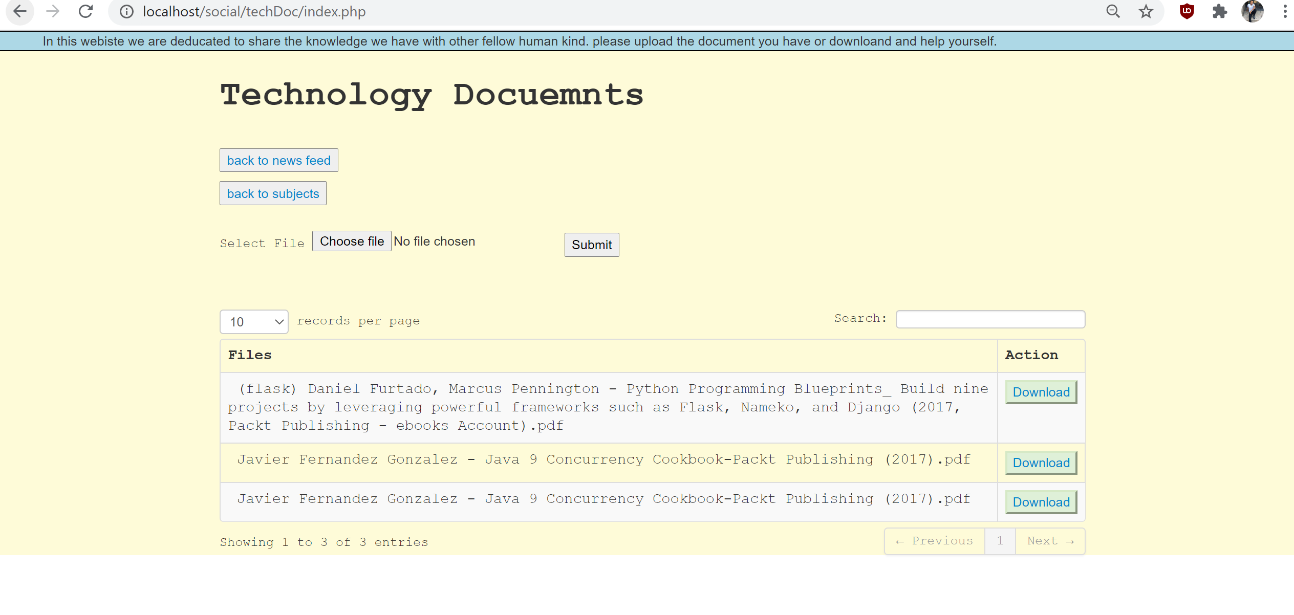

In this page if students find the document that they are look they can just click download so that they can download and benefit themselves.

## Social science subjects Page

This page can be found at the top as it shows below or on the right side of the page. The page included many subjects in the social science department as it shows in the picture below.

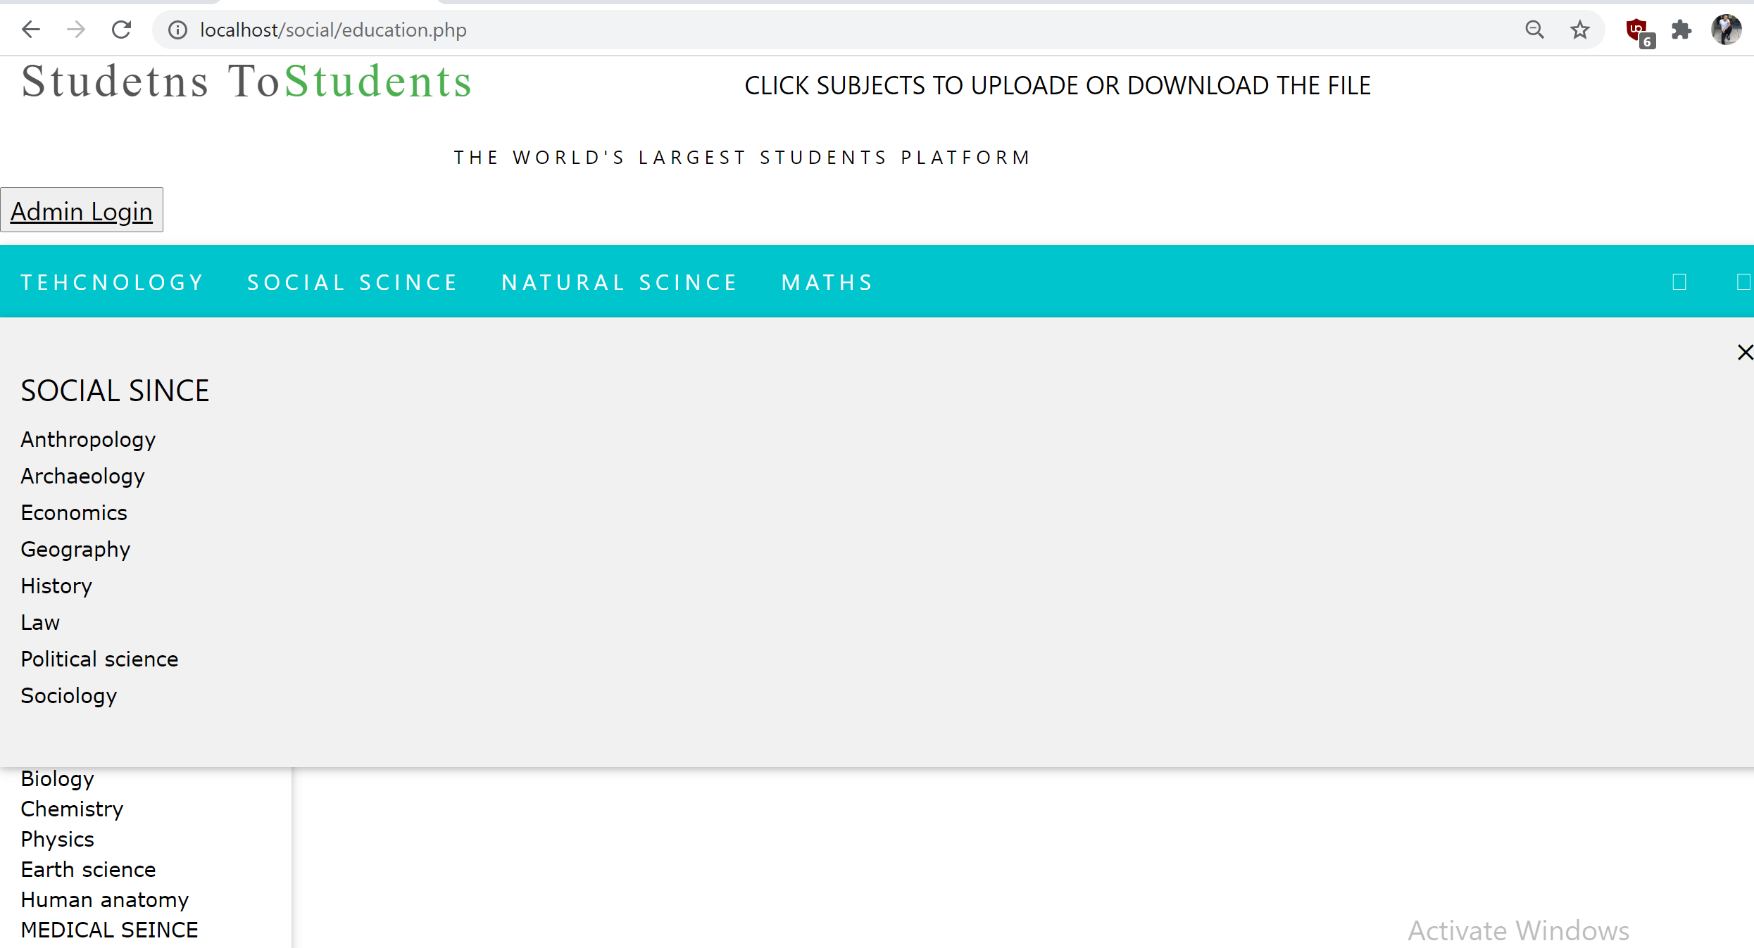

As we have seen there are some topics that I included in the social science page. However, the number of subjects might be increased for the future but for now the next step is to get the documents that students are searching to download.

### Social science documents page

In the social science page, we can download the document by clicking the download button.

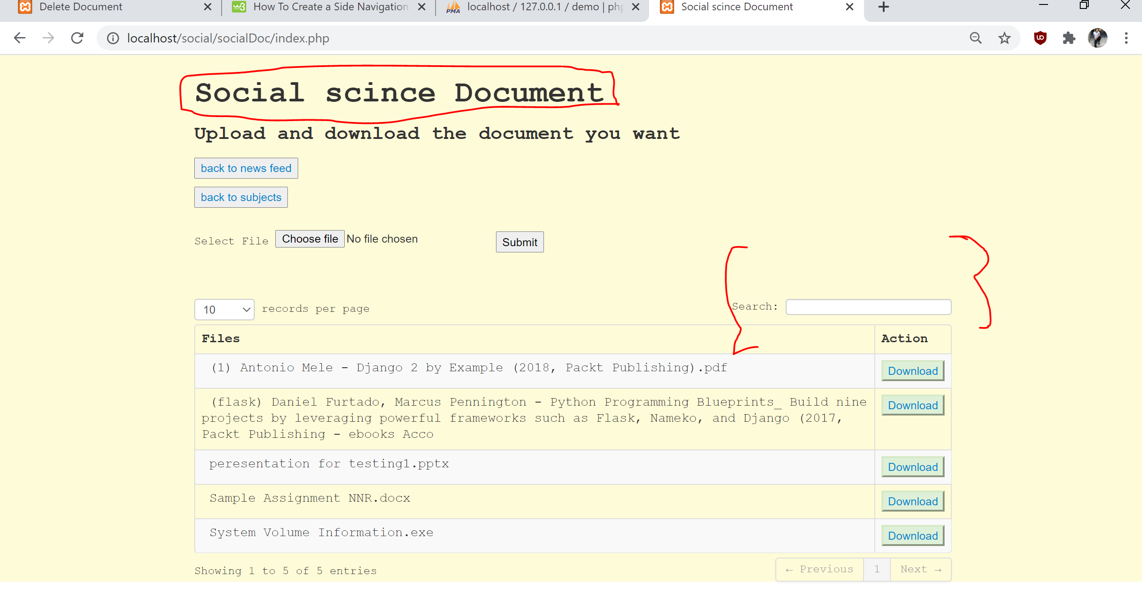

## Natural science subject’s pages

This page also has some of the natural science subjects. However in order to get the documents students have to click any of the subjects.

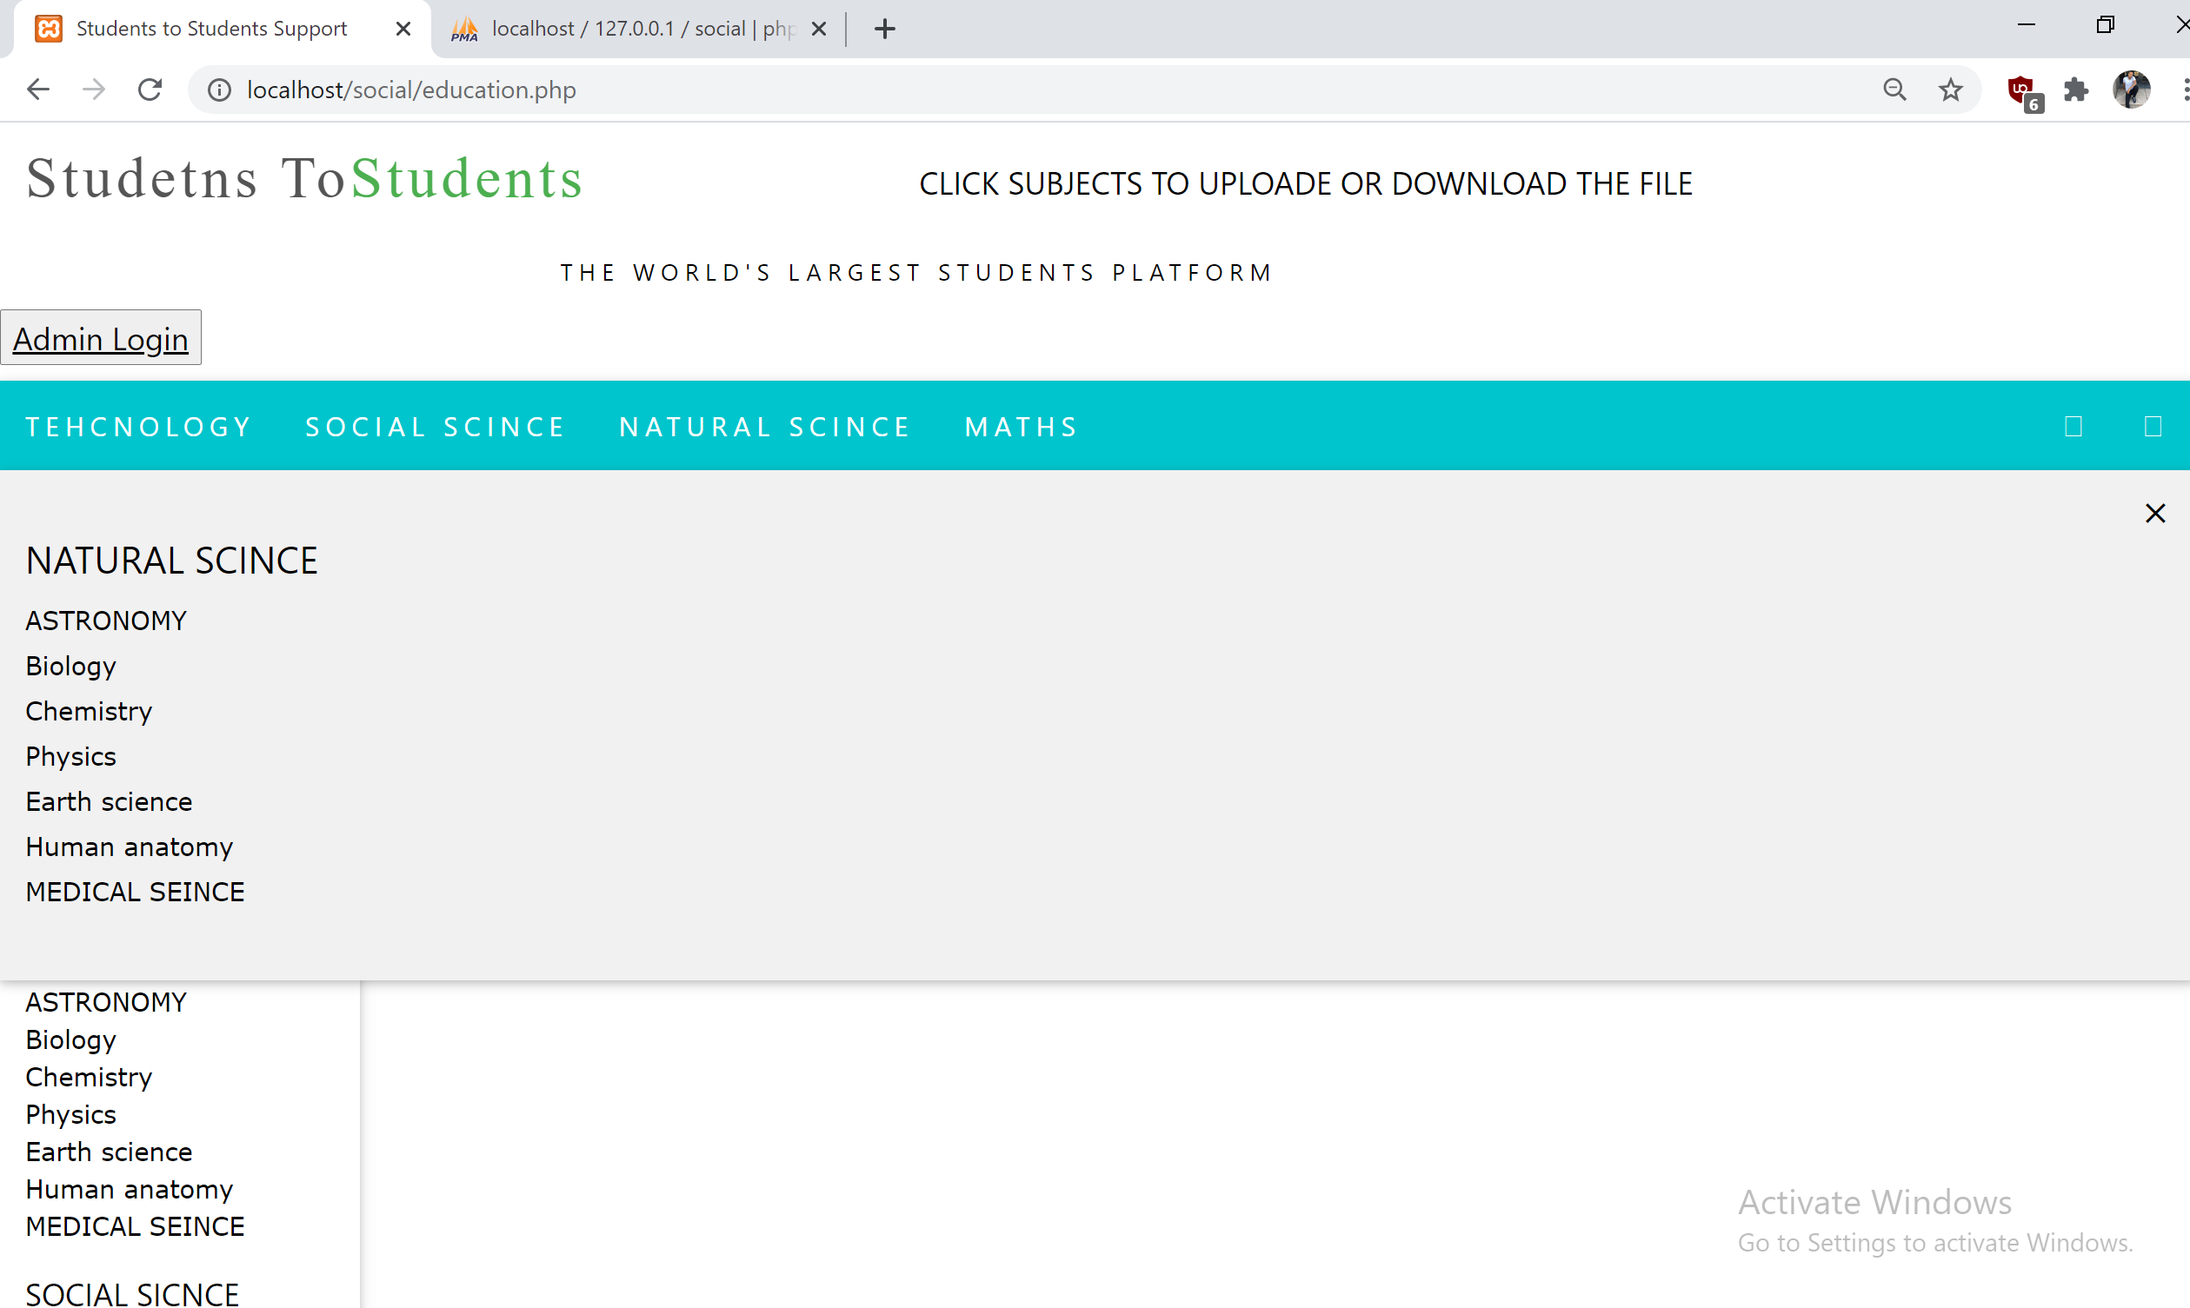

### Natural science document page

In this page students can upload or download any document. And also they can search the documents.

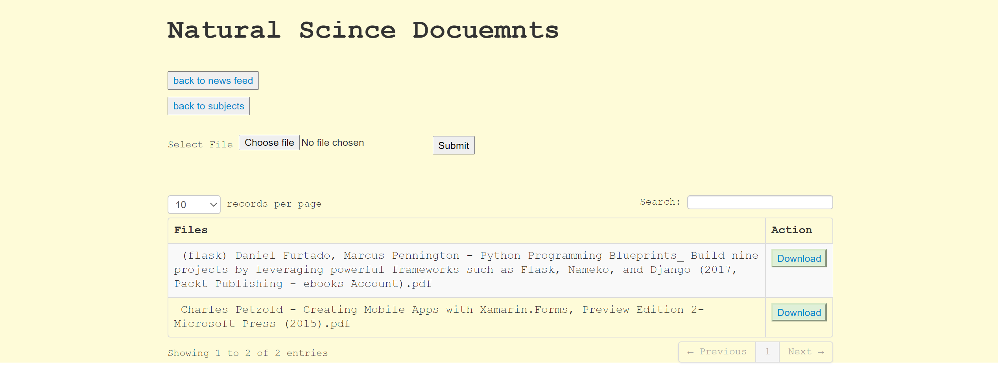

## Maths subjects Page

As the other page this page also has some maths topics included. To get the documents students can click any of the maths subjects.

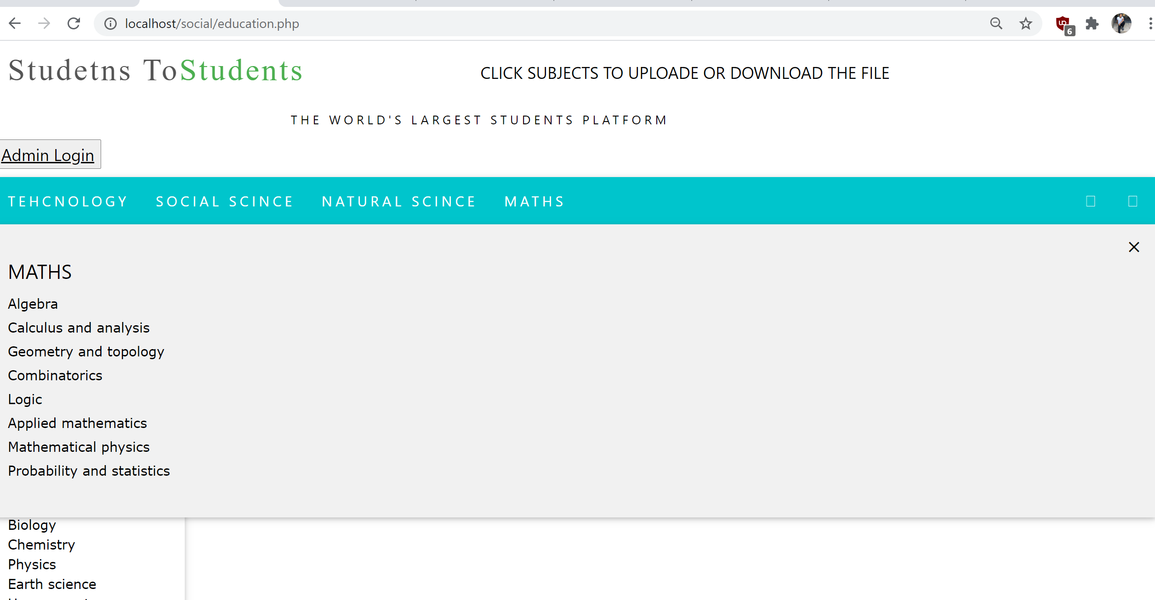

### Maths documents page

Like other document holder pages in her students can upload or download the document they want to upload or download. Moreover, students can also search the documents the want to download.

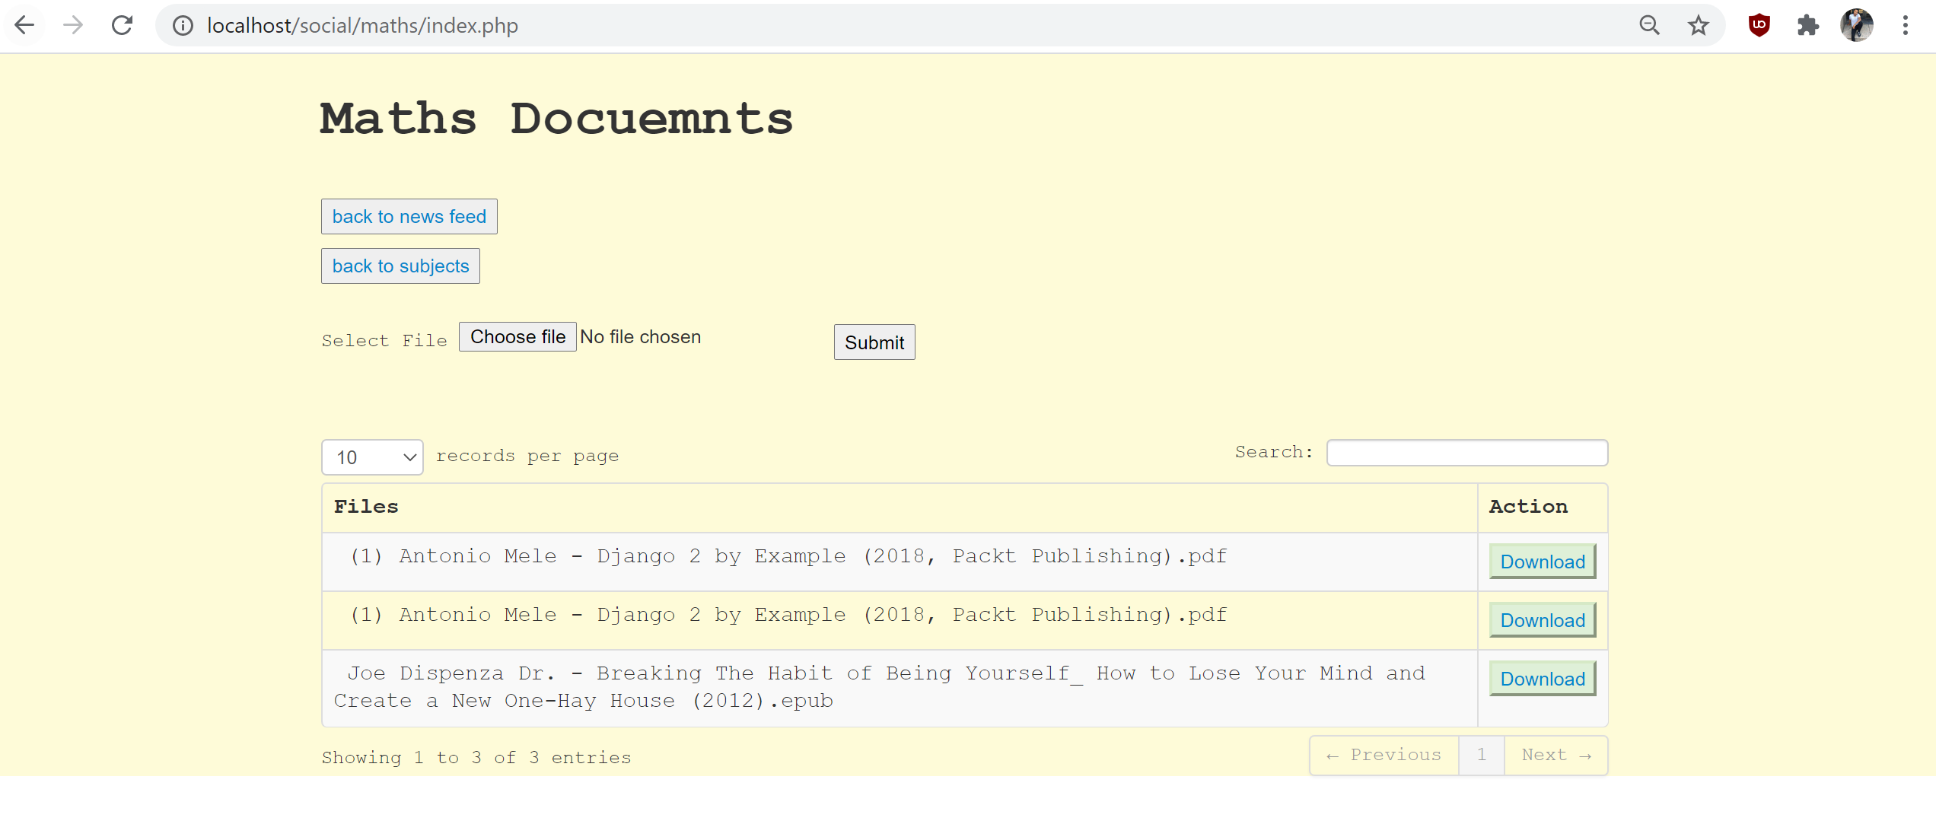

## Admin page

The admin page is the page that can be overlooking the website. This Page will be responsible to check how many documents are uploaded and how many members are registered. Moreover, if students are behaving bad this is where they can be blocked.

### Admins login page

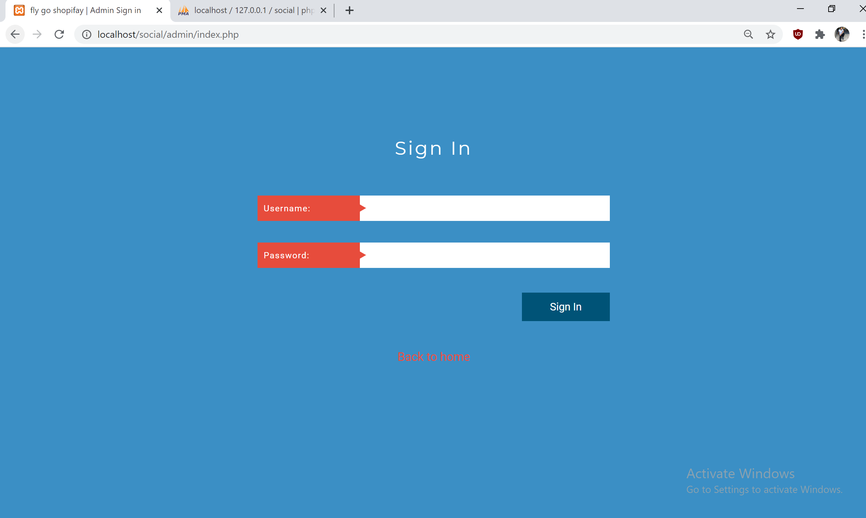

### Admin dashboard

The main importance of the admin page is to see how many documents are uploaded in the website and also how many students are registered in the website. Moreover, if there is student who misbehaved there will be no tolerance perhaps the student will be blocked by using admin page.

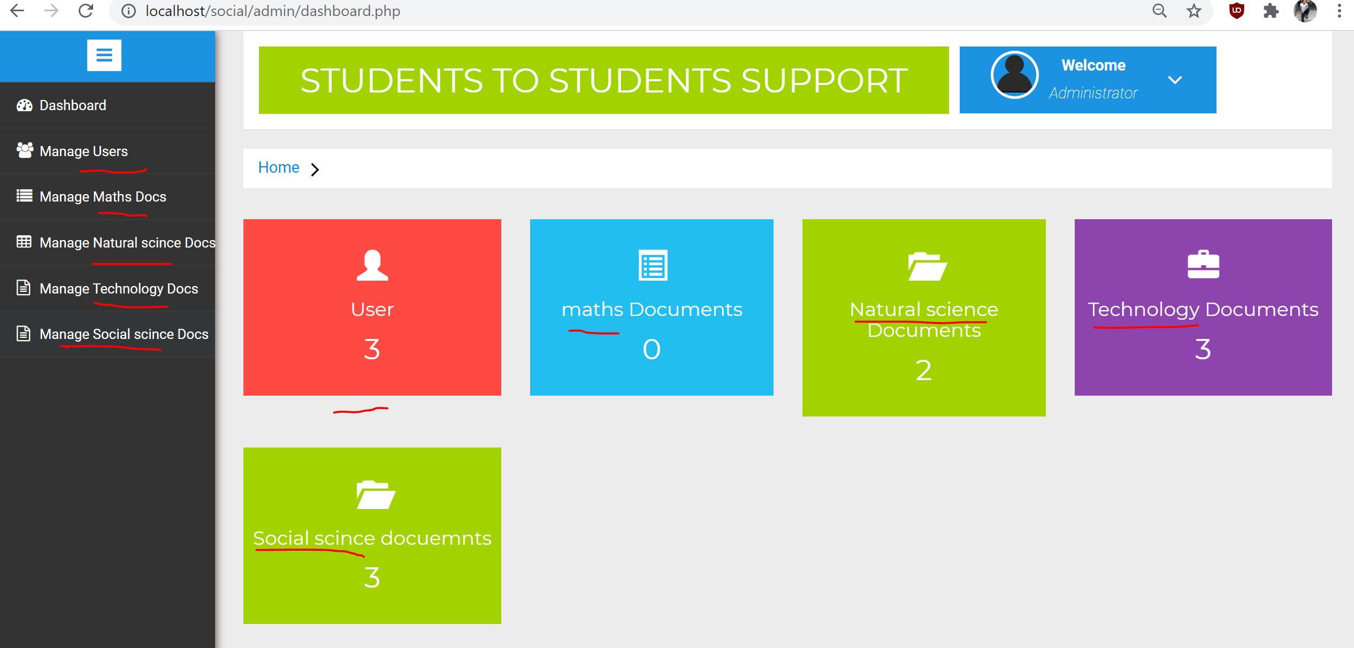

### Registered users list

As it shows on the following picture, all students who are registered in the website are listed her on the admin page

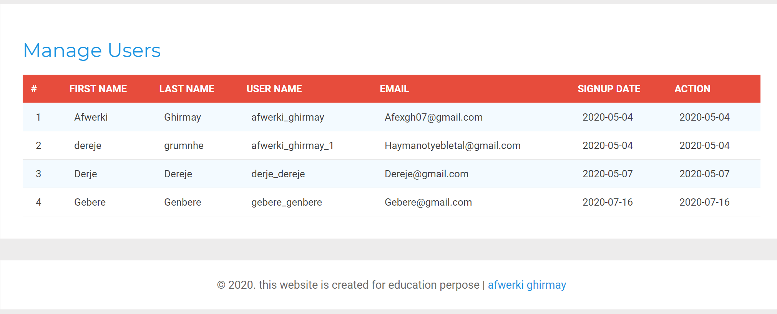

# Chapter 6: Testing

Testing is one of the main important task in computer science. Every written algorithm has to be tested and checked the performance of the system. Testing can also prevent any malicious behaviour that might corrupt the system.

## Different testing techniques

* Google Chrome
* Internet Explorer
* Mozilla Firefox
* Safari

Web browser testing was performed at the end of the project, after the implementation completion. That was done on top of the thorough testing of each class during the development process.

## Testing plan

In order to find out the correctness of the algorithms that I wrote in the students to students support website, I planned the test of each system functionality.

* The first test is unit testing. This test is achieved by creating automatic unit testing.
* Database for testing to retrieve the data and for correct data representation.
* Black box testing to check overall the system performance.

## Students to students website

In the following table I am going to show all the testing results as it happened in the process of testing.

|  |  |  |  |  |
| --- | --- | --- | --- | --- |
| Testing number | Input description | Predicted output | Passed | Comment |
| 1 | Testing the website in 3 different browser | Same layout and functionality in each browser | yes | I have seen what I expected |
| 2 | testing all connections in different browsers | Correct functionality with fast communication each page | yes | As expected there is no issues in the connection |
| 3 | Registration DB validation | Refuse the registration if the user email exist | yes | I used same email to create two different account and refused the second one. |
| 4 | Registration form for submission | User registered | yes | As expected the user registered |
| 5 | Log in redirection | After registration to redirect to log in form | yes | Once registration form is submitted users will be confirmed to go ahead and login in to the page. |
| 6 | Logout functionality | Logout users | yes |  |
| 7 | Sending Friend request | Sending friend request to other students of teachers. | yes | I sent request to the accounts that I created. |
| 8 | Searching for other users | Using the searching box students have to find user and send the request | yes | The searching box is filtering automatically while I am typing. |
| 9 | Liking/dislike and commenting | Writing comment on the picture or text and like or dislike it | yes | I posted the picture and commented on another account. And I also clicked like and dislike. It works fine. |
| 10 | Sending message | Sending to teachers or students for help | yes | I sent to different account that I registered in the website without any issue |
| 11 | Message alert from receivers side | any notification has to come at the tope showing the red sign | yes | Whenever I sent message or friend request it shows the alert at the top. |
| 12 | Posting pictures and writing texts | On the news page students to post any issues | yes | I posted different pictures and texts in the news page and deleted which works fine |
| 13 | Clickable Subjects list | Students to click the subject they are studying | yes | All subjects are clickable as I checked all of them |
| 14 | Getting all documents available | All documents to be selected from database and be available in the documents page | yes | All documents are available to download. |
| 15 | Downloading documents from the website | Students to download the document they want to download. | yes | all download buttons are working fine. |
| 16 | Uploading documents in to database | Students to upload any document in the website. | yes | I uploaded the document in to the website so many times. |
| 17 | Searching documents | Students to search the document by typing the name of the document | yes | I searched several times to check and as I type the name of the document it filters out automatically. |
| 18 | Admin login functionality | Admin to login in using user name and password | yes | I used the admin user name and password to login in the admin dashboard without any issue. |
| 19 | Admin users list view | from users table to select all the users list and view all the registered members | yes | It shows all the registered members as expected. |
| 20 | Admin view all the documents | Admin to see all the documents that are uploaded in the website | yes | All documents that are uploaded in to the website are available see the form the admin page. |
| 21 | Admin logout functionality | Admin to logout from the website | yes | As I logged in and out several times the logout in working as expected |

### Registration test validation

As the email is already being used the system refused the registeration on the same email.

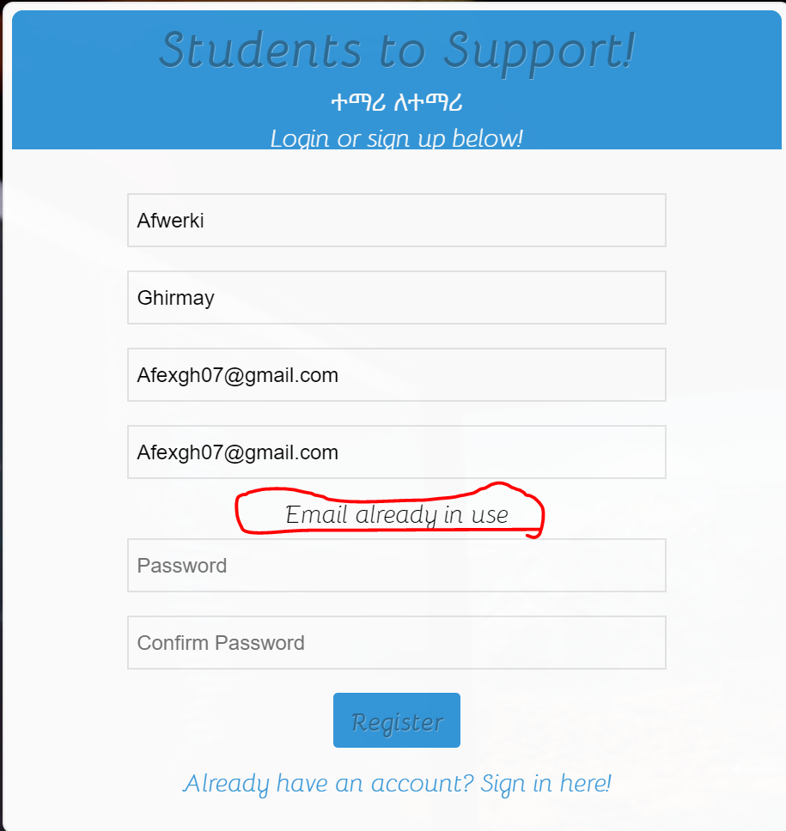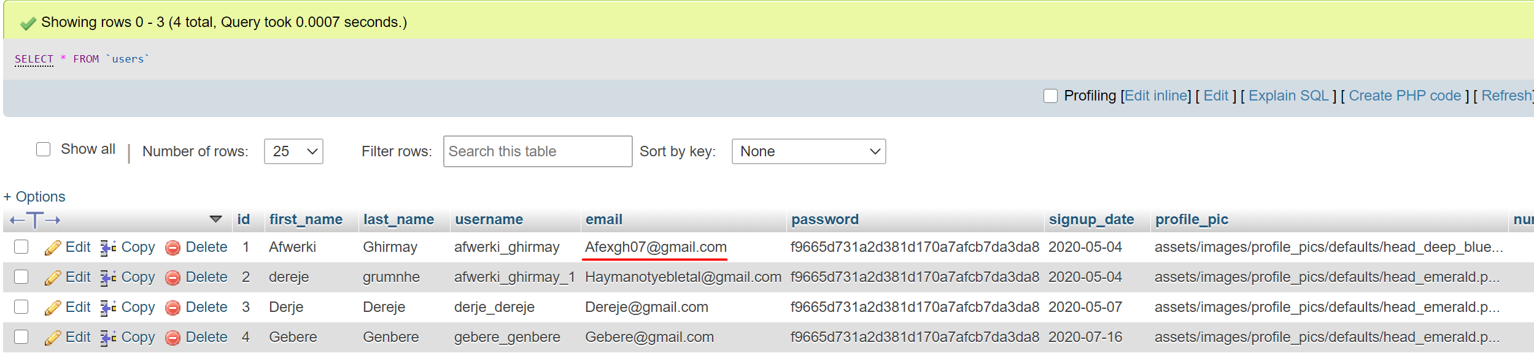

### Redirection to login page test validation

As it shows on the picture below when I change the email the system accepts all the registration from and tell me to login in to the system.

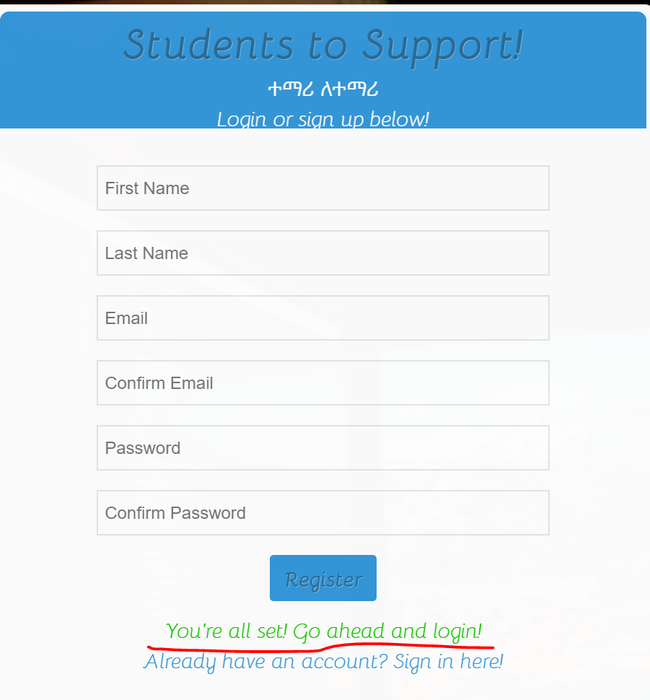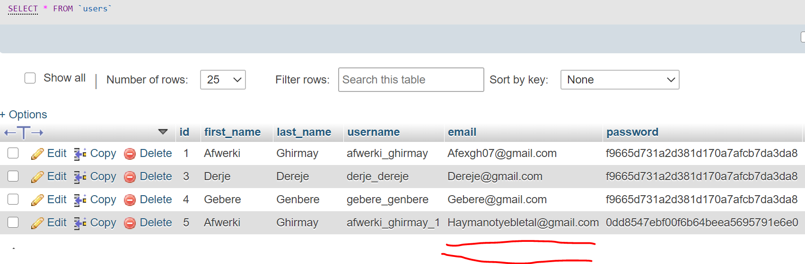

### Logout functionality test validation

As it shows on the right side there is a little arrow to log out which has no issue.

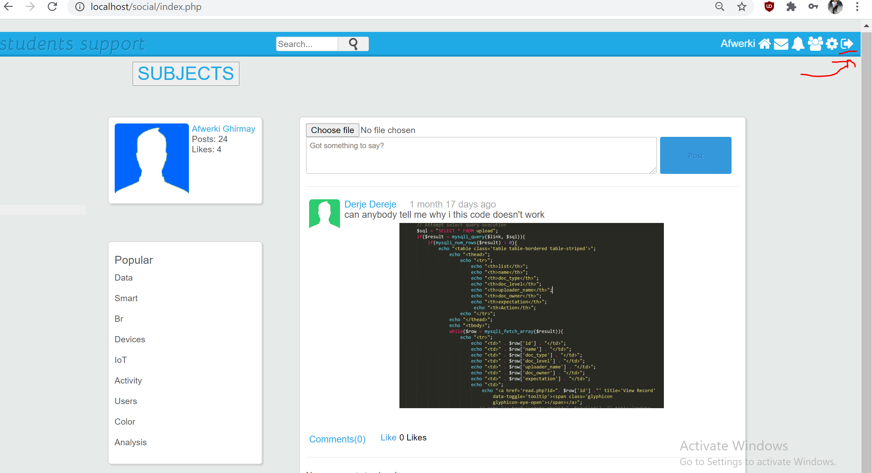

### Sending friend request test validation

As it shows below the friend request is sent to the person and waiting for confirmation. The database is holding the friend request until the person is accepting the friend request as shows in the picture below.

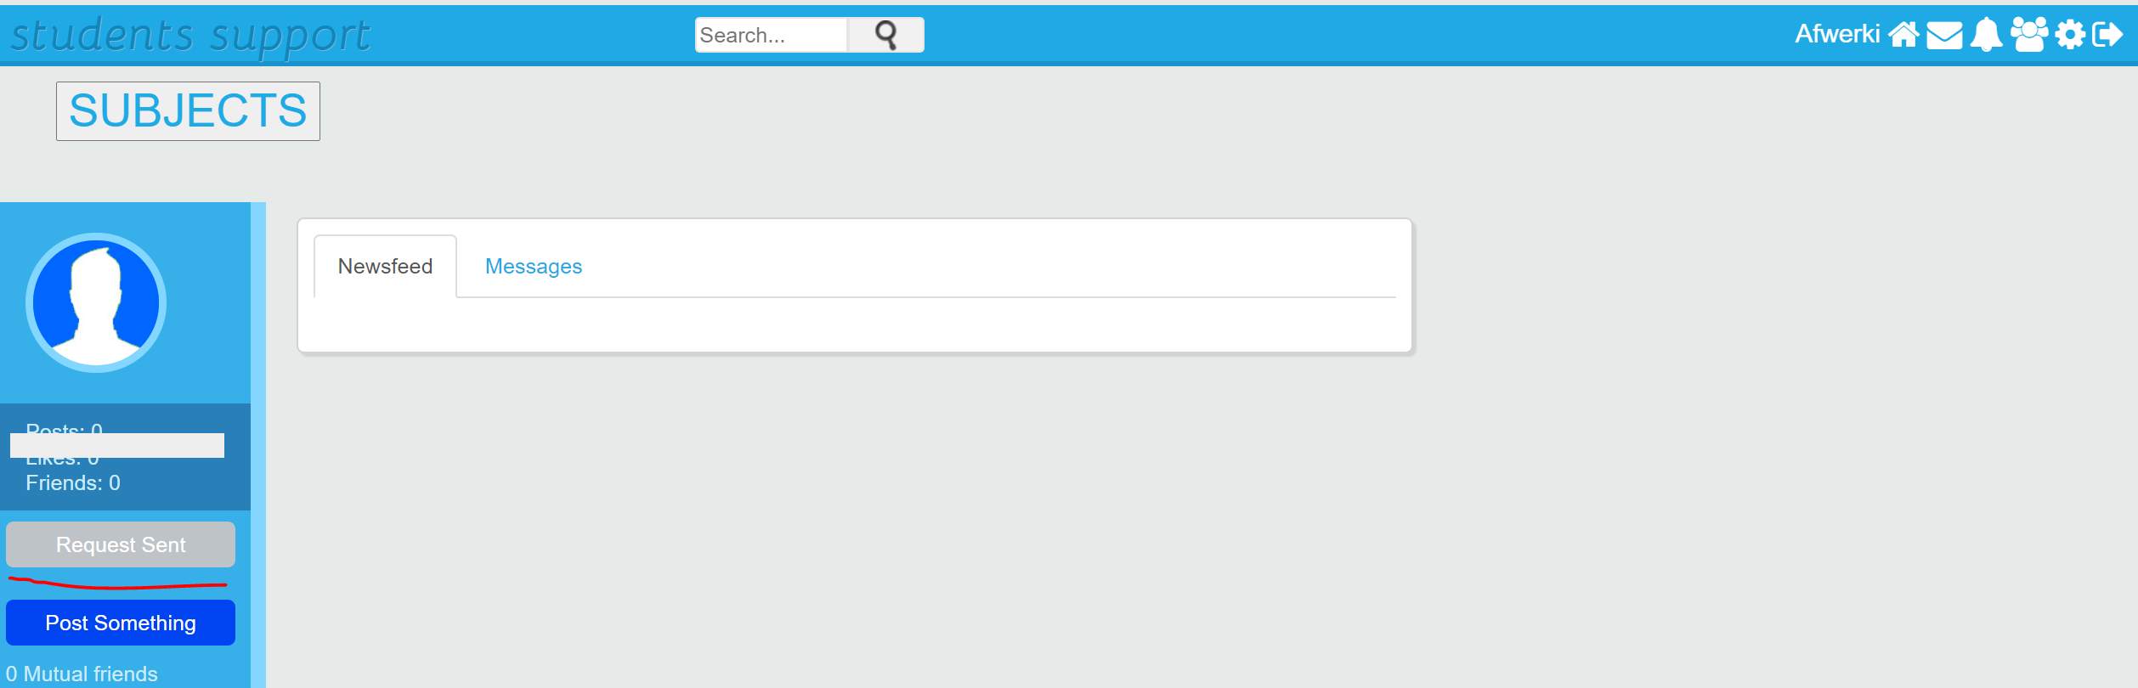

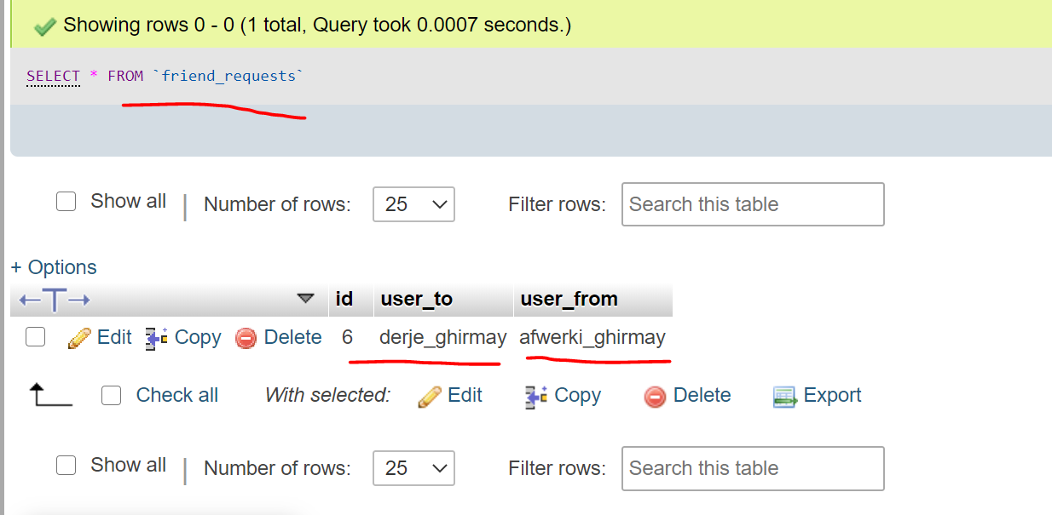

### Searching for other users validation test

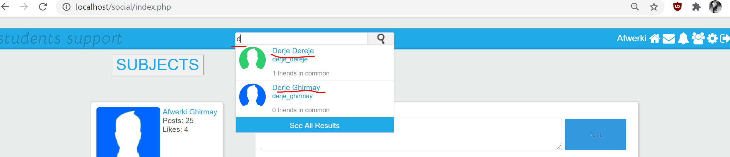

### Liking and commenting test validation

Once I like the picture on text the unlike button will appear as it shows on the picture below. Moreover, in the database it shows the like and who like the picture.

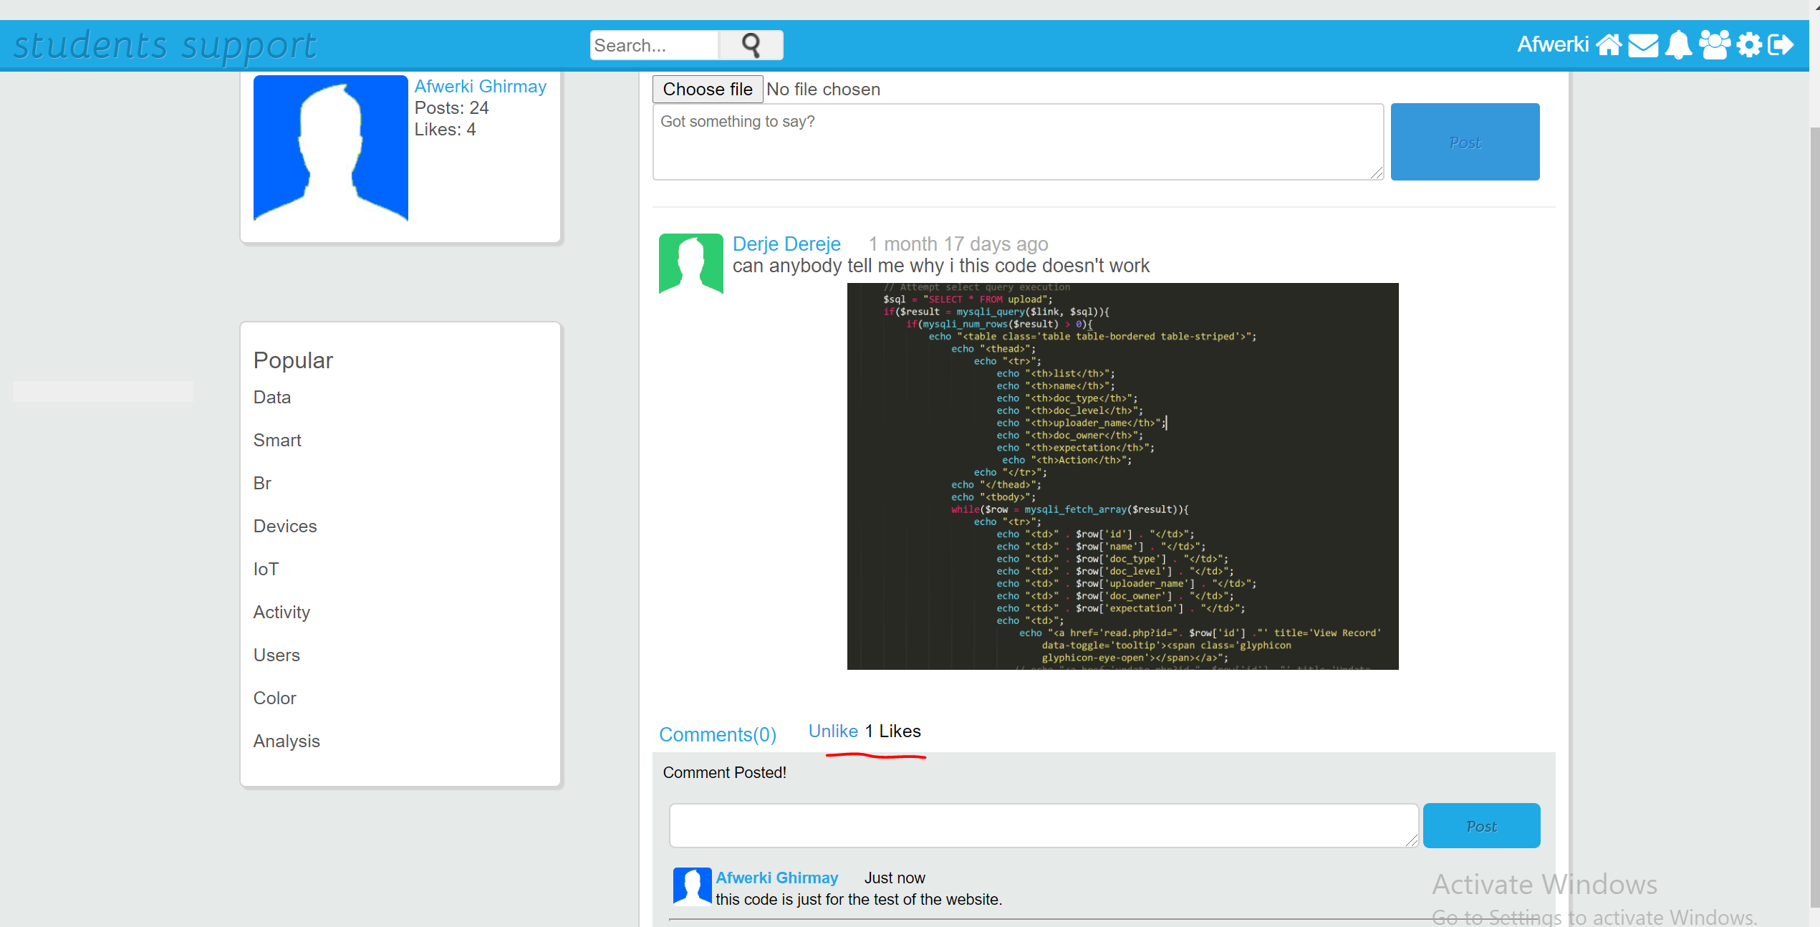

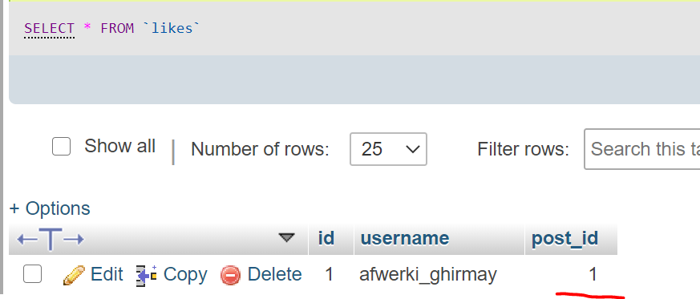

### Sending messages test validation

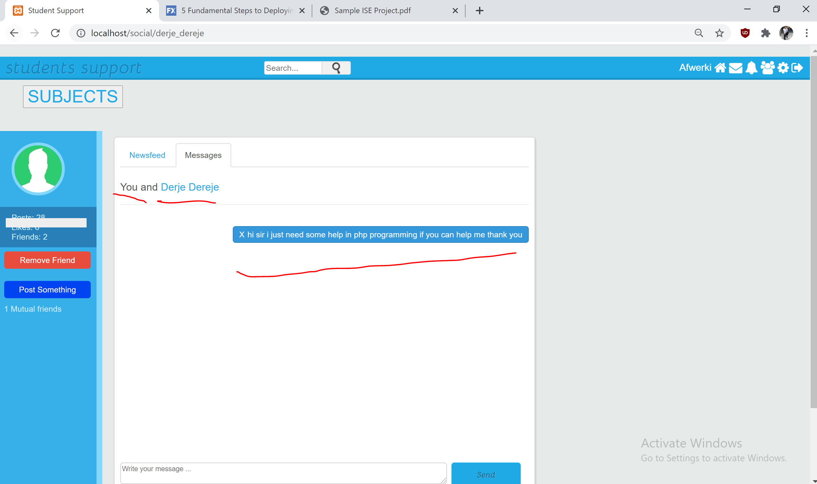

From database it looks as follows

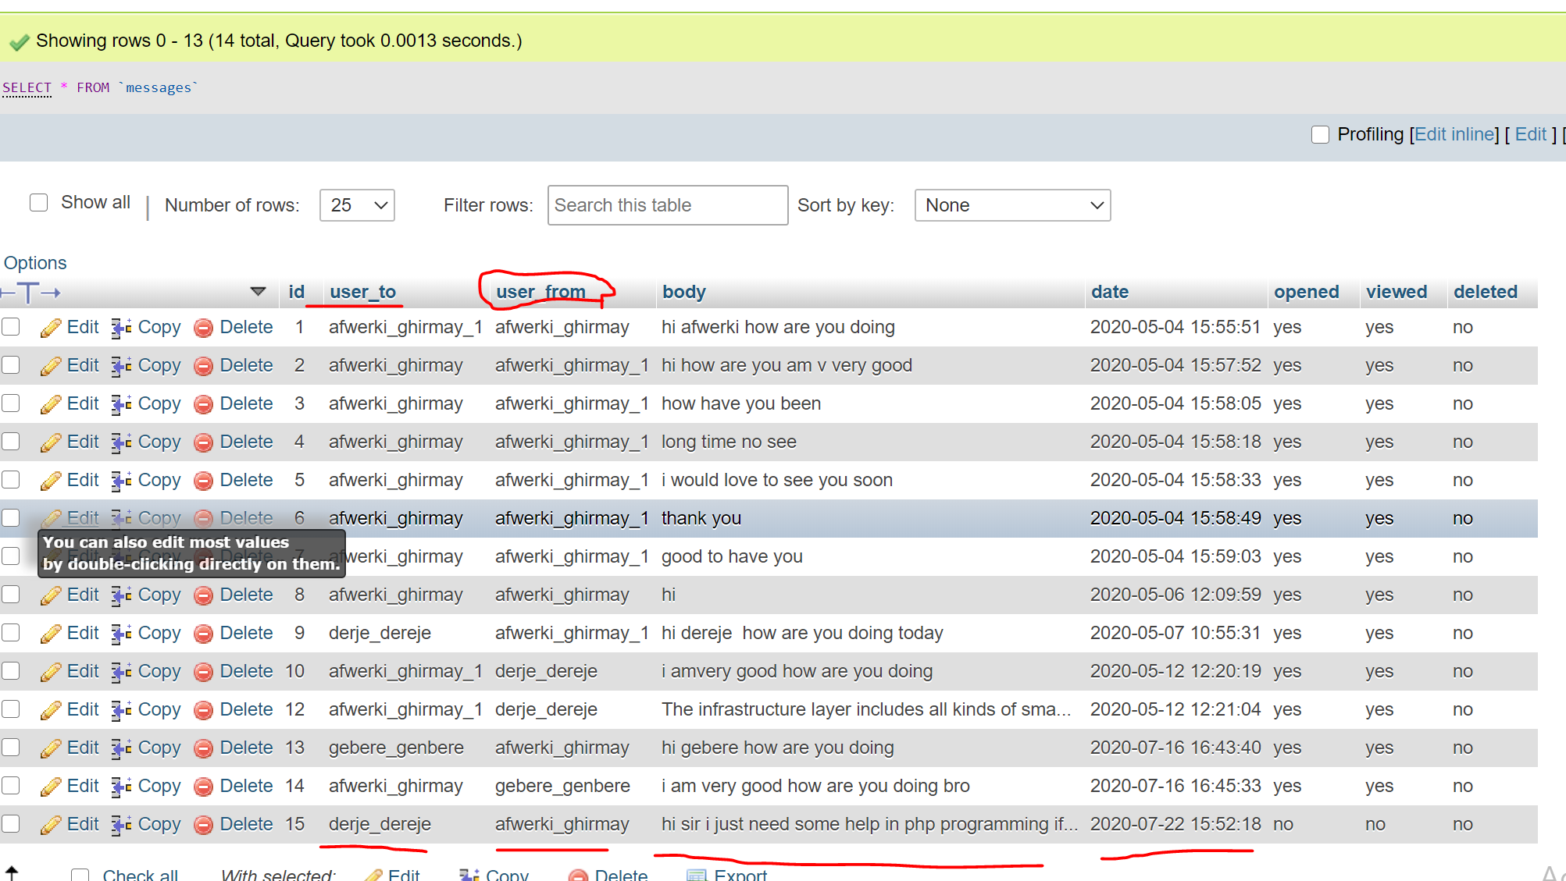

### Message alert from receiver’s side test validation

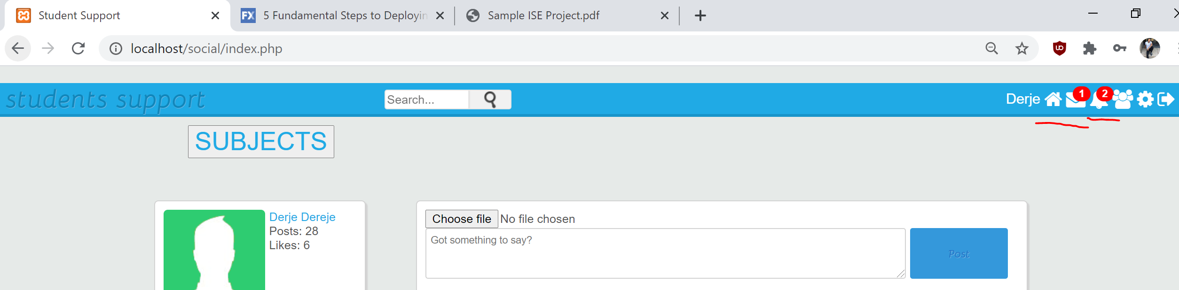

### Posting pictures and writing texts test validation

As it shows in the picture below I posted the picture and requested some help which works fine. Moreover, to delete the post there is a red arrow at the tope is it show on the picture below

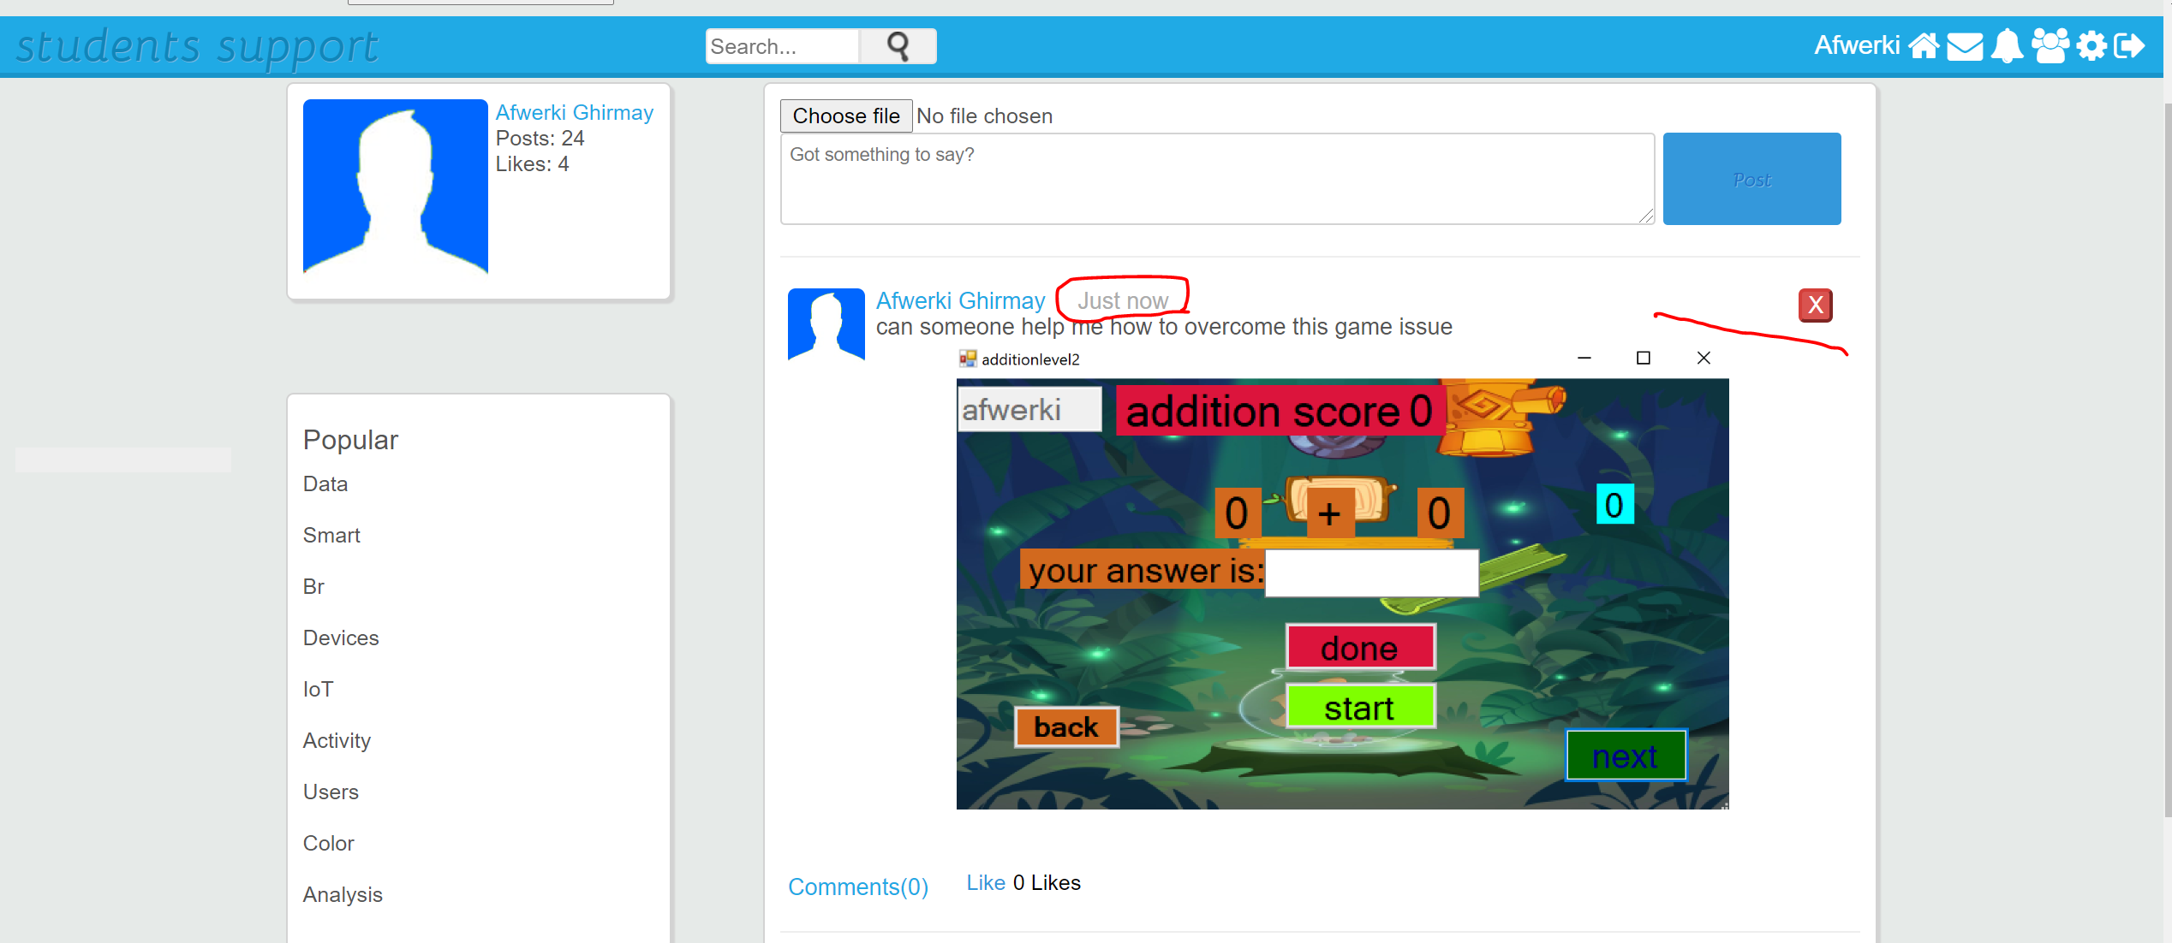

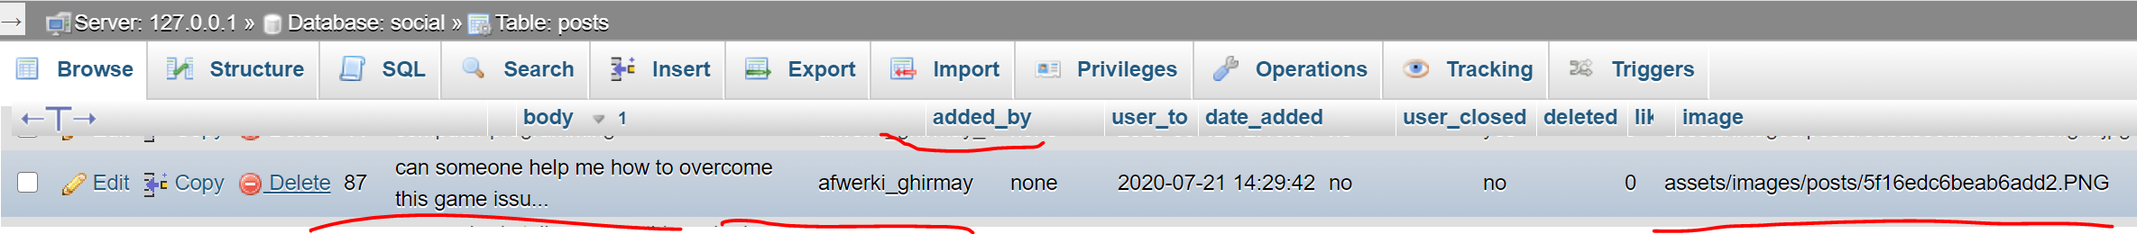

### Clickable Subjects list test validation

In order to see all the subjects that are available clicking the subjects button can open the subjects page.

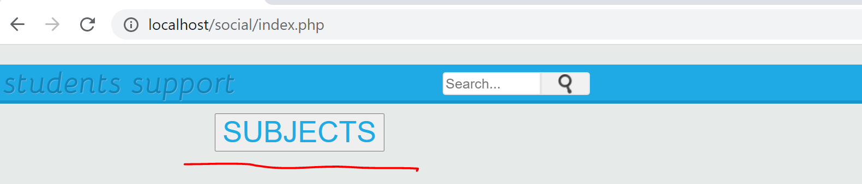

In the subject’s page all subjects are clickable but when I take a picture is impossible to show the click of the subjects.

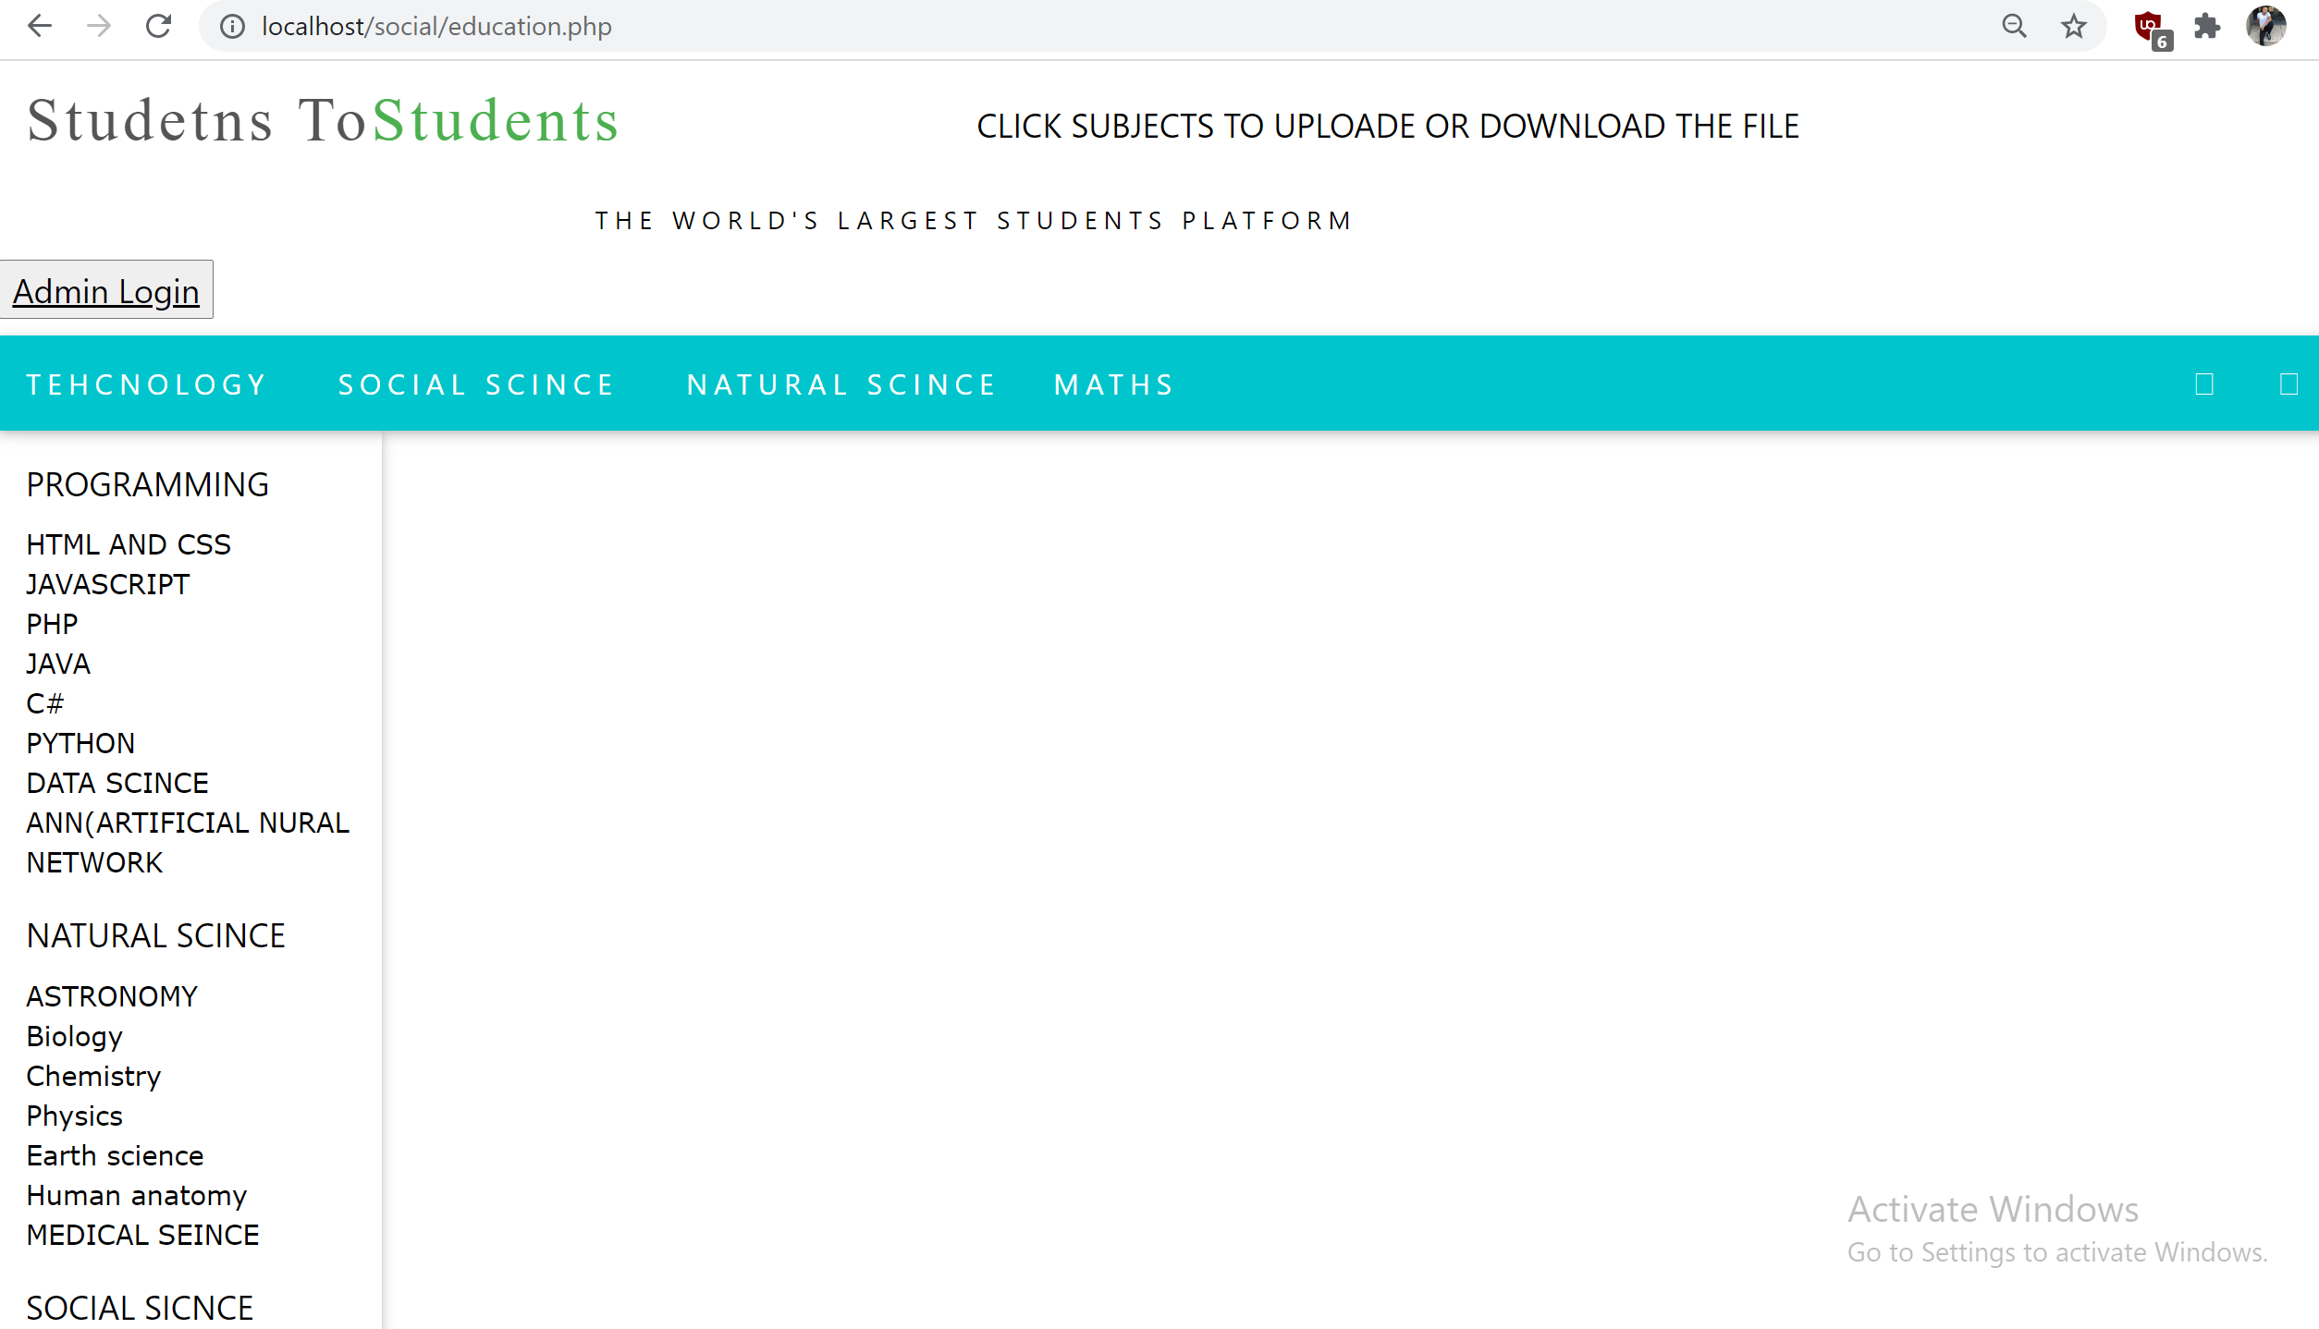

### Getting all documents available test validation

As it shows all documents are available for users in the website.

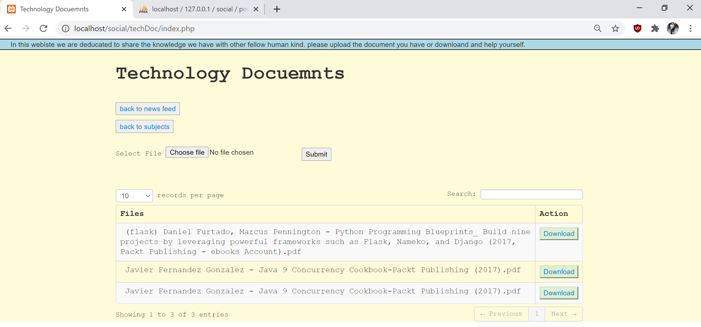

### Downloading documents from the website test validation

I downloaded the file a lot of time which have no problem of downloading the file. As it shows in the following picture.

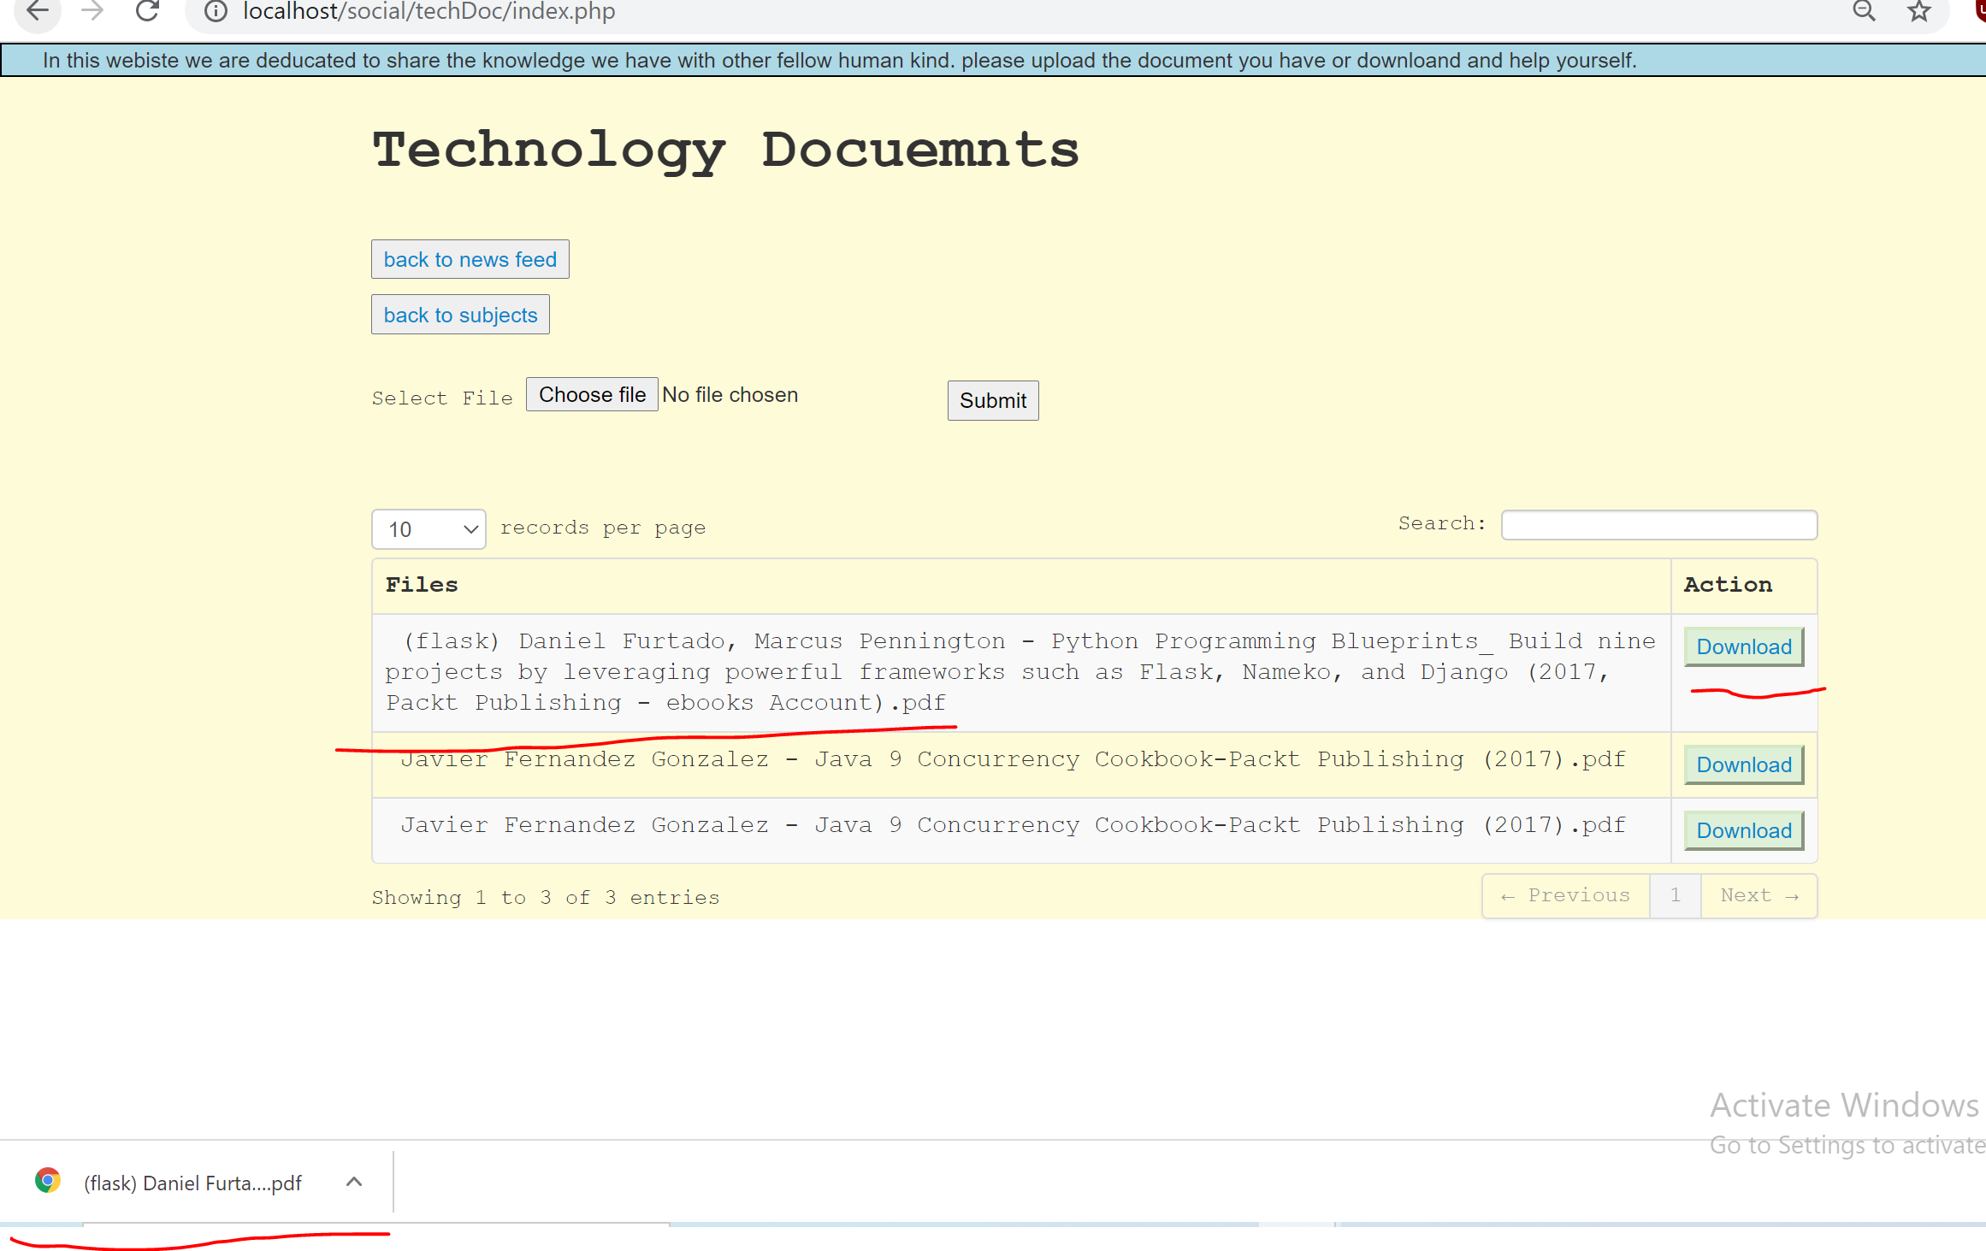

### Uploading documents in to database test validation

I just added one of my previous assigned which have no problem of uploading the file.

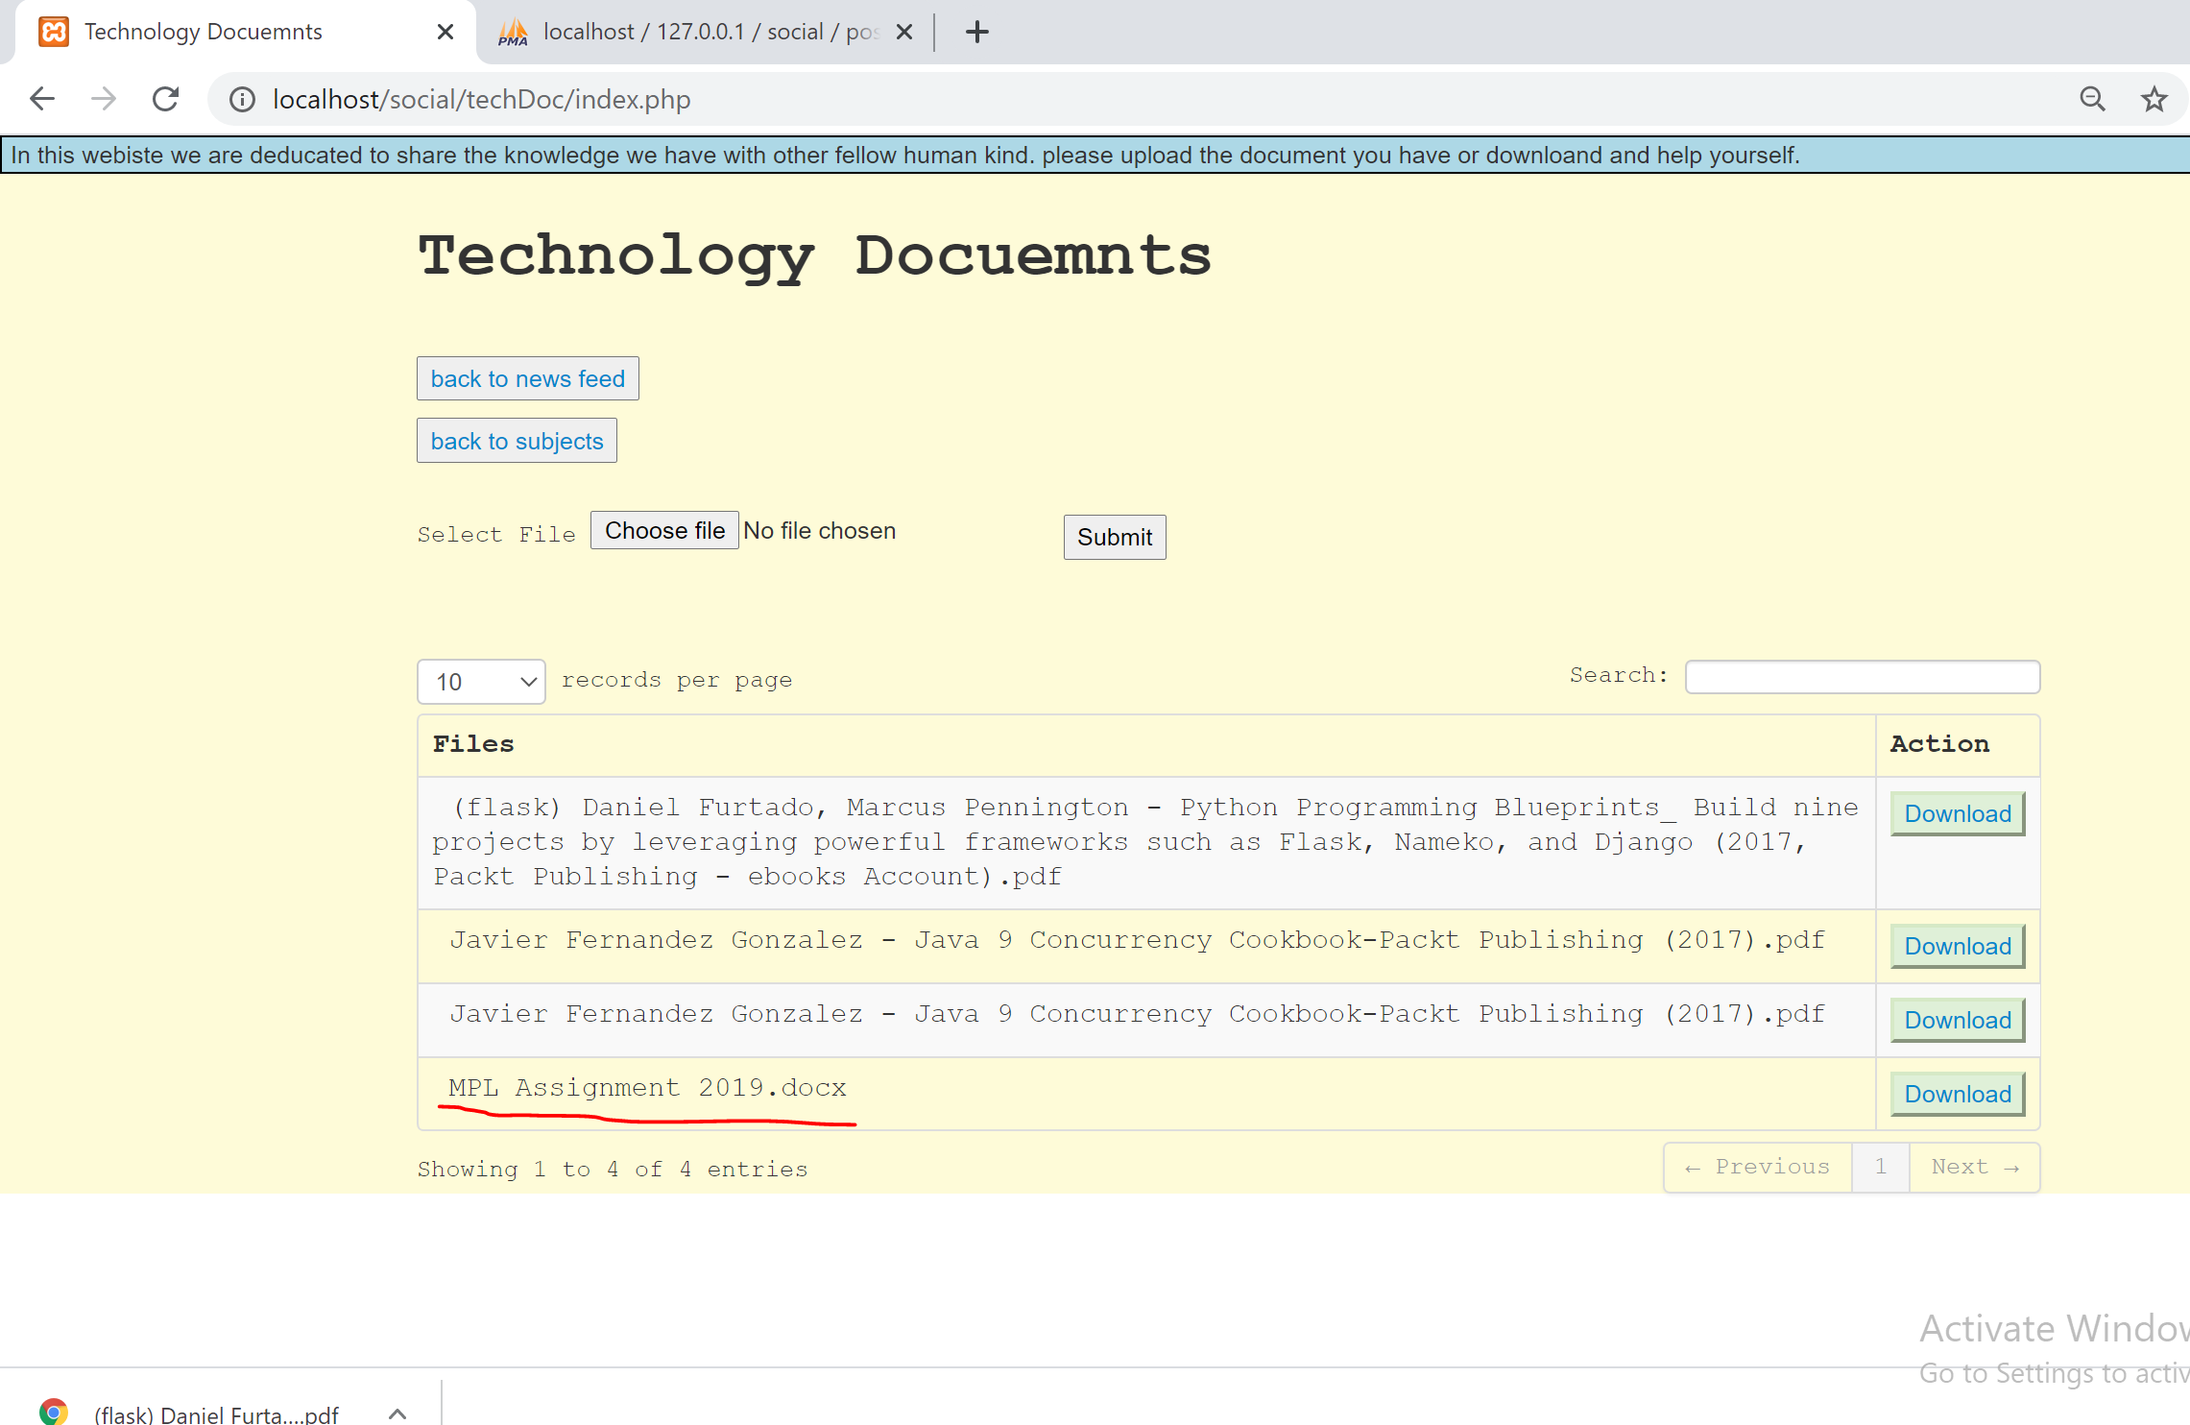

### Searching documents test validation

As I am typing the name of the document it filters automatically.

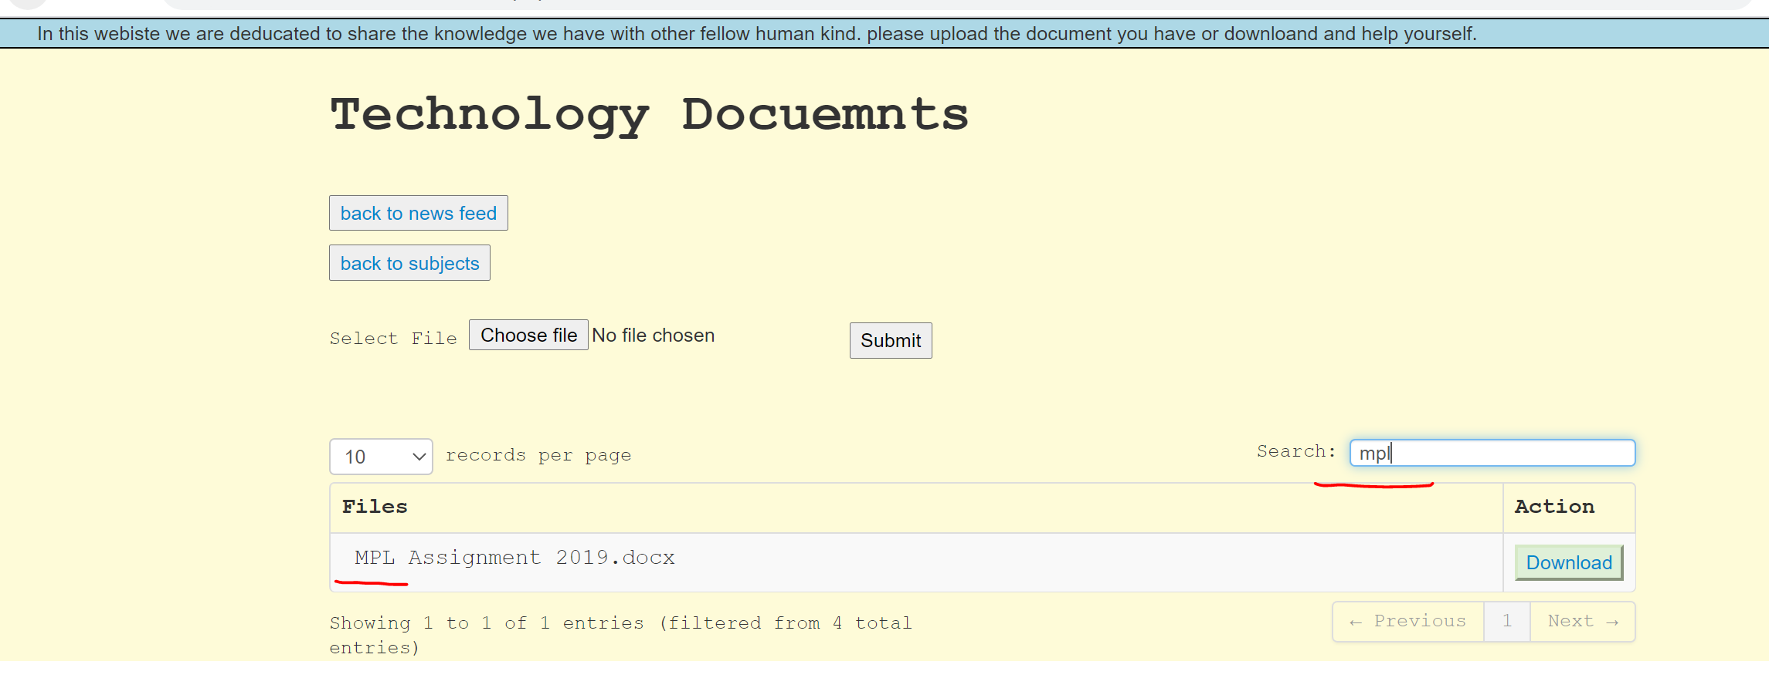

### Admin login functionality test validation

In the subject’s page at the top there is an admin page that can be clicked the to bring the admin login page that looks as follows. From there it can be logged in using the admin user name and password as it shows in the following picture.

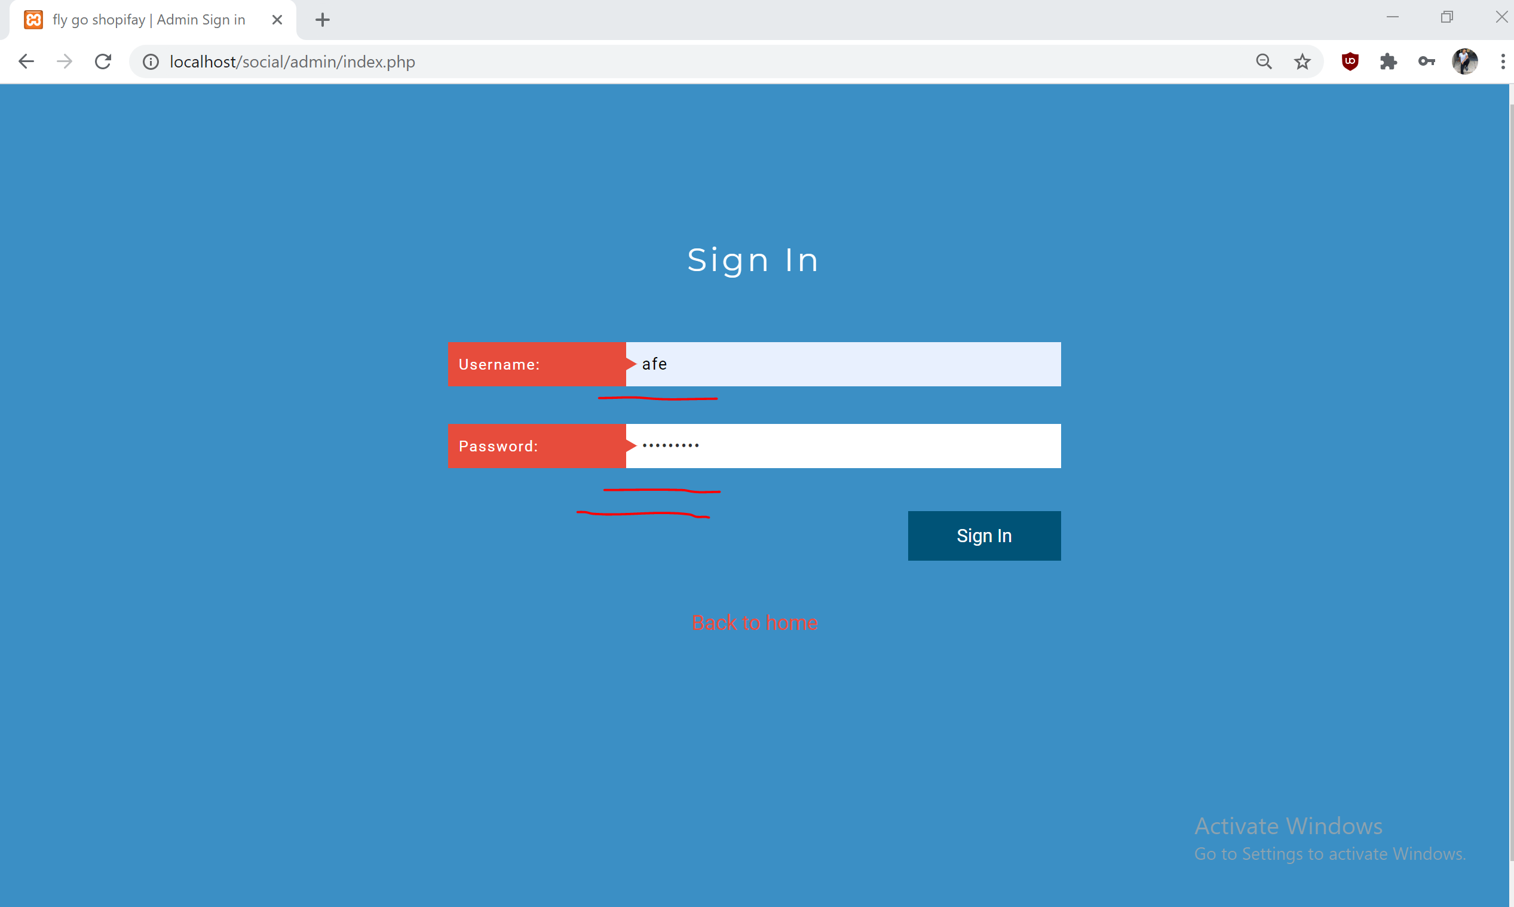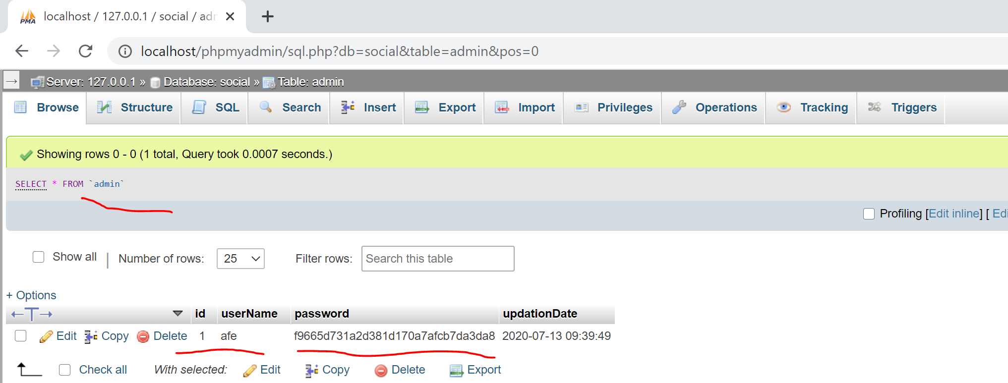

### Admin users list view test validation

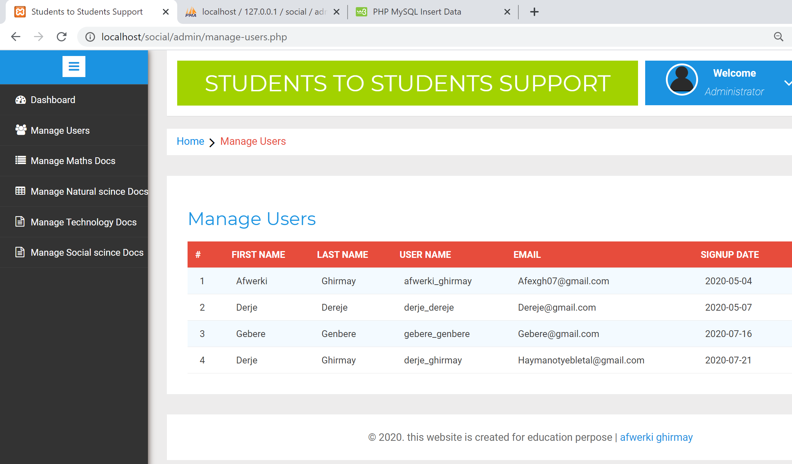

### Admin view all the documents test validation

In order to see the name of the documents we can just click the side menu so that we can see the name of the documents that are upload.

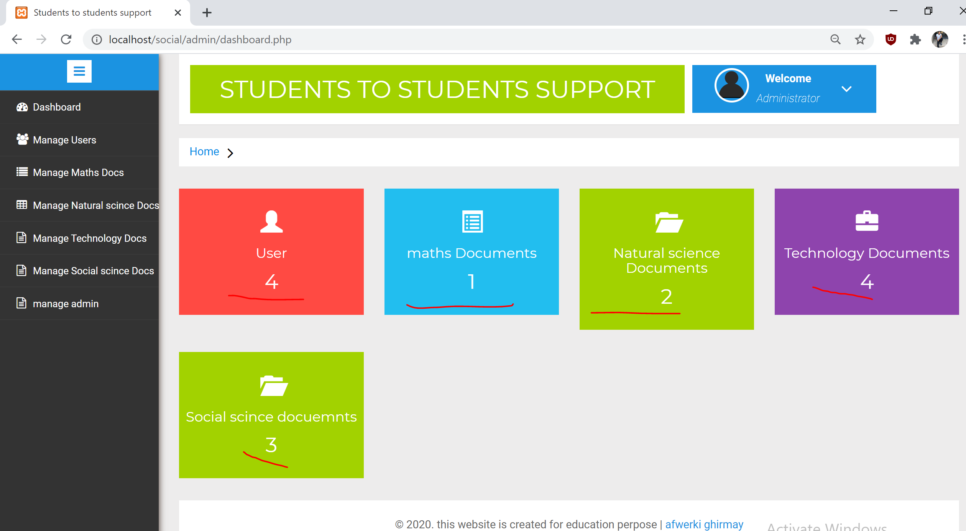

Manage users will show the following users list that are registered in the system

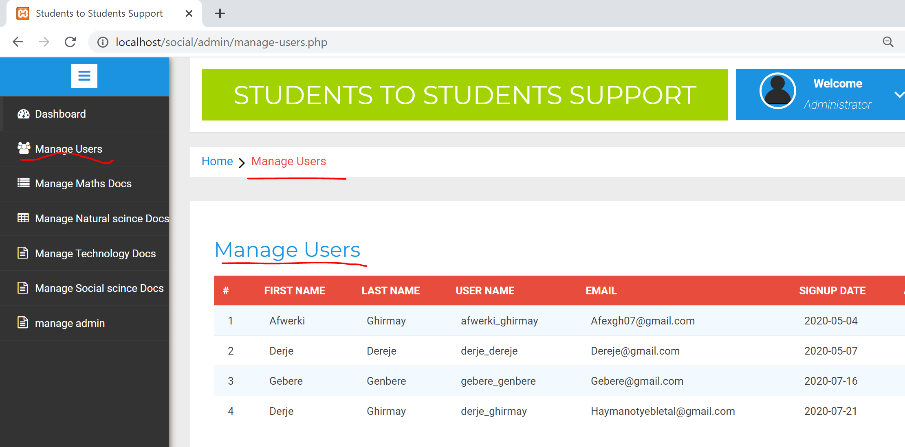

### Admin logout functionality test validation

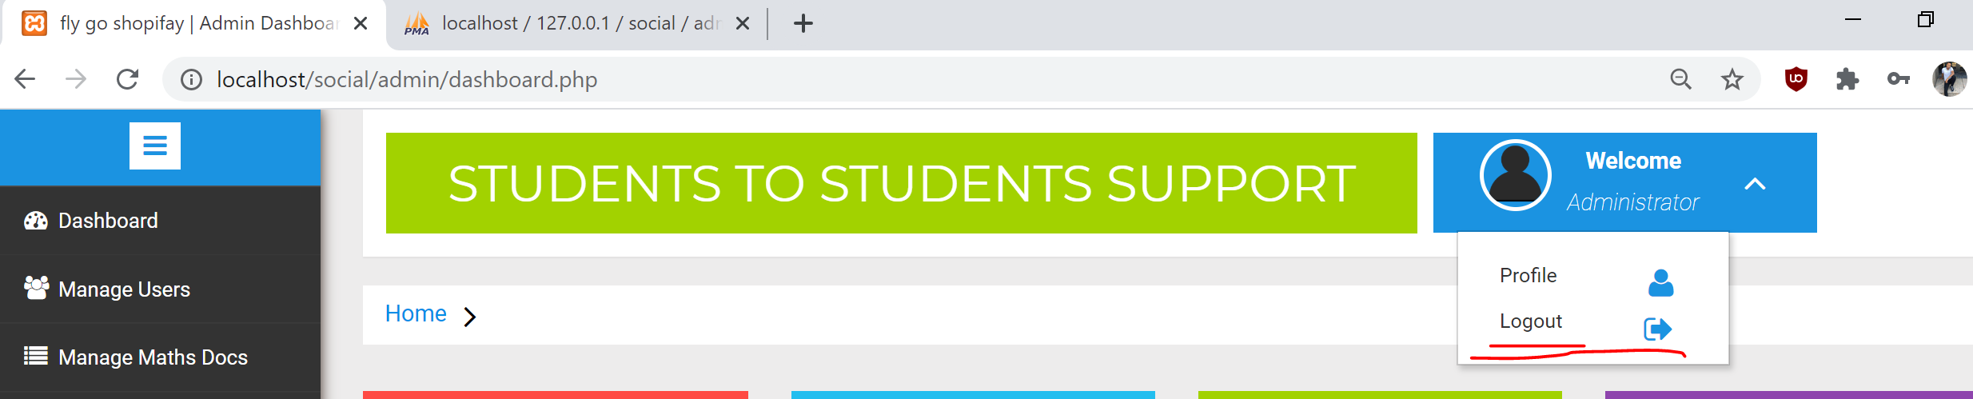

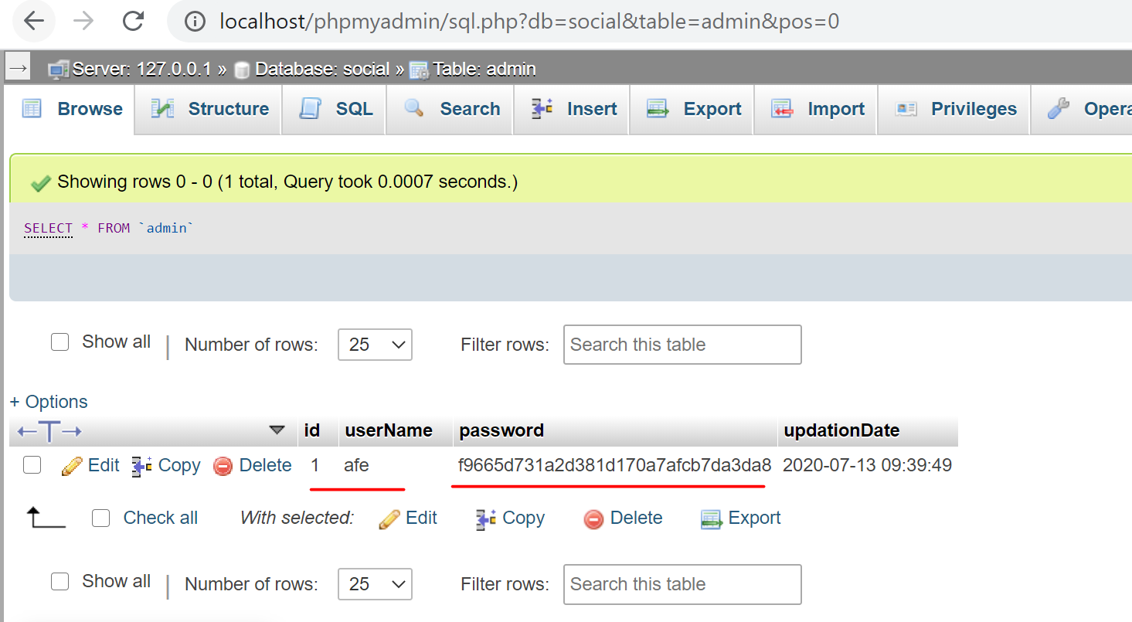

## Chapter summery

**Students to students support** website testing is successfully passed from black box and white box testing. Moreover, the website also passed from cross-browser testing. The next stage is to host the website online.

# Chapter7: Deployment and maintenance

**Students to students website** requirements are meet, reviewed, analazed and passed through functionality test. Moreover, the project is documented as it shows in the previous chapter. After all this progress the next step is to deploy the website online and follow the maintenance plan.

## Deployment

To deploy the website first we need DNS (domain name sever). In order to purchase the domain, I used the bluhost as they have very good rating and cheap price. Once I purchase the next step is to go ahead and fill the form and create the database in bluhost MySQL database

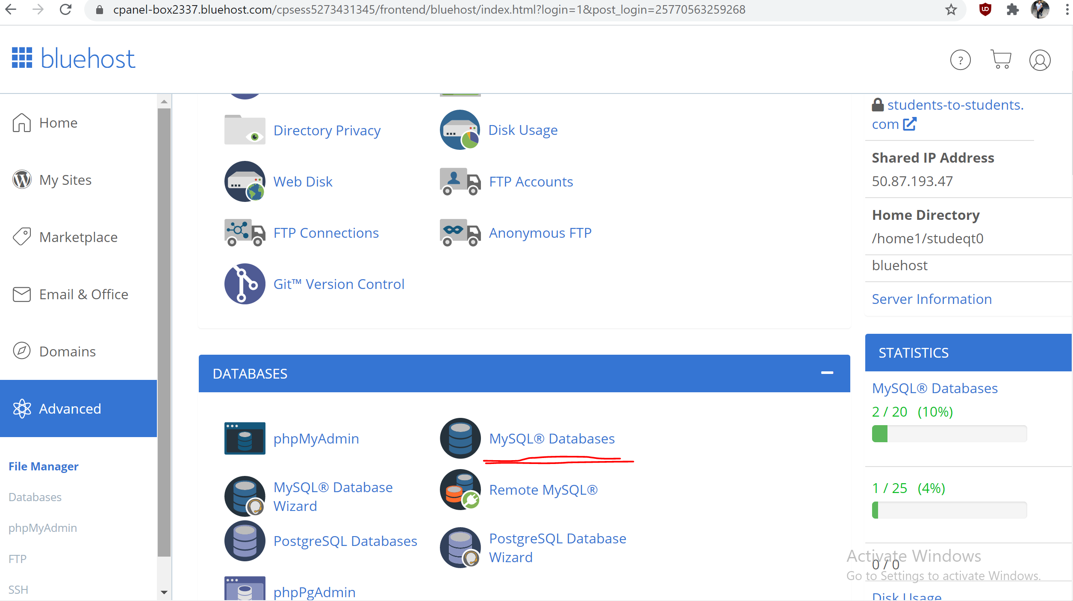

Once I create the database in blue host the next step the to migrating all tables and columns with its own stored data.

## Table migration from local server to bluehost cpanel

1. first from phpmyadmin there is Export button. Once we click that we can be able to download all the tables and columns with its fills.
2. Second from bluehost cpanel there in import button. By click the button we can migrate all the tables and columns with its fills.

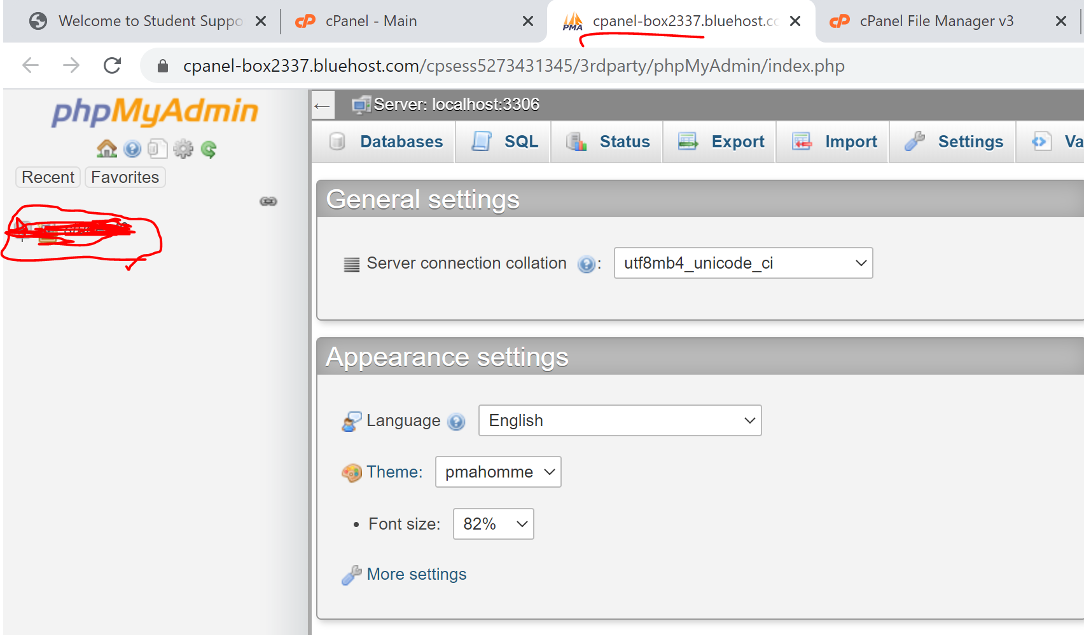

1. After all the database is set, the next step to go to the file manager and upload all the files in to the bluehost. To do that we click the public_html and click the upload.

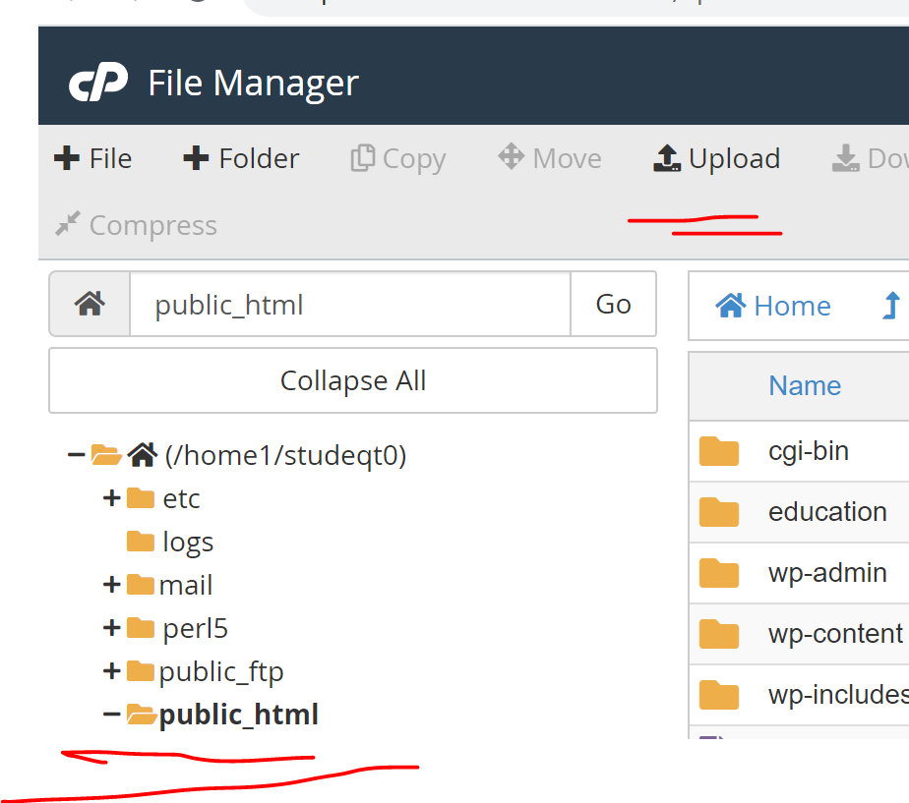

1. The final stage is to modify all the server name, user name, user password and database name. after modifying all we can click save the change and the website will be live (Bluehost, 2003).

# Chapter 8: Evaluation and conclusion

After all the hard work now we come to the conclusion. This is the last chapter of the project which will show the end result the project (afwerki, 2020).

## Cross-checking the objectives of the project

The objectives of this project are met. I have done a lot of researches based on the educational and social networking websites and applications that may support the education directly or in directly. I also discovered certain risks. For example, other user may use it as a social media than the education platform. Which I am going to work on eliminating this risks.

Moreover, I also created an admin page where I can get the students registration email as one of the goal was to own the data for the future software development. In the process of developing the project I have learn more than I expected.

## From user students prospective

From user students prospective **students to students support** website is very easy to use and highly beneficial. This website is the first website that will support students all over the world.

## From project management prospective

In terms of project management there has been some timing issues. However, the overall project management was not very poor from my gant chart plan. most of the tasks are completed on time. The only delay that I faced was when I write the code. Which was taking me longer than I expected.

## This project from developing prospective

Students to students website was developed based on the design that I designed and the time frame the I set. Even though the timing was a bit delayed.

## Chapter summery

This project is very successful. Therefore, the project evaluation completed successfully. Even though there are a possibility that I might add some more features. For example, adding like and dislike in the documents page so that students can see either the document is good or not.

# Chapter 9: Future work

There are some features that I am planning to add and also some designs that I have improve.

## Adding more in to the Registration page

In this page I might add some more descriptions to guide students what to expect and add some picture to show what is inside. Moreover, I am thinking to add some more lines on the registration form to find out if users are students or not. For example

1. Where are you studying currently?
2. What subject are you studying?
3. Where do you live?

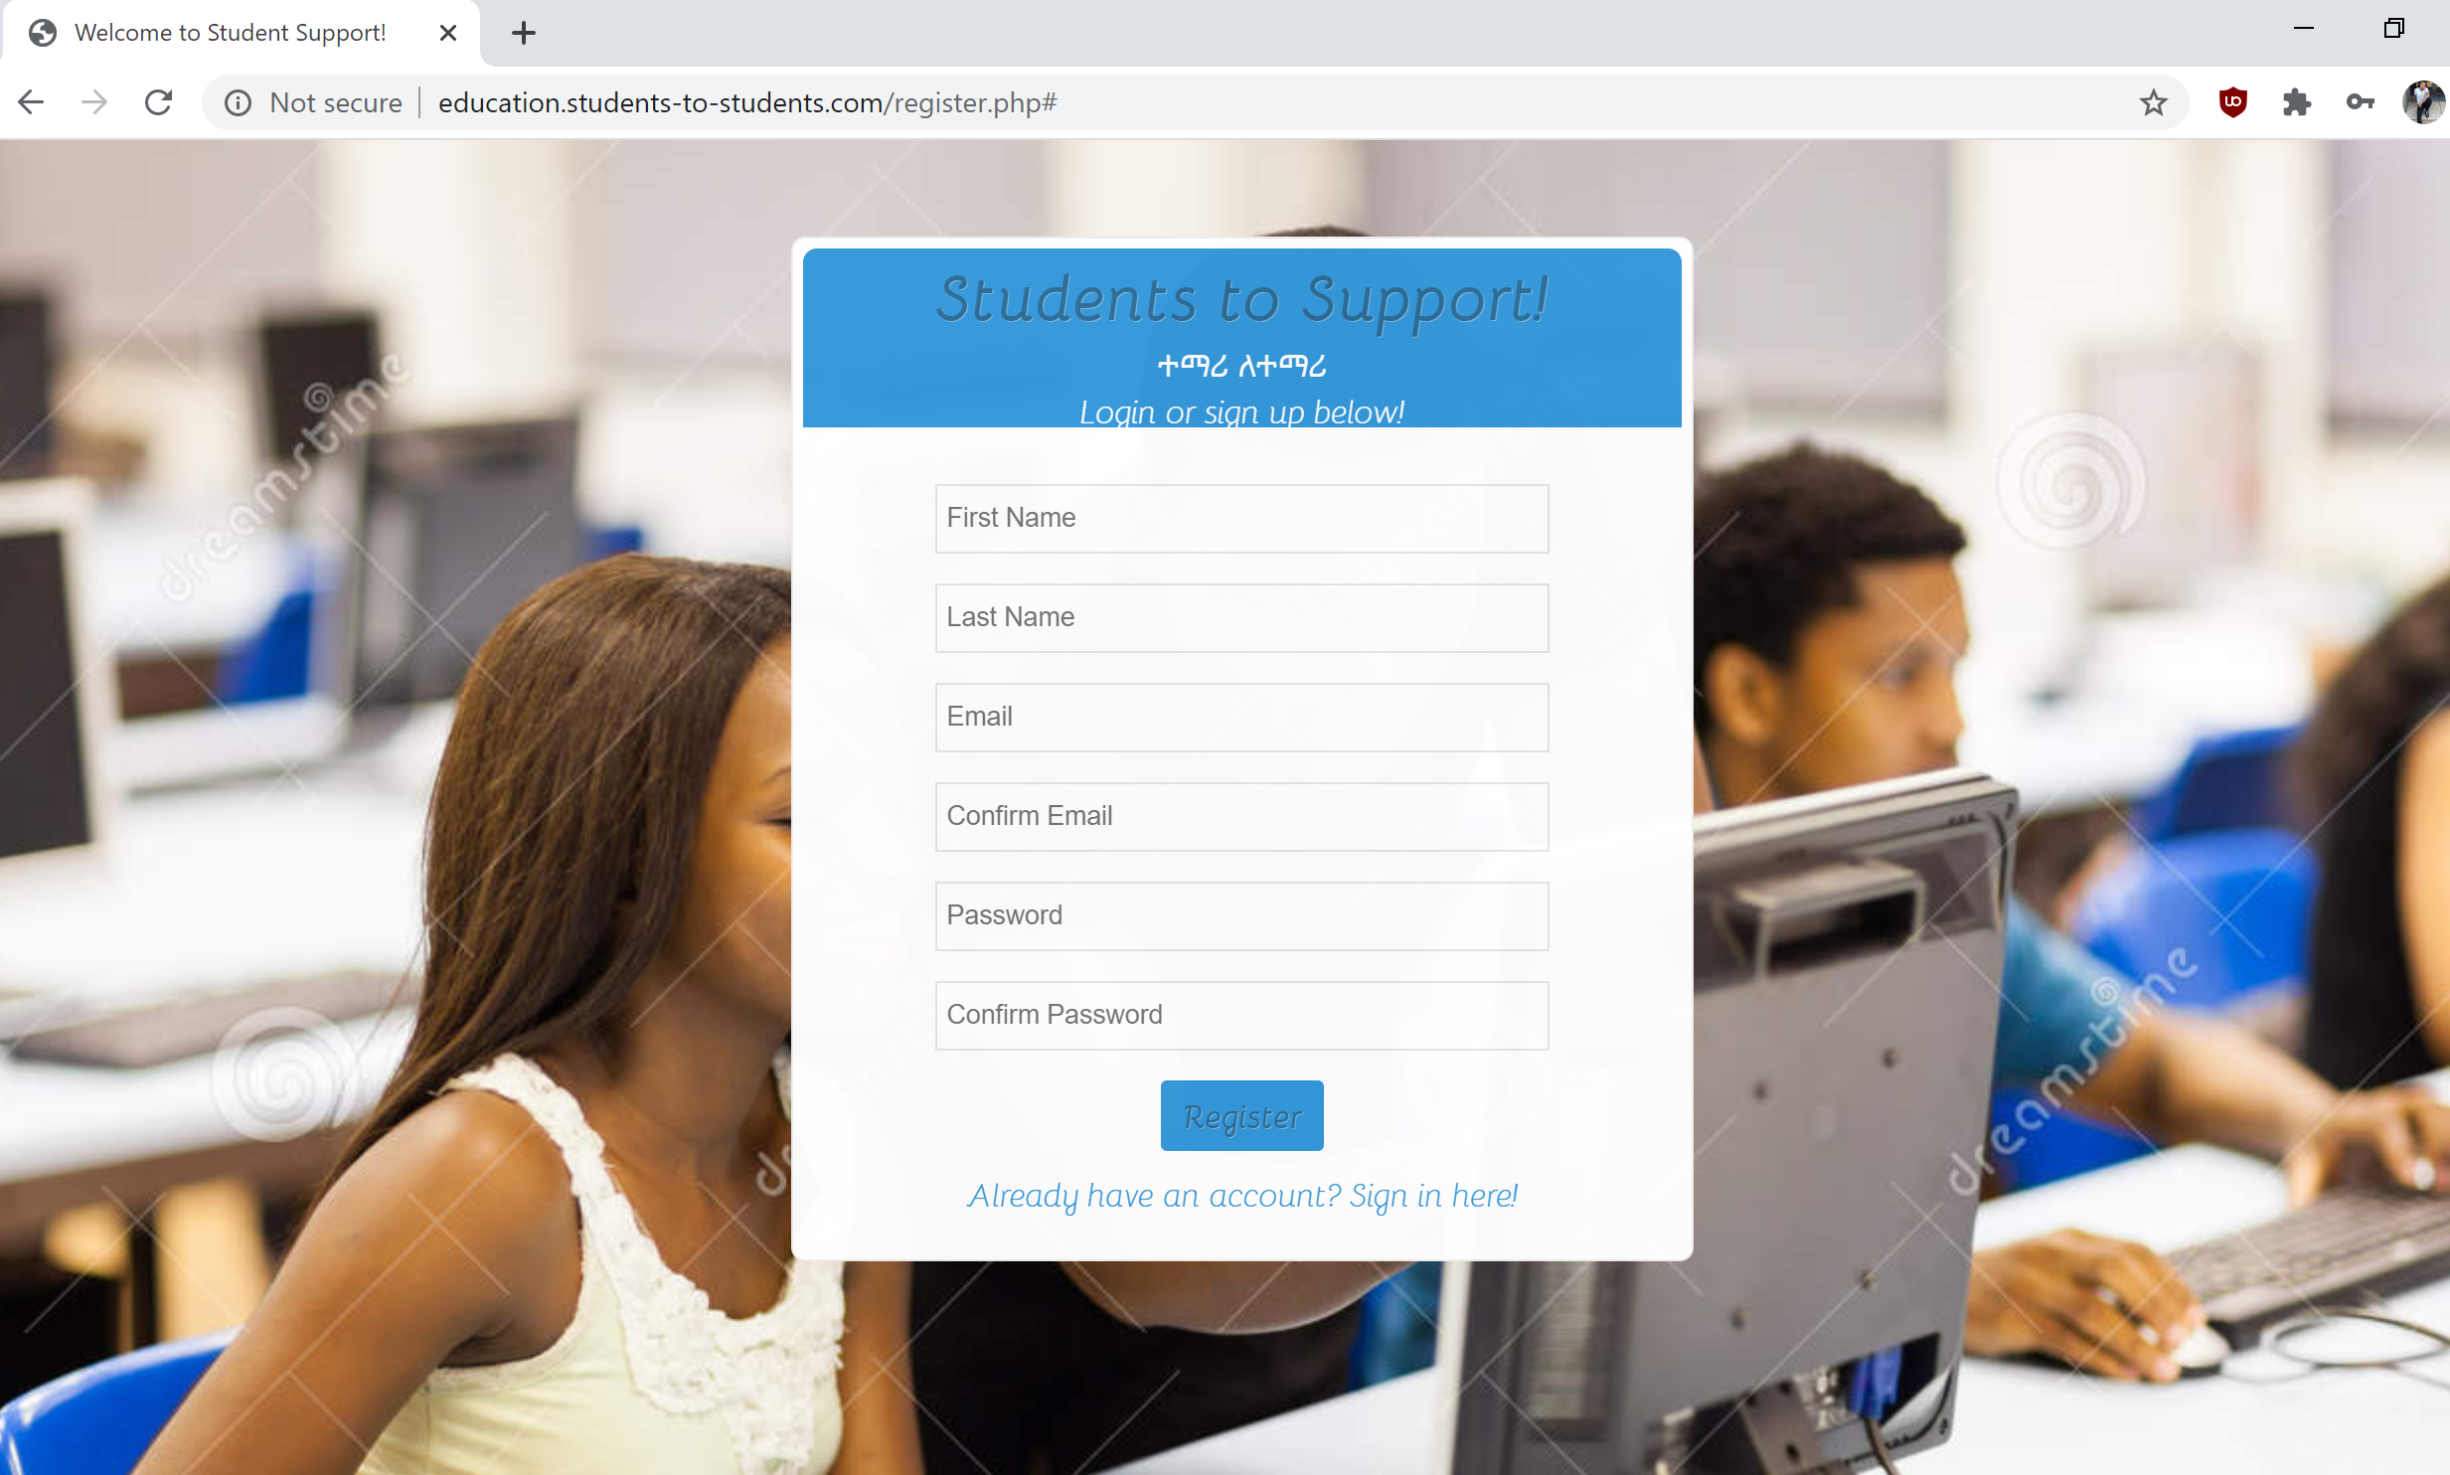

## Adding Forget password

As we have a human behaviour we might forget email and password that we used previously to login to the system. However, I wrote a code for a system to remember the email but I couldn’t write the same code to remember the password because that might make students vulnerable for hackers. Therefore, for the future I will add forget password in the login page so that users can reset the password if the forget the password.

## Styling the Index page

The index page looks a bit mess. so I might have to do a bit better design than the page that shows as the following picture. And also I have to get more data from the registration form and fill them in the empty html text that shows below. Moreover, to see the subjects page rather than putting the button as it shows below I might I have do the pop up to take user in the subjects page.

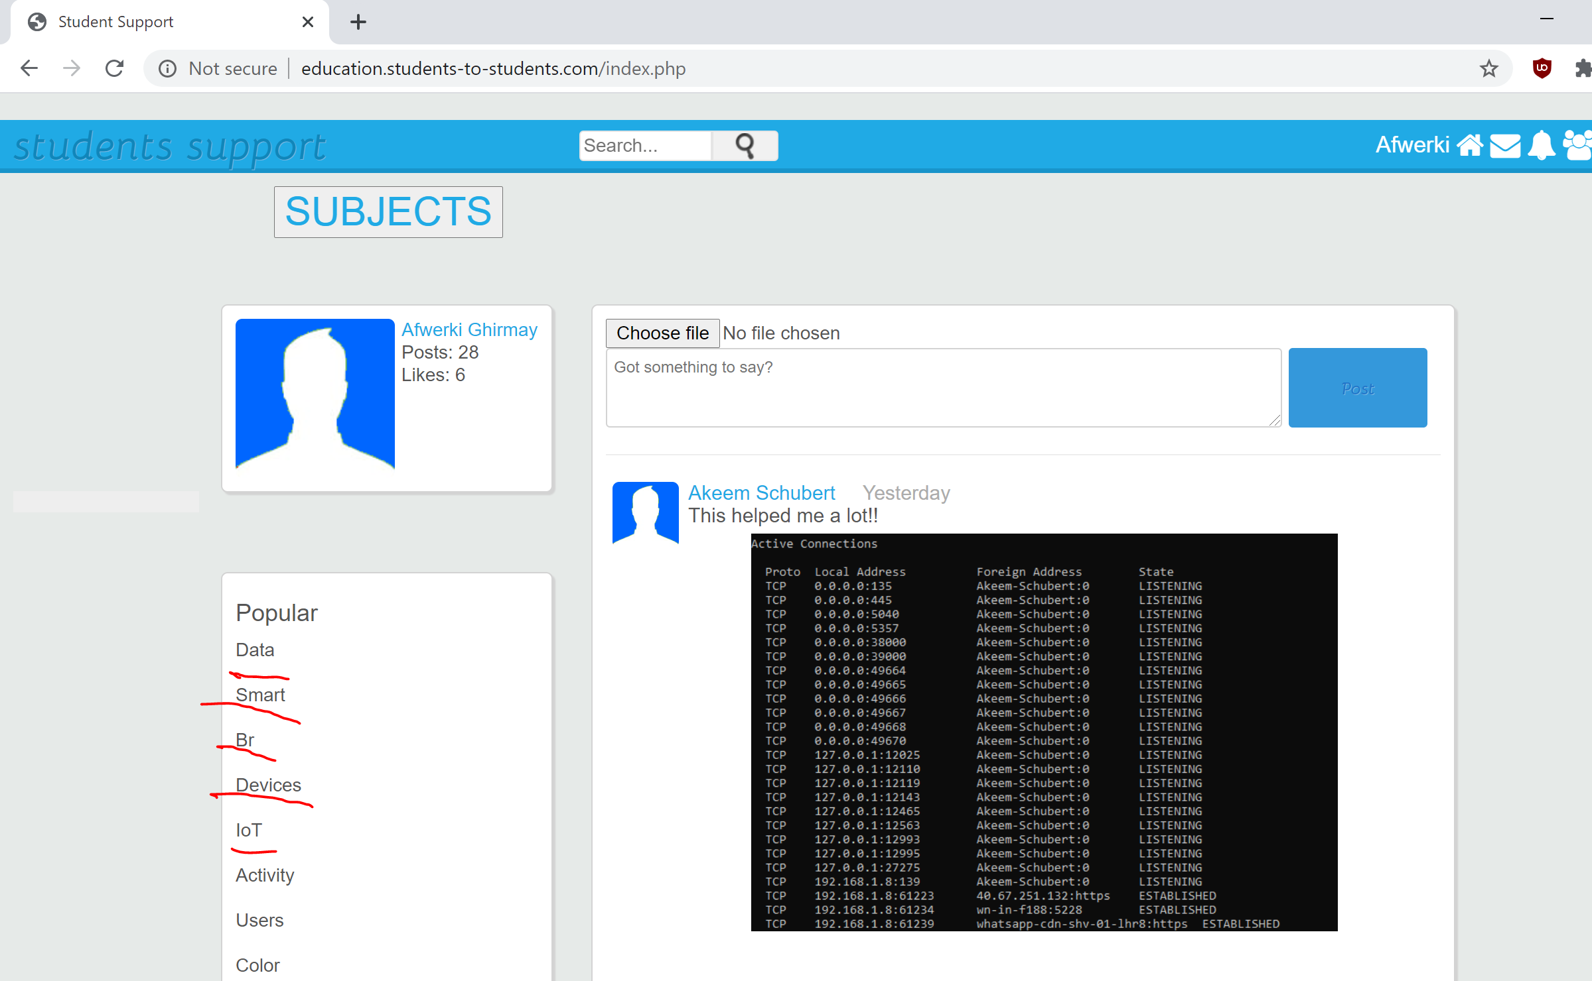

## Make use of all the Subjects page

Currently students have to click the subjects that they are interested on. However, the reason I left the middle part empty is I want students the get the file or upload the file in the same page rather than going to another page.

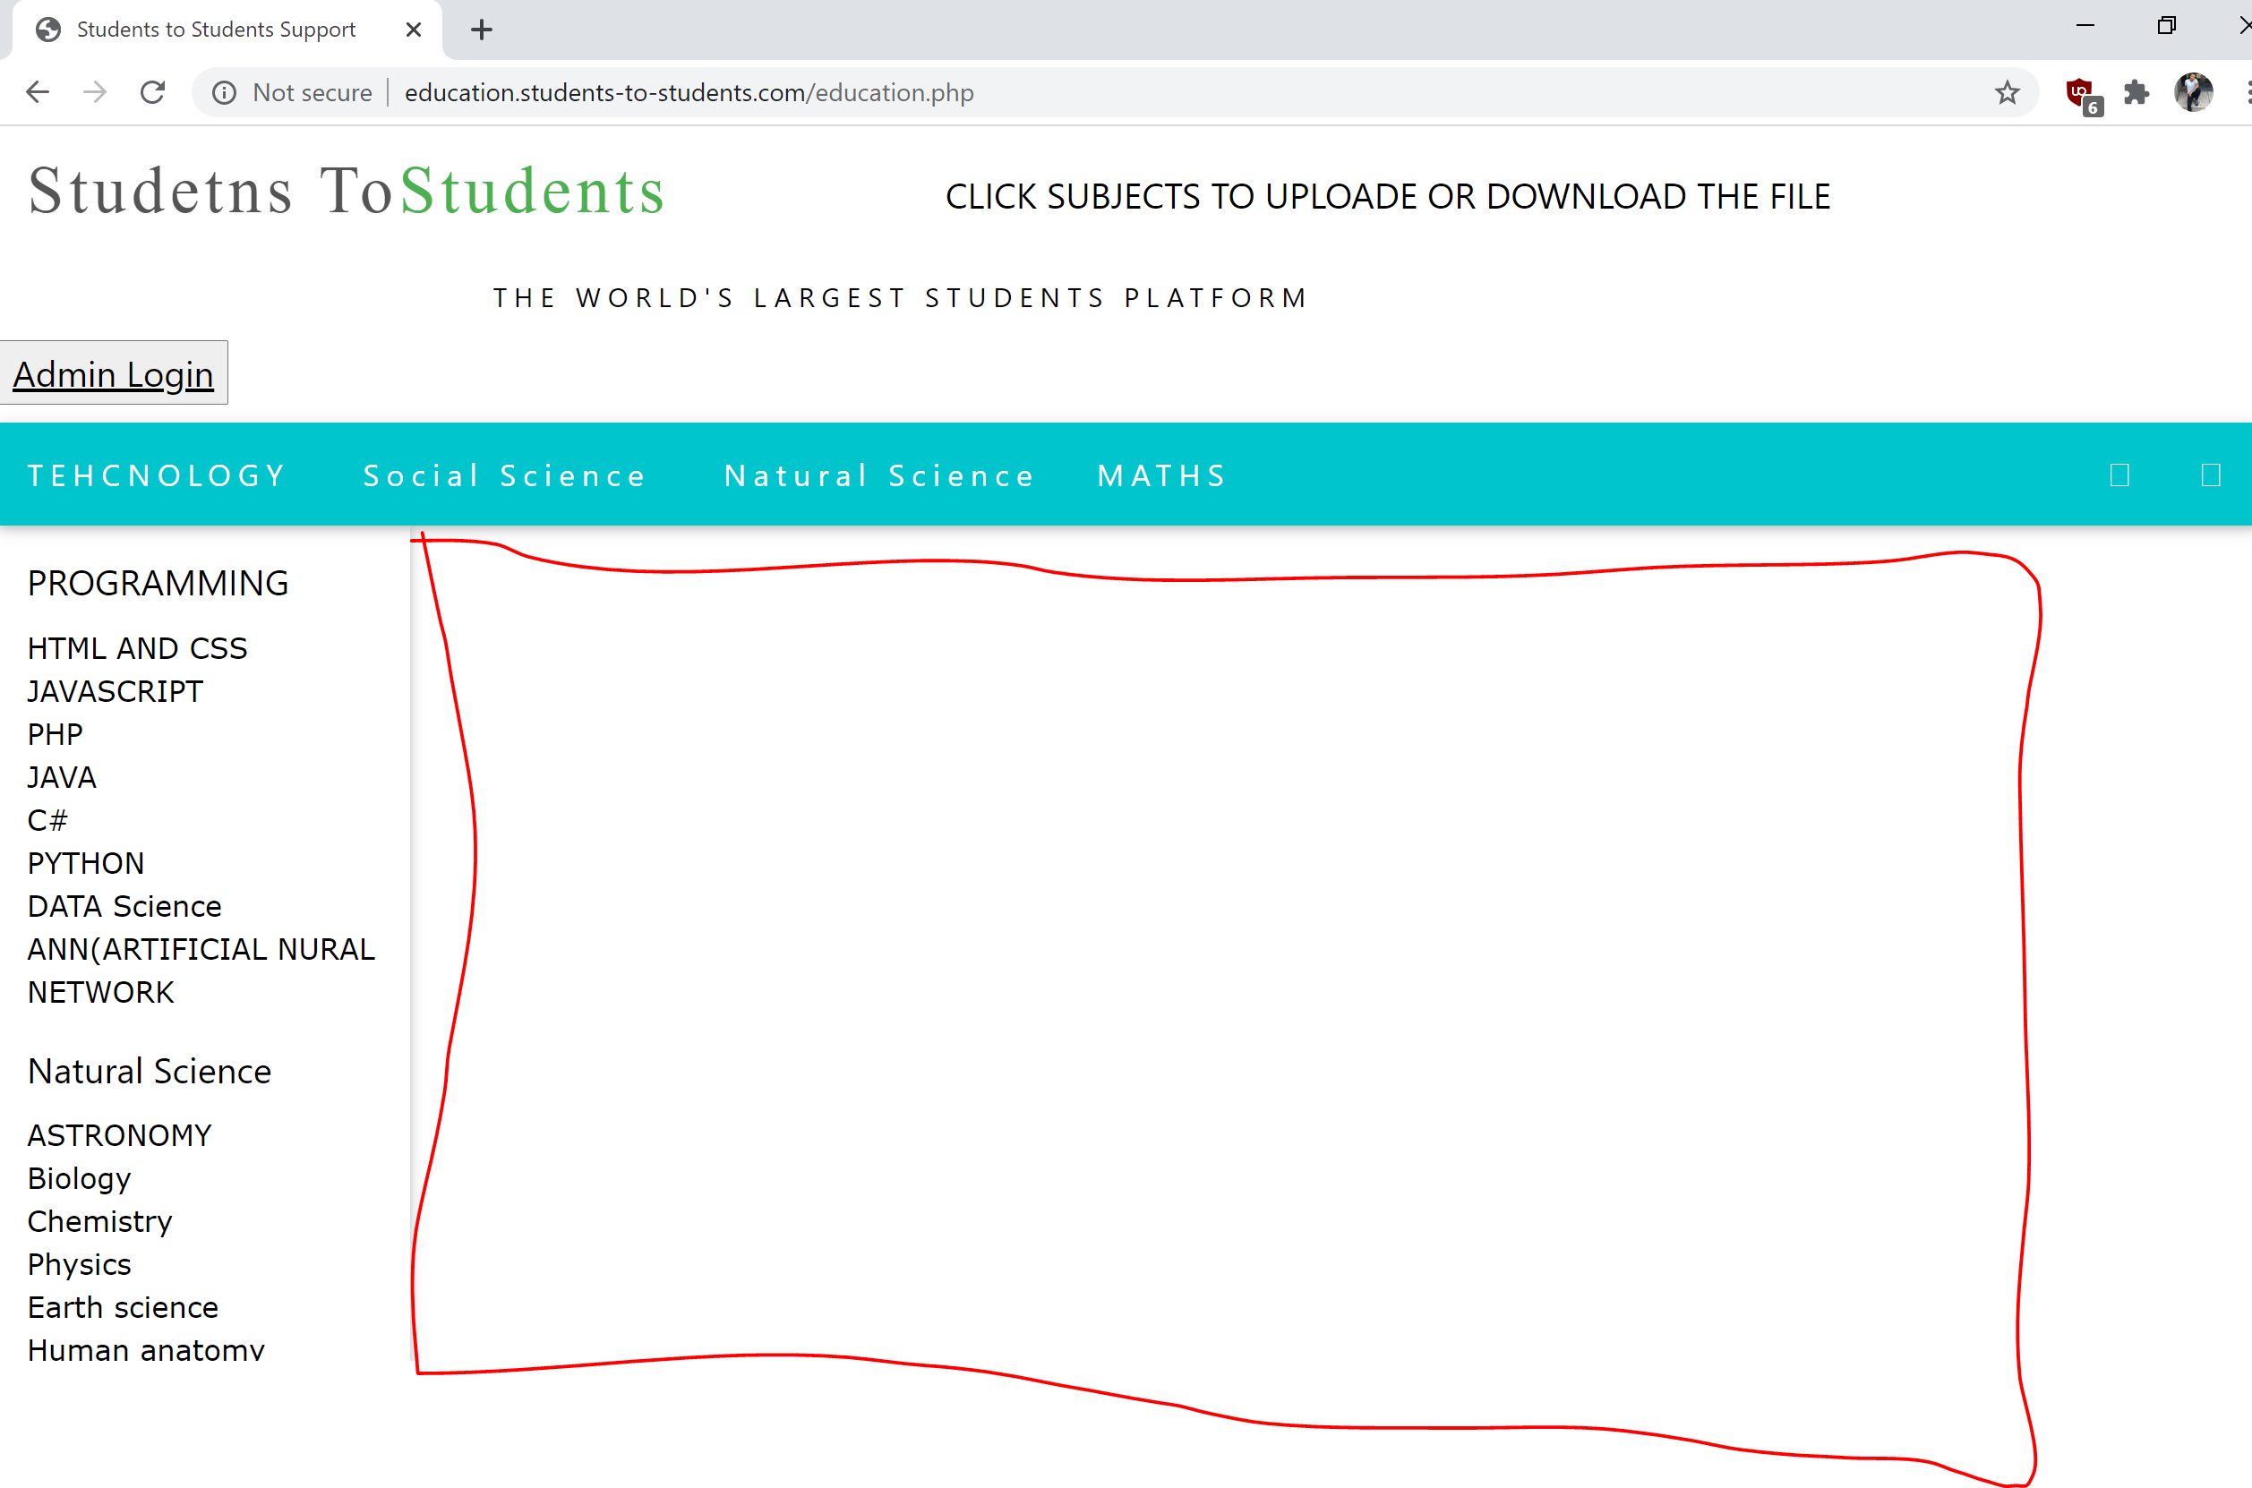

## Separating all subjects in to different Document holder page

As of now students who are studying technology they have to upload or download the file in the same page. Social science the same page, natural science the same page and maths the same page. However, this is not very good way to upload or download the file. If students from all over the world are joining, then it will be over crowded. Therefore, I am going to create different file for each subject so that it can be easy and handy to be upload or download the file. The documents page that shows as follows will be removed.

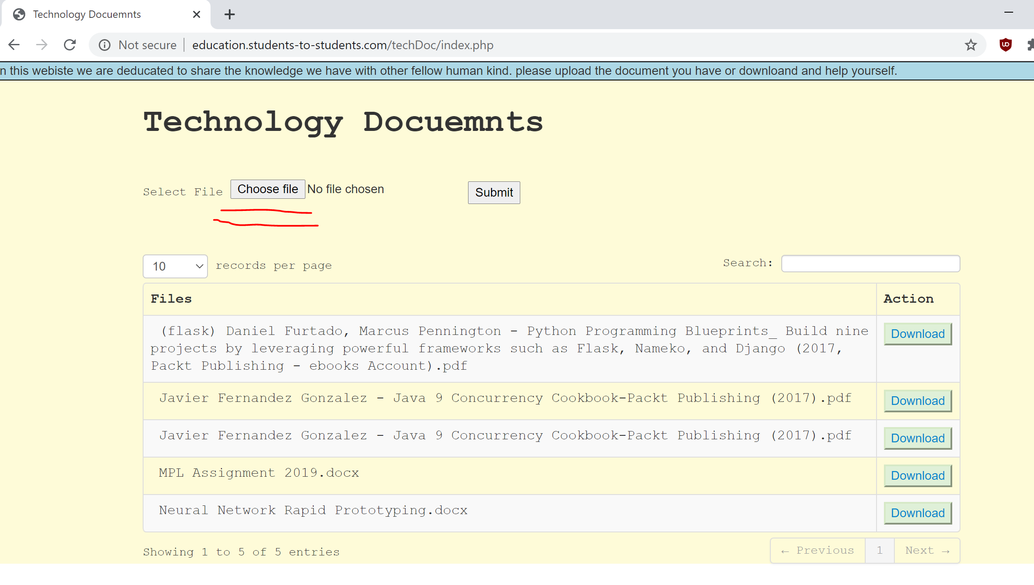

## Adding Delete button in to the file

Currently students can upload and download the file but they can’t delete the file that they are uploading in to the website. In this case I am going to add a button to delete the file if they want to delete it.

## Adding Like and dislike buttons in to the file

Students can be encouraged based on the reviews that they can get from other students. Therefore, I am going to add like and dislike button on each file so that students can see the review of the file that they are uploaded in to the website.

## Adding more detail about the file

Students must anticipate what to get before they download the file that they got from the website. For example, if one student from India download the project that I am working on currently, he has to know who uploaded the file, the size of the file, and the brief expectation. Therefore, I am going to add all this details in the website so that students can download the important and relevant file that they are looking forward to download.

## Collecting users based their preferred subject

After hosting the website what I noticed when I ask my friends to login in to the system for testing purposes is that when students login in to the website for the first time, they can’t see any one to send a friend request or to talk. as it shows in the picture below I am going to add one more button that can collect the students who registered to study that specific subject that the new comer students are looking forward to study.

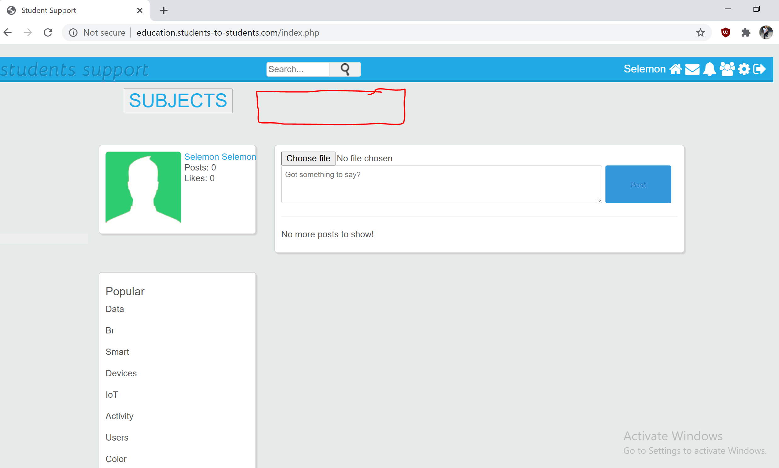

## Chapter summery

All the modification that I am going to make are very easy and possible to make in bluehost Cpanel. The bluhost cpanel is enabling to access the file and modify or add other files if necessary.

Therefor I will modify the website while the website is live and working for those students who need the website now and I will continue modifying until it is perfect both the frontend design and the backend functionality.

# Chapter 10: Overall conclusion

One of the aim in this project was to design and deploy the website that is fully functional and capable of handling the data without any issue. The other aim was to create and connect to database which both aims are achieved. Overall in the process I gain very good understanding of the website development from both front end and back end programming which was also one of the main aims of this project.

The outcome of this project is very positive. All the aims and objectives has been achieved. The plan to support students from all over the world is successfully completed.

I asked more than 13 friends to register and login in to the system. Which most of them are logged in to the system and have a chat with me. I also asked all of them to download and upload file in the website. All of them managed to do so without any issue. However, one issue that most of them encountered are the slowness of the system. For example, when I sent a friend request to one of the student he was waiting at least for 10 seconds to receive the request. This makes a system very slow which I am going to do some research about the slowness of the system after submitting the project.

Apart from this issue, I have the record of student’s registration form that can be found by logged in to the admin page.

All the conversation that I had with them have no problem and the pictures that they posted in to the website can be liked and disliked without any issue. Finally, the file they uploaded can be seen in the website and downloaded if necessary.

## Registration and login sequence diagram

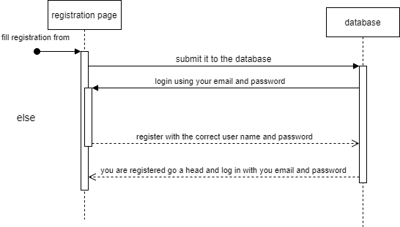

## Searching a person and sending a friend request sequence diagram

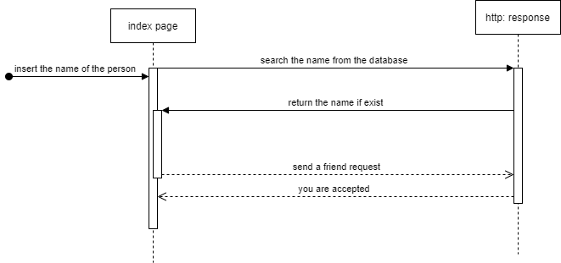

## Uploading the file sequence diagram

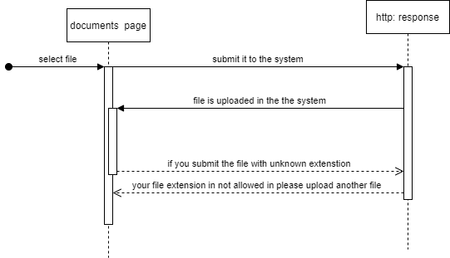

## Downloading the file sequence diagram

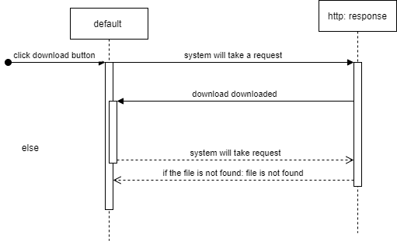

## Searching the file sequence diagram

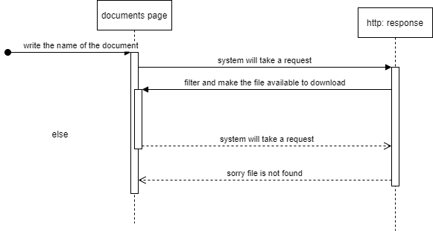

In the following I am going to copy and paste the main pages but I can’t past all codes her because it will be overwhelming. However, if anyone interested to see the code there will be two ways of getting the source code. One from get hub and the other is from the website that I developed. The website is live so it will be one way of testing the functionality. Therefore, if anyone is interested to download the source code I am going to upload it in the website on technology department so that Everyone can download the source code from there.

## Registration page source code

<?php

include("includes/header.php"); //Header

?>

<div class="main_column column" id="main_column">

    <h4>Friend Requests</h4>

    <?php

    $query = mysqli_query($con, "SELECT * FROM friend_requests WHERE user_to='$userLoggedIn'");

    if(mysqli_num_rows($query) == 0)

        echo "You have no friend requests at this time!";

    else {

        while($row = mysqli_fetch_array($query)) {

            $user_from = $row['user_from'];

            $user_from_obj = new User($con, $user_from);

            echo $user_from_obj->getFirstAndLastName() . " sent you a friend request!";

            $user_from_friend_array = $user_from_obj->getFriendArray();

            if(isset($_POST['accept_request' . $user_from ])) {

                $add_friend_query = mysqli_query($con, "UPDATE users SET friend_array=CONCAT(friend_array, '$user_from,') WHERE username='$userLoggedIn'");

                $add_friend_query = mysqli_query($con, "UPDATE users SET friend_array=CONCAT(friend_array, '$userLoggedIn,') WHERE username='$user_from'");

                $delete_query = mysqli_query($con, "DELETE FROM friend_requests WHERE user_to='$userLoggedIn' AND user_from='$user_from'");

                echo "You are now friends!";

                header("Location: requests.php");

            }

            if(isset($_POST['ignore_request' . $user_from ])) {

                $delete_query = mysqli_query($con, "DELETE FROM friend_requests WHERE user_to='$userLoggedIn' AND user_from='$user_from'");

                echo "Request ignored!";

                header("Location: requests.php");

            }

            ?>

            <form action="requests.php" method="POST">

                <input type="submit" name="accept_request<?php echo $user_from; ?>" id="accept_button" value="Accept">

                <input type="submit" name="ignore_request<?php echo $user_from; ?>" id="ignore_button" value="Ignore">

            </form>

            <?php

        }

    }

    ?>

</div>

## Registration handler.php

<?php

//Declaring variables to prevent errors

$fname = ""; //First name

$lname = ""; //Last name

$em = ""; //email

$em2 = ""; //email 2

$password = ""; //password

$password2 = ""; //password 2

$date = ""; //Sign up date

$error_array = array(); //Holds error messages

if(isset($_POST['register_button'])){

    //Registration form values

    //First name

    $fname = strip_tags($_POST['reg_fname']); //Remove html tags

    $fname = str_replace(' ', '', $fname); //remove spaces

    $fname = ucfirst(strtolower($fname)); //Uppercase first letter

    $_SESSION['reg_fname'] = $fname; //Stores first name into session variable

    //Last name

    $lname = strip_tags($_POST['reg_lname']); //Remove html tags

    $lname = str_replace(' ', '', $lname); //remove spaces

    $lname = ucfirst(strtolower($lname)); //Uppercase first letter

    $_SESSION['reg_lname'] = $lname; //Stores last name into session variable

    //email

    $em = strip_tags($_POST['reg_email']); //Remove html tags

    $em = str_replace(' ', '', $em); //remove spaces

    $em = ucfirst(strtolower($em)); //Uppercase first letter

    $_SESSION['reg_email'] = $em; //Stores email into session variable

    //email 2

    $em2 = strip_tags($_POST['reg_email2']); //Remove html tags

    $em2 = str_replace(' ', '', $em2); //remove spaces

    $em2 = ucfirst(strtolower($em2)); //Uppercase first letter

    $_SESSION['reg_email2'] = $em2; //Stores email2 into session variable

    //Password

    $password = strip_tags($_POST['reg_password']); //Remove html tags

    $password2 = strip_tags($_POST['reg_password2']); //Remove html tags

    $date = date("Y-m-d"); //Current date

    if($em == $em2) {

        //Check if email is in valid format

        if(filter_var($em, FILTER_VALIDATE_EMAIL)) {

            $em = filter_var($em, FILTER_VALIDATE_EMAIL);

            //Check if email already exists

            $e_check = mysqli_query($con, "SELECT email FROM users WHERE email='$em'");

            //Count the number of rows returned

            $num_rows = mysqli_num_rows($e_check);

            if($num_rows > 0) {

                array_push($error_array, "Email already in use<br>");

            }

        }

        else {

            array_push($error_array, "Invalid email format<br>");

        }

    }

    else {

        array_push($error_array, "Emails don't match<br>");

    }

    if(strlen($fname) > 25 || strlen($fname) < 2) {

        array_push($error_array, "Your first name must be between 2 and 25 characters<br>");

    }

    if(strlen($lname) > 25 || strlen($lname) < 2) {

        array_push($error_array,  "Your last name must be between 2 and 25 characters<br>");

    }

    if($password != $password2) {

        array_push($error_array,  "Your passwords do not match<br>");

    }

    else {

        if(preg_match('/[^A-Za-z0-9]/', $password)) {

            array_push($error_array, "Your password can only contain english characters or numbers<br>");

        }

    }

    if(strlen($password > 30 || strlen($password) < 5)) {

        array_push($error_array, "Your password must be betwen 5 and 30 characters<br>");

    }

    if(empty($error_array)) {

        $password = md5($password); //Encrypt password before sending to database

        //Generate username by concatenating first name and last name

        $username = strtolower($fname . "_" . $lname);

        $check_username_query = mysqli_query($con, "SELECT username FROM users WHERE username='$username'");

        $i = 0;

        //if username exists add number to username

        while(mysqli_num_rows($check_username_query) != 0) {

            $i++; //Add 1 to i

            $username = $username . "_" . $i;

            $check_username_query = mysqli_query($con, "SELECT username FROM users WHERE username='$username'");

        }

        //Profile picture assignment

        $rand = rand(1, 2); //Random number between 1 and 2

        if($rand == 1)

            $profile_pic = "assets/images/profile_pics/defaults/head_deep_blue.png";

        else if($rand == 2)

            $profile_pic = "assets/images/profile_pics/defaults/head_emerald.png";

        $query = mysqli_query($con, "INSERT INTO users VALUES ('', '$fname', '$lname', '$username', '$em', '$password', '$date', '$profile_pic', '0', '0', 'no', ',')");

        array_push($error_array, "<span style='color: #14C800;'>You're all set! Go ahead and login!</span><br>");

        //Clear session variables

        $_SESSION['reg_fname'] = "";

        $_SESSION['reg_lname'] = "";

        $_SESSION['reg_email'] = "";

        $_SESSION['reg_email2'] = "";

    }

}

?>

## Index.php home page source code

<?php

include("includes/header.php");

if(isset($_POST['post'])){

    $uploadOk = 1;

    $imageName = $_FILES['fileToUpload']['name'];

    $errorMessage = "";

    if($imageName != "") {

        $targetDir = "assets/images/posts/";

        $imageName = $targetDir . uniqid() . basename($imageName);

        $imageFileType = pathinfo($imageName, PATHINFO_EXTENSION);

        if($_FILES['fileToUpload']['size'] > 10000000) {

            $errorMessage = "Sorry your file is too large";

            $uploadOk = 0;

        }

        if(strtolower($imageFileType) != "jpeg" && strtolower($imageFileType) != "png" && strtolower($imageFileType) != "jpg") {

            $errorMessage = "Sorry, only jpeg, jpg and png files are allowed";

            $uploadOk = 0;

        }

        if($uploadOk) {

            if(move_uploaded_file($_FILES['fileToUpload']['tmp_name'], $imageName)) {

                //image uploaded okay

            }

            else {

                //image did not upload

                $uploadOk = 0;

            }

        }

    }

    if($uploadOk) {

        $post = new Post($con, $userLoggedIn);

        $post->submitPost($_POST['post_text'], 'none', $imageName);

    }

    else {

        echo "<div style='text-align:center;' class='alert alert-danger'>

                $errorMessage

            </div>";

    }

}

 ?>

    <div class="user_details column">

        <a href="<?php echo $userLoggedIn; ?>">  <img src="<?php echo $user['profile_pic']; ?>"> </a>

        <div class="user_details_left_right">

            <a href="<?php echo $userLoggedIn; ?>">

            <?php

            echo $user['first_name'] . " " . $user['last_name'];

             ?>

            </a>

            <br>

            <?php echo "Posts: " . $user['num_posts']. "<br>";

            echo "Likes: " . $user['num_likes'];

            ?>

        </div>

    </div>

    <div class="main_column column">

        <form class="post_form" action="index.php" method="POST" enctype="multipart/form-data">

            <input type="file" name="fileToUpload" id="fileToUpload">

            <textarea name="post_text" id="post_text" placeholder="Got something to say?"></textarea>

            <input type="submit" name="post" id="post_button" value="Post">

            <hr>

        </form>

        <div class="posts_area"></div>

        <!-- <button id="load_more">Load More Posts</button> -->

        <img id="loading" src="assets/images/icons/loading.gif">

    </div>

    <div class="user_details column">

        <h4>Popular</h4>

        <div class="trends">

            <?php

            $query = mysqli_query($con, "SELECT * FROM trends ORDER BY hits DESC LIMIT 9");

            foreach ($query as $row) {

                $word = $row['title'];

                $word_dot = strlen($word) >= 14 ? "..." : "";

                $trimmed_word = str_split($word, 14);

                $trimmed_word = $trimmed_word[0];

                echo "<div style'padding: 1px'>";

                echo $trimmed_word . $word_dot;

                echo "<br></div><br>";

            }

            ?>

        </div>

    </div>

    <script>

    var userLoggedIn = '<?php echo $userLoggedIn; ?>';

    $(document).ready(function() {

        $('#loading').show();

        //Original ajax request for loading first posts

        $.ajax({

            url: "includes/handlers/ajax_load_posts.php",

            type: "POST",

            data: "page=1&userLoggedIn=" + userLoggedIn,

            cache:false,

            success: function(data) {

                $('#loading').hide();

                $('.posts_area').html(data);

            }

        });

        $(window).scroll(function() {

        //$('#load_more').on("click", function() {

            var height = $('.posts_area').height(); //Div containing posts

            var scroll_top = $(this).scrollTop();

            var page = $('.posts_area').find('.nextPage').val();

            var noMorePosts = $('.posts_area').find('.noMorePosts').val();

            if ((document.body.scrollHeight == document.body.scrollTop + window.innerHeight) && noMorePosts == 'false') {

            //if (noMorePosts == 'false') {

                $('#loading').show();

                var ajaxReq = $.ajax({

                    url: "includes/handlers/ajax_load_posts.php",

                    type: "POST",

                    data: "page=" + page + "&userLoggedIn=" + userLoggedIn,

                    cache:false,

                    success: function(response) {

                        $('.posts_area').find('.nextPage').remove(); //Removes current .nextpage

                        $('.posts_area').find('.noMorePosts').remove(); //Removes current .nextpage

                        $('.posts_area').find('.noMorePostsText').remove(); //Removes current .nextpage

                        $('#loading').hide();

                        $('.posts_area').append(response);

                    }

                });

            } //End if

            return false;

        }); //End (window).scroll(function())

    });

    </script>

    </div>

</body>

</html>

## Search.php for searching users source code

<?php

include("includes/header.php");

if(isset($_GET['q'])) {

    $query = $_GET['q'];

}

else {

    $query = "";

}

if(isset($_GET['type'])) {

    $type = $_GET['type'];

}

else {

    $type = "name";

}

?>

<div class="main_column column" id="main_column">

    <?php

    if($query == "")

        echo "You must enter something in the search box.";

    else {

        //If query contains an underscore, assume user is searching for usernames

        if($type == "username")

            $usersReturnedQuery = mysqli_query($con, "SELECT * FROM users WHERE username LIKE '$query%' AND user_closed='no' LIMIT 8");

        //If there are two words, assume they are first and last names respectively

        else {

            $names = explode(" ", $query);

            if(count($names) == 3)

                $usersReturnedQuery = mysqli_query($con, "SELECT * FROM users WHERE (first_name LIKE '$names[0]%' AND last_name LIKE '$names[2]%') AND user_closed='no'");

            //If query has one word only, search first names or last names

            else if(count($names) == 2)

                $usersReturnedQuery = mysqli_query($con, "SELECT * FROM users WHERE (first_name LIKE '$names[0]%' AND last_name LIKE '$names[1]%') AND user_closed='no'");

            else

                $usersReturnedQuery = mysqli_query($con, "SELECT * FROM users WHERE (first_name LIKE '$names[0]%' OR last_name LIKE '$names[0]%') AND user_closed='no'");

        }

        //Check if results were found

        if(mysqli_num_rows($usersReturnedQuery) == 0)

            echo "We can't find anyone with a " . $type . " like: " .$query;

        else

            echo mysqli_num_rows($usersReturnedQuery) . " results found: <br> <br>";

        echo "<p id='grey'>Try searching for:</p>";

        echo "<a href='search.php?q=" . $query ."&type=name'>Names</a>, <a href='search.php?q=" . $query ."&type=username'>Usernames</a><br><br><hr id='search_hr'>";

        while($row = mysqli_fetch_array($usersReturnedQuery)) {

            $user_obj = new User($con, $user['username']);

            $button = "";

            $mutual_friends = "";

            if($user['username'] != $row['username']) {

                //Generate button depending on friendship status

                if($user_obj->isFriend($row['username']))

                    $button = "<input type='submit' name='" . $row['username'] . "' class='danger' value='Remove Friend'>";

                else if($user_obj->didReceiveRequest($row['username']))

                    $button = "<input type='submit' name='" . $row['username'] . "' class='warning' value='Respond to request'>";

                else if($user_obj->didSendRequest($row['username']))

                    $button = "<input type='submit' class='default' value='Request Sent'>";

                else

                    $button = "<input type='submit' name='" . $row['username'] . "' class='success' value='Add Friend'>";

                $mutual_friends = $user_obj->getMutualFriends($row['username']) . " friends in common";

                //Button forms

                if(isset($_POST[$row['username']])) {

                    if($user_obj->isFriend($row['username'])) {

                        $user_obj->removeFriend($row['username']);

                        header("Location: http://$_SERVER[HTTP_HOST]$_SERVER[REQUEST_URI]");

                    }

                    else if($user_obj->didReceiveRequest($row['username'])) {

                        header("Location: requests.php");

                    }

                    else if($user_obj->didSendRequest($row['username'])) {

                    }

                    else {

                        $user_obj->sendRequest($row['username']);

                        header("Location: http://$_SERVER[HTTP_HOST]$_SERVER[REQUEST_URI]");

                    }

                }

            }

            echo "<div class='search_result'>

                    <div class='searchPageFriendButtons'>

                        <form action='' method='POST'>

                            " . $button . "

                            <br>

                        </form>

                    </div>

                    <div class='result_profile_pic'>

                        <a href='" . $row['username'] ."'><img src='". $row['profile_pic'] ."' style='height: 100px;'></a>

                    </div>

                        <a href='" . $row['username'] ."'> " . $row['first_name'] . " " . $row['last_name'] . "

                        <p id='grey'> " . $row['username'] ."</p>

                        </a>

                        <br>

                        " . $mutual_friends ."<br>

                </div>

                <hr id='search_hr'>";

        } //End while

    }

    ?>

</div>

## request.php for sending a friend request source code

<?php

include("includes/header.php"); //Header

?>

<div class="main_column column" id="main_column">

    <h4>Friend Requests</h4>

    <?php

    $query = mysqli_query($con, "SELECT * FROM friend_requests WHERE user_to='$userLoggedIn'");

    if(mysqli_num_rows($query) == 0)

        echo "You have no friend requests at this time!";

    else {

        while($row = mysqli_fetch_array($query)) {

            $user_from = $row['user_from'];

            $user_from_obj = new User($con, $user_from);

            echo $user_from_obj->getFirstAndLastName() . " sent you a friend request!";

            $user_from_friend_array = $user_from_obj->getFriendArray();

            if(isset($_POST['accept_request' . $user_from ])) {

                $add_friend_query = mysqli_query($con, "UPDATE users SET friend_array=CONCAT(friend_array, '$user_from,') WHERE username='$userLoggedIn'");

                $add_friend_query = mysqli_query($con, "UPDATE users SET friend_array=CONCAT(friend_array, '$userLoggedIn,') WHERE username='$user_from'");

                $delete_query = mysqli_query($con, "DELETE FROM friend_requests WHERE user_to='$userLoggedIn' AND user_from='$user_from'");

                echo "You are now friends!";

                header("Location: requests.php");

            }

            if(isset($_POST['ignore_request' . $user_from ])) {

                $delete_query = mysqli_query($con, "DELETE FROM friend_requests WHERE user_to='$userLoggedIn' AND user_from='$user_from'");

                echo "Request ignored!";

                header("Location: requests.php");

            }

            ?>

            <form action="requests.php" method="POST">

                <input type="submit" name="accept_request<?php echo $user_from; ?>" id="accept_button" value="Accept">

                <input type="submit" name="ignore_request<?php echo $user_from; ?>" id="ignore_button" value="Ignore">

            </form>

            <?php

        }

    }

    ?>

</div>

## like.php to like a picture or text that has been posted by students source code

<html>

<head>

    <title></title>

    <link rel="stylesheet" type="text/css" href="assets/css/style.css">

</head>

<body>

    <style type="text/css">

    * {

        font-family: Arial, Helvetica, Sans-serif;

    }

    body {

        background-color: #fff;

    }

    form {

        position: absolute;

        top: 0;

    }

    </style>

    <?php

    require 'config/config.php';

    include("includes/classes/User.php");

    include("includes/classes/Post.php");

    include("includes/classes/Notification.php");

    if (isset($_SESSION['username'])) {

        $userLoggedIn = $_SESSION['username'];

        $user_details_query = mysqli_query($con, "SELECT * FROM users WHERE username='$userLoggedIn'");

        $user = mysqli_fetch_array($user_details_query);

    }

    else {

        header("Location: register.php");

    }

    //Get id of post

    if(isset($_GET['post_id'])) {

        $post_id = $_GET['post_id'];

    }

    $get_likes = mysqli_query($con, "SELECT likes, added_by FROM posts WHERE id='$post_id'");

    $row = mysqli_fetch_array($get_likes);

    $total_likes = $row['likes'];

    $user_liked = $row['added_by'];

    $user_details_query = mysqli_query($con, "SELECT * FROM users WHERE username='$user_liked'");

    $row = mysqli_fetch_array($user_details_query);

    $total_user_likes = $row['num_likes'];

    //Like button

    if(isset($_POST['like_button'])) {

        $total_likes++;

        $query = mysqli_query($con, "UPDATE posts SET likes='$total_likes' WHERE id='$post_id'");

        $total_user_likes++;

        $user_likes = mysqli_query($con, "UPDATE users SET num_likes='$total_user_likes' WHERE username='$user_liked'");

        $insert_user = mysqli_query($con, "INSERT INTO likes VALUES('', '$userLoggedIn', '$post_id')");

        //Insert Notification

        if($user_liked != $userLoggedIn) {

            $notification = new Notification($con, $userLoggedIn);

            $notification->insertNotification($post_id, $user_liked, "like");

        }

    }

    //Unlike button

    if(isset($_POST['unlike_button'])) {

        $total_likes--;

        $query = mysqli_query($con, "UPDATE posts SET likes='$total_likes' WHERE id='$post_id'");

        $total_user_likes--;

        $user_likes = mysqli_query($con, "UPDATE users SET num_likes='$total_user_likes' WHERE username='$user_liked'");

        $insert_user = mysqli_query($con, "DELETE FROM likes WHERE username='$userLoggedIn' AND post_id='$post_id'");

    }

    //Check for previous likes

    $check_query = mysqli_query($con, "SELECT * FROM likes WHERE username='$userLoggedIn' AND post_id='$post_id'");

    $num_rows = mysqli_num_rows($check_query);

    if($num_rows > 0) {

        echo '<form action="like.php?post_id=' . $post_id . '" method="POST">

                <input type="submit" class="comment_like" name="unlike_button" value="Unlike">

                <div class="like_value">

                    '. $total_likes .' Likes

                </div>

            </form>

        ';

    }

    else {

        echo '<form action="like.php?post_id=' . $post_id . '" method="POST">

                <input type="submit" class="comment_like" name="like_button" value="Like">

                <div class="like_value">

                    '. $total_likes .' Likes

                </div>

            </form>

        ';

    }

    ?>

</body>

</html>

## Comment_frame.php to comment on anything that has been posted source code

<?php

    require 'config/config.php';

    include("includes/classes/User.php");

    include("includes/classes/Post.php");

    include("includes/classes/Notification.php");

    if (isset($_SESSION['username'])) {

        $userLoggedIn = $_SESSION['username'];

        $user_details_query = mysqli_query($con, "SELECT * FROM users WHERE username='$userLoggedIn'");

        $user = mysqli_fetch_array($user_details_query);

    }

    else {

        header("Location: register.php");

    }

?>

<html>

<head>

    <title></title>

    <link rel="stylesheet" type="text/css" href="assets/css/style.css">

</head>

<body>

    <style type="text/css">

    * {

        font-size: 12px;

        font-family: Arial, Helvetica, Sans-serif;

    }

    </style>

    <script>

        function toggle() {

            var element = document.getElementById("comment_section");

            if(element.style.display == "block")

                element.style.display = "none";

            else

                element.style.display = "block";

        }

    </script>

    <?php

    //Get id of post

    if(isset($_GET['post_id'])) {

        $post_id = $_GET['post_id'];

    }

    $user_query = mysqli_query($con, "SELECT added_by, user_to FROM posts WHERE id='$post_id'");

    $row = mysqli_fetch_array($user_query);

    $posted_to = $row['added_by'];

    $user_to = $row['user_to'];

    if(isset($_POST['postComment' . $post_id])) {

        $post_body = $_POST['post_body'];

        $post_body = mysqli_escape_string($con, $post_body);

        $date_time_now = date("Y-m-d H:i:s");

        $insert_post = mysqli_query($con, "INSERT INTO comments VALUES ('', '$post_body', '$userLoggedIn', '$posted_to', '$date_time_now', 'no', '$post_id')");

        if($posted_to != $userLoggedIn) {

            $notification = new Notification($con, $userLoggedIn);

            $notification->insertNotification($post_id, $posted_to, "comment");

        }

        if($user_to != 'none' && $user_to != $userLoggedIn) {

            $notification = new Notification($con, $userLoggedIn);

            $notification->insertNotification($post_id, $user_to, "profile_comment");

        }

        $get_commenters = mysqli_query($con, "SELECT * FROM comments WHERE post_id='$post_id'");

        $notified_users = array();

        while($row = mysqli_fetch_array($get_commenters)) {

            if($row['posted_by'] != $posted_to && $row['posted_by'] != $user_to

                && $row['posted_by'] != $userLoggedIn && !in_array($row['posted_by'], $notified_users)) {

                $notification = new Notification($con, $userLoggedIn);

                $notification->insertNotification($post_id, $row['posted_by'], "comment_non_owner");

                array_push($notified_users, $row['posted_by']);

            }

        }

        echo "<p>Comment Posted! </p>";

    }

    ?>

    <form action="comment_frame.php?post_id=<?php echo $post_id; ?>" id="comment_form" name="postComment<?php echo $post_id; ?>" method="POST">

        <textarea name="post_body"></textarea>

        <input type="submit" name="postComment<?php echo $post_id; ?>" value="Post">

    </form>

    <!-- Load comments -->

    <?php

    $get_comments = mysqli_query($con, "SELECT * FROM comments WHERE post_id='$post_id' ORDER BY id ASC");

    $count = mysqli_num_rows($get_comments);

    if($count != 0) {

        while($comment = mysqli_fetch_array($get_comments)) {

            $comment_body = $comment['post_body'];

            $posted_to = $comment['posted_to'];

            $posted_by = $comment['posted_by'];

            $date_added = $comment['date_added'];

            $removed = $comment['removed'];

            //Timeframe

            $date_time_now = date("Y-m-d H:i:s");

            $start_date = new DateTime($date_added); //Time of post

            $end_date = new DateTime($date_time_now); //Current time

            $interval = $start_date->diff($end_date); //Difference between dates

            if($interval->y >= 1) {

                if($interval == 1)

                    $time_message = $interval->y . " year ago"; //1 year ago

                else

                    $time_message = $interval->y . " years ago"; //1+ year ago

            }

            else if ($interval->m >= 1) {

                if($interval->d == 0) {

                    $days = " ago";

                }

                else if($interval->d == 1) {

                    $days = $interval->d . " day ago";

                }

                else {

                    $days = $interval->d . " days ago";

                }

                if($interval->m == 1) {

                    $time_message = $interval->m . " month". $days;

                }

                else {

                    $time_message = $interval->m . " months". $days;

                }

            }

            else if($interval->d >= 1) {

                if($interval->d == 1) {

                    $time_message = "Yesterday";

                }

                else {

                    $time_message = $interval->d . " days ago";

                }

            }

            else if($interval->h >= 1) {

                if($interval->h == 1) {

                    $time_message = $interval->h . " hour ago";

                }

                else {

                    $time_message = $interval->h . " hours ago";

                }

            }

            else if($interval->i >= 1) {

                if($interval->i == 1) {

                    $time_message = $interval->i . " minute ago";

                }

                else {

                    $time_message = $interval->i . " minutes ago";

                }

            }

            else {

                if($interval->s < 30) {

                    $time_message = "Just now";

                }

                else {

                    $time_message = $interval->s . " seconds ago";

                }

            }

            $user_obj = new User($con, $posted_by);

            ?>

            <div class="comment_section">

                <a href="<?php echo $posted_by?>" target="_parent"><img src="<?php echo $user_obj->getProfilePic();?>" title="<?php echo $posted_by; ?>" style="float:left;" height="30"></a>

                <a href="<?php echo $posted_by?>" target="_parent"> <b> <?php echo $user_obj->getFirstAndLastName(); ?> </b></a>

                &nbsp;&nbsp;&nbsp;&nbsp; <?php echo $time_message . "<br>" . $comment_body; ?>

                <hr>

            </div>

            <?php

        }

    }

    else {

        echo "<center><br><br>No Comments to Show!</center>";

    }

    ?>

</body>

</html>

## Message.php for chatting source code

<?php

include("includes/header.php");

$message_obj = new Message($con, $userLoggedIn);

if(isset($_GET['u']))

    $user_to = $_GET['u'];

else {

    $user_to = $message_obj->getMostRecentUser();

    if($user_to == false)

        $user_to = 'new';

}

if($user_to != "new")

    $user_to_obj = new User($con, $user_to);

if(isset($_POST['post_message'])) {

    if(isset($_POST['message_body'])) {

        $body = mysqli_real_escape_string($con, $_POST['message_body']);

        $date = date("Y-m-d H:i:s");

        $message_obj->sendMessage($user_to, $body, $date);

    }

}

 ?>

 <div class="user_details column">

        <a href="<?php echo $userLoggedIn; ?>">  <img src="<?php echo $user['profile_pic']; ?>"> </a>

        <div class="user_details_left_right">

            <a href="<?php echo $userLoggedIn; ?>">

            <?php

            echo $user['first_name'] . " " . $user['last_name'];

             ?>

            </a>

            <br>

            <?php echo "Posts: " . $user['num_posts']. "<br>";

            echo "Likes: " . $user['num_likes'];

            ?>

        </div>

    </div>

    <div class="main_column column" id="main_column">

        <?php

        if($user_to != "new"){

            echo "<h4>You and <a href='$user_to'>" . $user_to_obj->getFirstAndLastName() . "</a></h4><hr><br>";

            echo "<div class='loaded_messages' id='scroll_messages'>";

                echo $message_obj->getMessages($user_to);

            echo "</div>";

        }

        else {

            echo "<h4>New Message</h4>";

        }

        ?>

        <div class="message_post">

            <form action="" method="POST">

                <?php

                if($user_to == "new") {

                    echo "Select the friend you would like to message <br><br>";

                    ?>

                    To: <input type='text' onkeyup='getUsers(this.value, "<?php echo $userLoggedIn; ?>")' name='q' placeholder='Name' autocomplete='off' id='seach_text_input'>

                    <?php

                    echo "<div class='results'></div>";

                }

                else {

                    echo "<textarea name='message_body' id='message_textarea' placeholder='Write your message ...'></textarea>";

                    echo "<input type='submit' name='post_message' class='info' id='message_submit' value='Send'>";

                }

                ?>

            </form>

        </div>

        <script>

            var div = document.getElementById("scroll_messages");

            div.scrollTop = div.scrollHeight;

        </script>

    </div>

    <div class="user_details column" id="conversations">

            <h4>Conversations</h4>

            <div class="loaded_conversations">

                <?php echo $message_obj->getConvos(); ?>

            </div>

            <br>

            <a href="messages.php?u=new">New Message</a>

        </div>

## education.php to list all subjects source code

<!DOCTYPE html>

<html lang="en-US">

<head>

<title>Students to Students Support</title>

<nav class="w3-sidebar w3-collapse w3-white w3-card-2" id="mySidenav">

<div class="w3-bar-block">

 <div class="w3-container">

  <h4 class="w3-margin-top">PROGRAMMING</h4>

 </div>

 <a class="w3-bar-item w3-button" href="techDoc/index.php">HTML AND CSS</a>

 <a class="w3-bar-item w3-button" href="techDoc/index.php">JAVASCRIPT</a>

 <a class="w3-bar-item w3-button" href="techDoc/index.php">PHP</a>

 <a class="w3-bar-item w3-button" href="techDoc/index.php"></a>

 <a class="w3-bar-item w3-button" href="techDoc/index.php">JAVA</a>

 <a class="w3-bar-item w3-button" href="techDoc/index.php">C#</a>

 <a class="w3-bar-item w3-button" href="techDoc/index.php">PYTHON</a>

 <a class="w3-bar-item w3-button" href="techDoc/index.php">DATA SCINCE</a>

 <a class="w3-bar-item w3-button" href="techDoc/index.php">ANN(ARTIFICIAL NURAL NETWORK</a>

 <div class="w3-container">

  <h4 class="w3-margin-top">NATURAL SCINCE</h4>

 </div>

 <a class="w3-bar-item w3-button" href="naturalDoc/index.php">ASTRONOMY</a>

 <a class="w3-bar-item w3-button" href="naturalDoc/index.php">Biology</a>

 <a class="w3-bar-item w3-button" href="naturalDoc/index.php">Chemistry</a>

 <a class="w3-bar-item w3-button" href="naturalDoc/index.php">Physics</a>

 <a class="w3-bar-item w3-button" href="naturalDoc/index.php">Earth science</a>

 <a class="w3-bar-item w3-button" href="naturalDoc/index.php">Human anatomy</a>

 <a class="w3-bar-item w3-button" href="naturalDoc/index.php">MEDICAL SEINCE</a>

 <div class="w3-container">

  <h4 class="w3-margin-top">SOCIAL SICNCE</h4>

 </div>

 <a class="w3-bar-item w3-button" href="socialDoc/index.php">Anthropology</a>

 <a class="w3-bar-item w3-button" href="socialDoc/index.php">Archaeology</a>

 <a class="w3-bar-item w3-button" href="socialDoc/index.php">Economics</a>

 <a class="w3-bar-item w3-button" href="socialDoc/index.php">Geography</a>

 <a class="w3-bar-item w3-button" href="socialDoc/index.php">History</a>

 <a class="w3-bar-item w3-button" href="socialDoc/index.php">Law</a>

 <a class="w3-bar-item w3-button" href="socialDoc/index.php">Political science</a>

 <a class="w3-bar-item w3-button" href="socialDoc/index.php">Sociology</a>

  <h3 class="w3-margin-top">TECHNOLOGY</h3>

 <a class="w3-bar-item w3-button" href="techDoc/index.php">HTML AND CSS</a>

 <a class="w3-bar-item w3-button" href="techDoc/index.php">JAVASCRIPT</a>

 <a class="w3-bar-item w3-button" href="techDoc/index.php">PHP</a>

 <a class="w3-bar-item w3-button" href="techDoc/index.php"></a>

 <a class="w3-bar-item w3-button" href="techDoc/index.php">JAVA</a>

 <a class="w3-bar-item w3-button" href="techDoc/index.php">C#</a>

 <a class="w3-bar-item w3-button" href="techDoc/index.php">PYTHON</a>

 <a class="w3-bar-item w3-button" href="techDoc/index.php">DATA SCINCE</a>

 <a class="w3-bar-item w3-button" href="techDoc/index.php">ANN(ARTIFICIAL NURAL NETWORK</a>

<div class="w3-col l3 m6">

   <h3 class="w3-margin-top">SOCIAL SINCE</h3>

 <a class="w3-bar-item w3-button" href="socialDoc/index.php">Anthropology</a>

 <a class="w3-bar-item w3-button" href="socialDoc/index.php">Archaeology</a>

 <a class="w3-bar-item w3-button" href='socialDoc/index.php'>Economics</a>

 <a class="w3-bar-item w3-button" href='socialDoc/index.php'>Geography</a>

 <a class="w3-bar-item w3-button" href='socialDoc/index.php'>History</a>

 <a class="w3-bar-item w3-button" href='socialDoc/index.php'>Law</a>

 <a class="w3-bar-item w3-button" href='socialDoc/index.php'>Political science</a>

 <a class="w3-bar-item w3-button" href='socialDoc/index.php'>Sociology</a>

## Document handler page Index.php source code

<?php

$conn=new PDO('mysql:host=localhost; dbname=social', 'root', '') or die(mysql_error());

if(isset($_POST['submit'])!=""){

  $name=$_FILES['photo']['name'];

  $size=$_FILES['photo']['size'];

  $type=$_FILES['photo']['type'];

  $temp=$_FILES['photo']['tmp_name'];

  $caption1=$_POST['caption'];

  $link=$_POST['link'];

  move_uploaded_file($temp,"upload/".$name);

$query=$conn->query("insert into upload(name)values('$name')");

if($query){

header("location:index.php");

}

else{

die(mysql_error());

}

}

?>

<html>

<head>

<title>Social scince Document</title>

        <link href="css/bootstrap.css" rel="stylesheet" type="text/css" media="screen">

        <link rel="stylesheet" type="text/css" href="css/DT_bootstrap.css">

         <link rel="stylesheet" type="text/css" href="style.css">

</head>

    <script src="js/jquery.js" type="text/javascript"></script>

    <script src="js/bootstrap.js" type="text/javascript"></script>

    <script type="text/javascript" charset="utf-8" language="javascript" src="js/jquery.dataTables.js"></script>

    <script type="text/javascript" charset="utf-8" language="javascript" src="js/DT_bootstrap.js"></script>

<style>

</style>

<body>

        <div class="row-fluid">

            <div class="span12">

                <div class="container">

        <br />

        <h1><p>Social scince Document</p></h1>

        <h3><p>Upload and download the document you want</p></h>

        <h2><button><a class="backbutton" href="/students/index.php">back to news feed</a></button></h2>

        <h2><button><a href="/students/education.php">back to subjects</a></button></h2>

        <br />

            <form enctype="multipart/form-data" action="" name="form" method="post">

                Select File

                    <input type="file" name="photo" id="photo" /></td>

                    <input type="submit" name="submit" id="submit" value="Submit" />

            </form>

        <br />

        <br />

        <table cellpadding="0" cellspacing="0" border="0" class="table table-striped table-bordered" id="example">

            <thead>

                <tr>

                    <th width="100%" align="center">Files</th>

                    <th align="center">Action</th>

                </tr>

            </thead>

            <?php

            $query=$conn->query("select * from upload order by id desc");

            while($row=$query->fetch()){

                $name=$row['name'];

            ?>

            <tr>

                <td>

                    &nbsp;<?php echo $name ;?>

                </td>

                <td>

                    <button class="alert-success"><a href="download.php?filename=<?php echo $name;?>">Download</a></button>

                </td>

            </tr>

            <?php }?>

        </table>

    </div>

    </div>

    </div>

</body>

</html>

## Download.php to download the document source code

<?php

function output_file($file, $name, $mime_type='')

{

if(!is_readable($file)) die('File not found!');

$size = filesize($file);

$name = rawurldecode($name);

$known_mime_types=array(

"pdf" => "application/pdf",

"txt" => "text/plain",

"html" => "text/html",

"htm" => "text/html",

"exe" => "application/octet-stream",

"zip" => "application/zip",

"doc" => "application/msword",

"xls" => "application/vnd.ms-excel",

"ppt" => "application/vnd.ms-powerpoint",

"gif" => "image/gif",

"png" => "image/png",

"jpeg"=> "image/jpg",

"jpg" => "image/jpg",

"php" => "text/plain"

);

if($mime_type==''){

$file_extension = strtolower(substr(strrchr($file,"."),1));

if(array_key_exists($file_extension, $known_mime_types)){

$mime_type=$known_mime_types[$file_extension];

} else {

$mime_type="application/force-download";

};

};

@ob_end_clean();

if(ini_get('zlib.output_compression'))

ini_set('zlib.output_compression', 'Off');

header('Content-Type: ' . $mime_type);

header('Content-Disposition: attachment; filename="'.$name.'"');

header("Content-Transfer-Encoding: binary");

header('Accept-Ranges: bytes');

header("Cache-control: private");

header('Pragma: private');

header("Expires: Mon, 26 Jul 1997 05:00:00 GMT");

if(isset($_SERVER['HTTP_RANGE']))

{

list($a, $range) = explode("=",$_SERVER['HTTP_RANGE'],2);

list($range) = explode(",",$range,2);

list($range, $range_end) = explode("-", $range);

$range=intval($range);

if(!$range_end) {

$range_end=$size-1;

} else {

$range_end=intval($range_end);

}

$new_length = $range_end-$range+1;

header("HTTP/1.1 206 Partial Content");

header("Content-Length: $new_length");

header("Content-Range: bytes $range-$range_end/$size");

} else {

$new_length=$size;

header("Content-Length: ".$size);

}

$chunksize = 1*(1024*1024);

$bytes_send = 0;

if ($file = fopen($file, 'r'))

{

if(isset($_SERVER['HTTP_RANGE']))

fseek($file, $range);

while(!feof($file) &&

(!connection_aborted()) &&

($bytes_send<$new_length)

)

{

$buffer = fread($file, $chunksize);

print($buffer);

flush();

$bytes_send += strlen($buffer);

}

fclose($file);

} else

die('Error - cannot open file.');

die();

}

set_time_limit(0);

$file_path='upload/'.$_REQUEST['filename'];

output_file($file_path, ''.$_REQUEST['filename'].'', 'text/plain');

?>

# Bibliography

afwerki. (2020, July 23). *students to studetns support*. Retrieved from students to studetns support: http://education.students-to-students.com/register.php#

Bluehost. (2003, january 23). *Bluehost*. Retrieved from Bluehost: https://www.bluehost.com/

phpMyAdmin. (2019, April 27). *Bringing MySQL to the web*. Retrieved from Bringing MySQL to the web: https://www.phpmyadmin.net/

point, t. (2017, january 25). *UML - Use Case Diagrams*. Retrieved from totorials point: https://www.tutorialspoint.com/uml/uml_use_case_diagram.htm#:~:text=To%20understand%20the%20dynamics%20of,describes%20how%20they%20are%20implemented.

QRA. (2017, february 28). *QRA*. Retrieved from Functional vs Non-Functional Requirements: https://qracorp.com/functional-vs-non-functional-requirements/#:~:text=Functional%20requirements%20are%20features%20that,and%20focus%20on%20user%20requirements.

Rouse, M. (20128, december 28). *TechTarget*. Retrieved from PHP (Hypertext Preprocessor): https://whatis.techtarget.com/definition/PHP-Hypertext-Preprocessor